www.phonicsplay.co.uk
See Y1 homepage for login details

Tues.8/o_e 2 (woke)

Warm-up (revision) – Log onto Phonics Play - today let’s play:

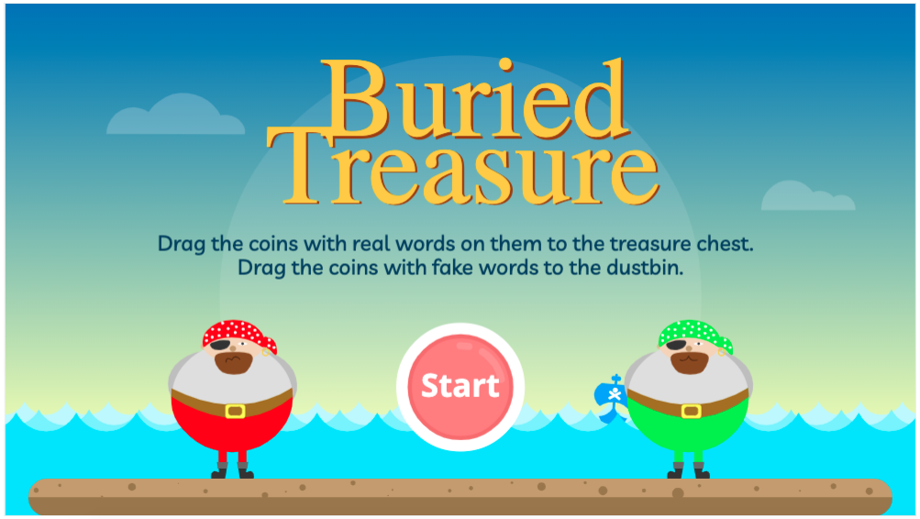

https://www.phonicsplay.co.uk/resources/phase/5/buried-treasure

Choose (Phase 5). Are the o_e words real or nonsense? Sort them. How did you get on?

* Today we are learning more about yesterday’s grapheme o_e and how to read and write it.*

Watch the rest of yesterday’s Letters and Sounds lesson (o_e). Start the clip at 14:20 mins:
https://www.youtube.com/watch?v=HOajky46znQ&feature=youtu.be

Task : See resources link for today on website .
In some of yesterday’s sentences, some of the o_e words have been replaced by a picture. Today’s challenge is to write an o_e word for each picture in your workbook. There are ten in total.
e.g. for you would write globe

Well done Biffs – keep it up!

