Biffs’ o_e challenge
Look back at yesterday’s sentences (written below). Ten of the o_e words have been replaced by a picture – work out the missing o_e words and make a list of them in your book.
The rose from the old stove.
The people found a dinosaur on their way up the 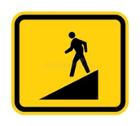.

Can a shiny 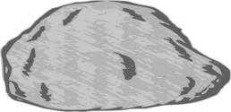 ?
When he was alone, he chose to speak on the .
I hope to find a skipping 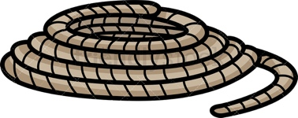 in the loft of my new .
Have you ever seen the queen on the or on an ?

