www.phonicsplay.co.uk
See Y1 homepage for login details

Weds.2/trickywordsx5

Warm-up (revision) – Log onto Phonics Play:
https://www.phonicsplay.co.uk/resources/phase/5/reading-robot
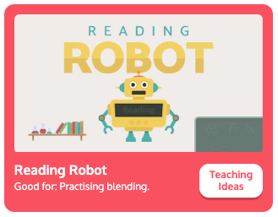
Choose then read the words. How did you do?
* We are learning to read the tricky words Mr, Mrs, looked, called, asked.
Task 1 – Read the tricky words below:
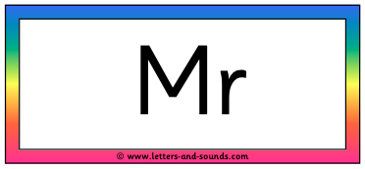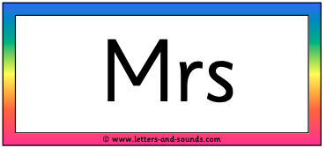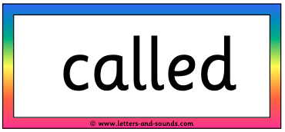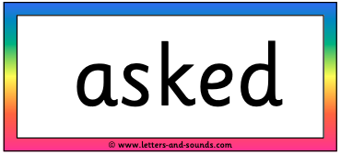

- Now write the 3 tricky words ending in -ed in your books.
- Highlight the ed on the end of each word (e.g. walked, talked).
- Can you read the part of the word that you haven’t highlighted? (i.e. walk, talk) That is known as the root word – like the roots of a tree or plant!

Task 2 – Fill the Gaps
Read the sentences below and fill in the missing words. Choose from today’s tricky words: Mr, Mrs, looked, called, asked. Copy each completed sentence into your book.

- I can see _______ and _______ Hall.
- Our class is ________ Year 1.
- What time is it? they ________.
- We ________ out of the window.
Well done Chips!

