www.phonicsplay.co.uk
See Y1 homepage for login details

Weds.8/e_e (even)

Warm-up (revision) – Warm up your brains by playing the Odd & Bob game on Phonics Bloom (no login needed).
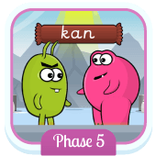 Choose or .
https://www.phonicsbloom.com/uk/game/odd-and-bob?phase=5
How did you get on?

* Today we are learning a new grapheme e_e and how to read and write it.*

Watch today’s Letters and Sounds lesson (e_e).
https://www.youtube.com/watch?v=5V-e55XOHCQ&feature=youtu.be
Stop the clip at 13:48 mins.

*Note* - There are not too many words that contain the e_e grapheme.
Task 1: Can you read the e_e words below?

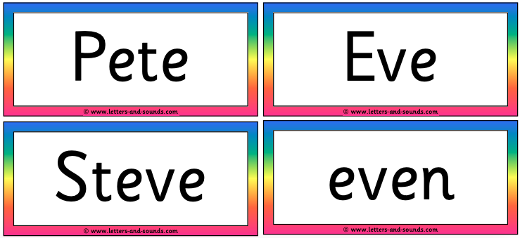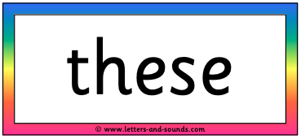

Task 2: Ask an adult to read each of the sentences below aloud. Please write out each sentence and use a ruler to underline each of the e_e words. (No peeking!)
- I will delete these words here.
- Athletes can run, even in the evening.
Well done Biffs – keep it up!

