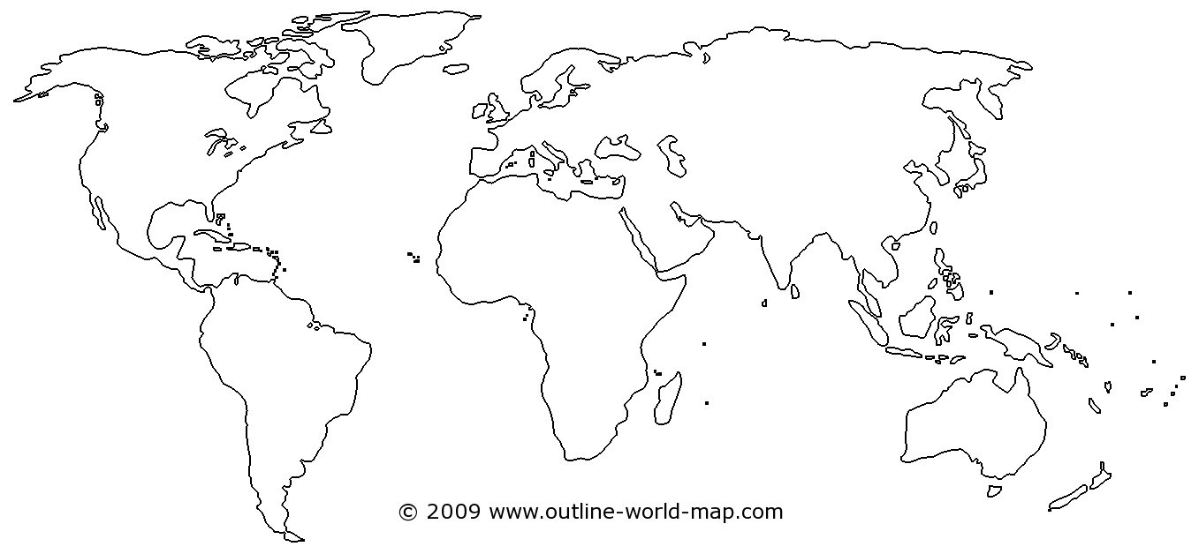
WALT: name the continents and oceans of the world and locate St. Lucia Date………………………..

