WALT: compare Shaw and Coll Date…………………………………………………
Shaw  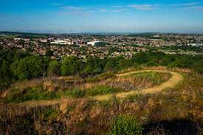 | Isle of Coll  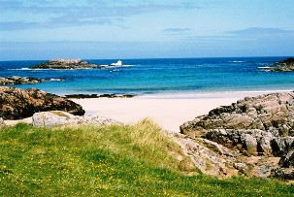
What physical features would you see? | What physical features would you see?
Draw and colour a type of transport you would see. | Draw and colour a type of transport you would see.
What jobs might people do? | What jobs might people do?
What shops would you see?  What do I like about Shaw? Draw 2 things | What shops would you see?  What do I like about Coll? Draw 2 things.
How many people live in Shaw? (Use Google) | How many people live in Coll? (Use Google)
What do you not like about living in Shaw? | What would you not like about living on Coll?

