*** This week is National Child Mental Health Week *** 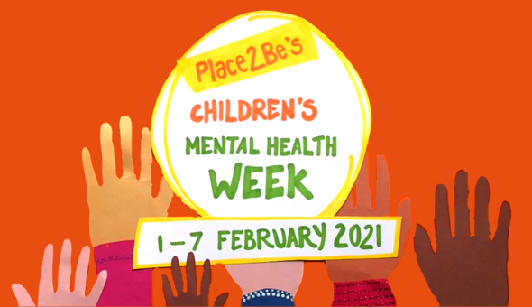
There are lots of ideas and resources at https://www.childrensmentalhealthweek.org.uk/
On Friday afternoon, our timetable will be different to normal as we have decided that the whole school should forget formal lessons and instead snuggle down and watch a family film that will make them feel good. In school we are all going to watch 'Inside Out' as this film deals with emotional well-being, but obviously at home you can choose to watch any film - just one that you feel you and your family will all enjoy together! 😊

Home Learning: Monday 1st February
Phonics/Handwriting: Start by singing all of the sounds we've learnt so far by clicking on the Jolly Phonics link; all of the songs up to and including ng... don't forget to do the actions too! Afterwards we're going to practise writing the next set of letters that are in the same 'family' because they all start the same way: The Curly Caterpillars! The Curly Caterpillars all contain a 'curly c' shape, so make sure that you're forming this correctly (starting from the top and the correct way round!) before you start on any of the other letters. The letters in this family are: c, a, d, g, q, e, s, f, o. You can either practise these letters in your book (several times each) or use the Curly Caterpillars worksheet.

Maths: Start with this Counting to 20 song. Then this week we are going to focus on take away. First watch my subtraction video and discuss that the sign for take away is - and that if you ever hear the 'fancy' words minus or subtract it just means the same thing!
Then try some practical subtraction problems of your own at home to make sure that your child understands the concept, e.g. give them 5 objects and then give them the sum "5-2=' Can they take away 2 of the objects and then count the remaining ones to give you the correct answer of 3?
Try a few practical questions like this (starting with a number up to 10) - no written work is necessary, but do let us know how they get on either by a Tapestry message or photograph.

Topic: This week we're going to look at really brave 'real-life' superheroes... firefighters! Start by watching the What do firefighters do? video on Espresso and this What does a firefighter do? powerpoint presentation together and discussing what you find out together.
Then draw, paint or colour your own firefighter picture. Here is a Fire Engine Colouring Page you could use - just remember to use your very neatest colouring skills!
To finish the afternoon, sit back and enjoy the Let's Play Firefighters episode. 👩‍🚒😊👨‍🚒

Home Learning: Tuesday 2nd February
Phonics/Handwriting: To start, play the Flash cards speed sounds game on Phonics Play again, to see if you can beat last week's score. Don't forget, to get the right sounds for us you need to select Pick individual graphemes and then click All on sets 1 to 8 (this will make sure that it uses all the sounds up to and including ng). Afterwards practise any sounds that you found tricky.
Then we're going to play a new game on PhonicsPlay: Pick a Picture - select Phases 3: sets 6-7 (if your child finds this hard, go back to Phases 2: sets 1-5 first). The children will need to use their phonics skills to read the word and then find the correct picture.

Maths: Start with a counting to 20 song. Then we're going to think about subtraction/take away again. Remember when you take away the answer will usually be smaller - and that the words 'subtract' and 'minus' just mean the same as take away! Go through this Subtraction PowerPoint together to reinforce how to take away (click on 'Enable Editing' and then 'Slide show' and 'From beginning' to be able to view it properly).
Then it's your turn! Can you use objects from around your house to answer these subtraction number sentences? (write the completed number sentences down in your books):
- 5 - 2 =
- 7 - 3 =
- 6 - 4 =
- 9 - 1=
- 10 - 5 =
- For an extra challenge can you make 3 more subtraction number sentences of your own?

Topic: This afternoon we're going to continue our learning on firefighters.
Fireman Sam is one of the most well known and loved firefighters we know. There are lots of Fireman Sam episodes available to watch on the internet, choose one to watch and enjoy (depending on how much time you have). Then, for our activity there are lots of different Fireman Sam games to choose from on the Cartoonito website to practise our computer skills. In school we will be learning how to use a mouse for these games in our computer suite, so if you do have a mouse attached to your computer please encourage your child to use this, if not don't worry - we will learn this skill when they return to school.
***Reception class Zoom 'drop in' session 2.30pm ***
Details will be sent to you via Tapestry.

Home Learning: 'Well-being Wednesday' 3rd February
English/Topic: Start by reading the Charlie The Firefighter story together. Afterwards, discuss what YOU would like to be when you grow up - would you like to be one of the 'real-life superheroes' that we've been learning about, or is there something else you'd really like to be?
Use the When I'm Grown Up page (or just use this to give you an idea of the activity if you don't have access to a printer) to write and draw a picture of what you'd like to be when you grow up and why (adults can scribe this part for their child).

Maths: Start by joining in with this counting to 20 video. Then watch the Numberblocks subtraction episode. Afterwards have a quick chat to remind yourself what 'take away' means and what the sign for it looks like. Then use your subtraction skills (and practical resources from around your house) to see if you can solve the tricky subtraction problems on my Tricky Take Aways sheet. For an extra challenge can you make up your own 'tricky take away' problem and find the answer to it too?

'Well-being Wednesday' Afternoon Activity: *Reception Smile Challenge*
First listen to me reading you a story: 'Where's your smile crocodile?' by Claire Freedman and Sean Julian. Then discuss how doing something kind for someone else can make you feel happy too, like how helping the little lion cub made Kyle the crocodile feel happy himself too!
This afternoon we want you to think about somebody special in your life. Your challenge is to do something thoughtful or kind to put a big smile on their face 😃 - it could be drawing them a special picture or making them a card, it could be helping them to do a tricky job, it could be baking them a cake, it could be reading them a story or even putting on a special show for them!
What could you do to put a smile on somebody special's face? We can't wait to see what you do!

Home Learning: Thursday 4th February
Phonics/Handwriting: We're going to start by playing the Grab a Giggling Grapheme game on Phonics Play. Select '+ch sh th ng' to practise the right sounds for us.
Then we're going to do a reading activity, which focusses particularly on those tricky sounds ch, sh, th and ng. Press on the Phonics Play Comics link and see if your child can use their phonics skills to independently read the comic strips out loud to you?

Maths: Start with this Counting to 20 song. Afterwards if you feel your child would benefit from watching either my subtraction video or the Subtraction PowerPoint again, to revise how to take away, then watch one of these. If your child is now confident with subtraction feel free to go straight into the activity: Play the Topmarks Subtraction to 10 game to practise subtraction skills further.

Topic: Thursday is our 'craft afternoon'. Start by watching the Firefighting Tools video on Espresso to have a look at some of the special equipment that firefighters need. Then be as creative as you like, what firefighter - themed activity will you do this afternoon?
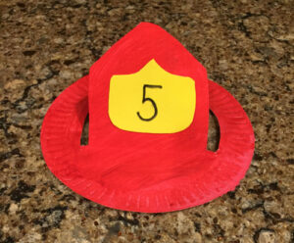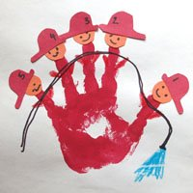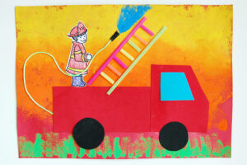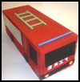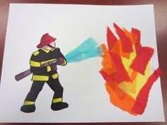
We can't wait to see what you make... don't forget to bring it to our zoom call tomorrow! 👨‍🚒👩‍🚒

Home Learning: 'Feel-good Friday' 5th February
*Remember today is a little different to a usual Friday as it is child mental health week *
First, remember that today we are going to have a "Dress to Express" non-uniform day for all our children whether learning at home or at school. “Dress to Express’ simply means express yourself by wearing a colourful outfit. Please take pictures of your children at home and send them in via Tapestry and we will take pictures of the children in school so they can all be shared on the website together.
'We have three main activities today:
1. Forest Fun - to get us out and having fun in the fresh air 🌳
2. Our class zoom - to help us stay connected and remember how much we all miss each other 🤗
3. Movie time - a time to snuggle up and just watch a feel-good film! 🍿🎞*

Forest Fun: As always do your forest fun session at a time that best suits your family - both time and weather-wise!
This week we're going to use our forest fun session to get arty... As it's our last week on superheroes I was thinking how fun it would be to make our own superhero initial badge, using natural resources that we find on our forest fun walk/outdoor time! All you need to do is collect some natural resources that you find outdoors - such as sticks, leaves, stones etc. and then use them to create your first-name initial... the way that Superman has and Wonderwoman has !
Here's a photograph of the whole alphabet made out of natural resources to give you an idea... we can't wait to see yours! 😊
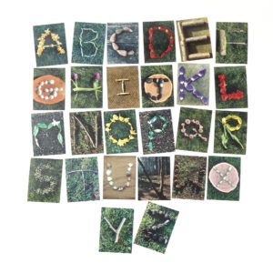
*** Reception class Zoom 'drop in' session 11.am ***
Details will be sent to you via Tapestry.

Movie Time: Just enjoy your family time - chill out and snuggle up together 😊

Have a happy and safe weekend everyone 🌈

