This week it is Chinese New Year!

We are going to spend our last week of this half term learning all about the Chinese New Year celebrations. Also we will be revising our addition and subtraction skills, as well as completing our ‘Scrap’s Phonics’ module.

Thursday will be our dedicated ‘Chinese New Year celebration day’ * and Friday will be our ‘end of term treat day’… it’s going to be lots of fun this week!

(*in school we will be tasting some Chinese foods on Thursday – this is obviously not compulsory at home, but we just wanted to give you the ‘heads up’ incase you want to add anything different to your shopping list this week!)

Home Learning: Monday 8th February
Phonics/Handwriting: Start by singing all of the sounds we’ve learnt so far by clicking on the Jolly Phonics link; all of the songs up to and including ng… don’t forget to do the actions too! Afterwards we’re going to practise writing the next set of letters that are in the same ‘family’ because they all start the same way: The One-Armed Robots! The One-Armed Robots all start in the same way: “Down, then back up and over”. The letters in this family are: b, h, k, m, n, p, r. You can either practise these letters in your book (several times each) or use the One Armed Robot Letters worksheet.

Maths: This week we are going to re-cap both addition and subtraction.
Start by playing the Blast Off game on Topmarks – choose ‘Direct’ and ’10 to 20′ if your child needs practise on number recognition up to 20, or choose ‘In Between’ and ’10 to 20′ if they are ready for more of a challenge.
Then we’re going to revise addition – can you remember what the sign for ‘add’ looks like? Practise our addition skills by playing the Addition game on Topmarks (if your child is unsure/ has forgotten what addition means just watch my addition video again first).

Topic: First watch The Chinese New Year video. Chinese New Year is the biggest celebration in the Chinese calendar and is celebrated in many countries throughout the world. We’re then going to watch The Story of the Chinese Zodiac video.
Here is a list of the animal for each recent year of birth: Chinese New Year Animals And Years Can you find out which animal you are?
Once you know which animal you are, your task is to draw/paint your animal. Here are some colouring sheets you can use if you prefer to colour your animal: Chinese New Year Colouring Sheets (*The goat is page 7, the monkey is page 12!)

Home Learning: Tuesday 9th February
Phonics/Handwriting: Start by playing the Grab a Giggling Grapheme game on Phonics Play. Select ‘+ch sh th ng’ to practise the right sounds for us.
Then, we’re going to try and write some simple sentences, which focus on the phonics sounds that we’ve learnt so far. Slowly read the following sentences for your child to write (don’t start the next until they’ve finished the first). Remind them first that there are five words in each sentence – they need to say the sentence out loud before they can write it down – use their five fingers to remember the five words (point to each finger as they say a new word):
- a cat had a hat
- a dog had a log
- a fish had a wish
*For some children three sentences might be too much all in one session – and this is fine. If this is the case, simply choose one sentence and then get them to draw a picture to go with that sentence.

Maths: Start by playing the Helicopter Rescue game on Topmarks – choose ‘Direct’ and ‘1 to 20’ if your child needs practise on number recognition up to 20, or choose ‘In Between’ and ‘1 to 20’ if they are ready for more of a challenge.
Then remind your child what ‘take away’ means, can they remember what the sign looks like? Try some practical take away problems of your own at home, using any objects up to 10 (if your child is unsure/ has forgotten what take away means just watch my take away video again first).

Topic: There are two Chinese New Year activities to choose from on Purple Mash: Chinese Fan or Chinese Lion (*top tip: the Chinese Fan is much simpler!) Choose one and decorate it as neatly as you can. Remember to save it when it’s finished in the Reception Chinese New Year folder so that we can all your picture!
Here are the two that I’ve done:
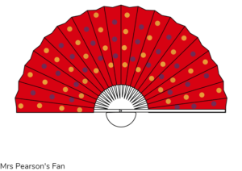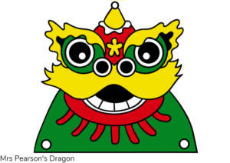
To finish, we’re going to watch the CBeebies Preparing for Chinese New Year episode together.

***Reception class Zoom ‘drop in’ session 2.30pm ***
Details will be sent to you via Tapestry.

Home Learning: Wednesday 10th February
English/Topic: To start, play your child’s favourite from the Phonics Play quick ‘starter’ games, either: Flash cards speed sounds or Grab a Giggling Grapheme.
Then we’re going to go all the way down Scrap’s Phonics Path on Espresso. Test your child on every step (sound) along the path (both in and out of order), watch the videos for any sounds that they don’t know confidently. Today is our last focus day on these sounds as we will be moving on to new ones next half term, so spend as long as they need going over any of the sounds – and afterwards play any of the ‘Activities‘ on Scrap’s Phonics to practise further.
To finish, please tell your child that we will have a ‘Scrap’s Phonics certificate’ waiting for them in school to say well done (obviously you can print this out yourselves if you wish, but we will be giving them one in school anyway, so don’t feel you have to)!

Maths: Start by joining in with this counting to 20 video. Then play your favourite from either the Blast Off or the Helicopter Rescue game on Topmarks.
Then we’re going to have one last go at addition and subtraction. Today there is a choice of activities depending on what your child needs most:
- The majority of children are quite solid with addition at this stage but might need more practise with subtraction. If this is the case for your child, then please could you do some more practical subtraction problems with them (numbers up to 10) to help embed the process.
- If you feel that your child is already solid with both addition and subtraction then you can try my Mixed up + and – number Sentences! (just copy the questions from the sheet if you don’t have a printer).

Topic: First, watch the Chinese New Year video again. Then we’re going to have a Chinese craft afternoon! There are many different Chinese crafts that you could try at home. Here are some ideas, but you can make whatever you like – it could be a model of the animal for your year of birth, it could be a Chinese dragon, it could be a decoration for your house… don’t forget to take a photograph so we can see what you’ve made!
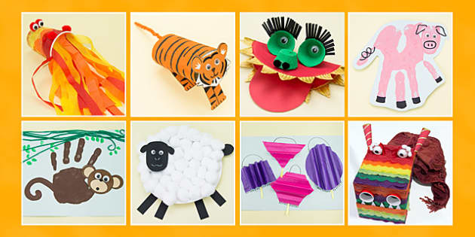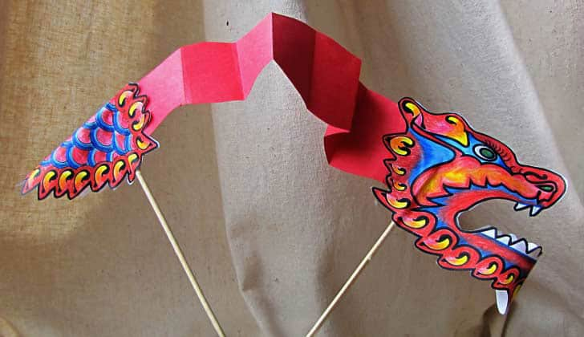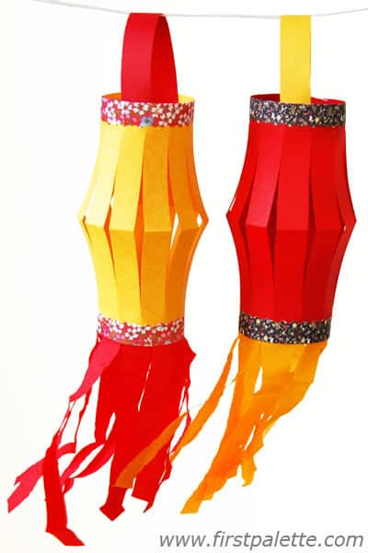

Home Learning: Thursday 11th February
Phonics/Handwriting: Today is going to be a little different as we are having a ‘Chinese New Year day’ today! Start by watching the CBeebies Story of the Chinese Zodiac. Then for our handwriting activity we are going to use the Chinese New Year Animals Handwriting Paper Chain Activity – if you don’t have access to a printer it doesn’t matter, just use this to give you an idea and create your own paper strips on pieces of paper. The task is to practise letter formation/ handwriting skills by writing the name of each of the twelve animals and then colouring in the animal pictures neatly.
(The rest of this activity we will do in our maths session!)

Maths: Start with this Counting to 20 song. Then we’re going to complete our Chinese new year paper chain activity by cutting out (please let the children do this themselves, we need to practise our cutting skills!) and then sticking the paper chains together in the right order that they finished in the race: 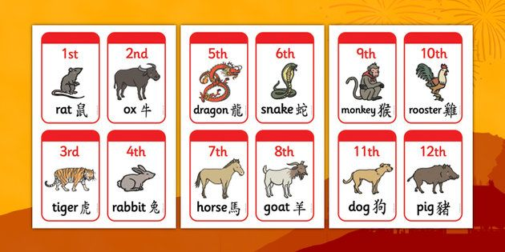

Topic: Chinese New Year celebration afternoon!
To start we’re going to watch and join in with the Chinese New Year song. Then this afternoon we want you to basically just immerse yourselves in all things Chinese new year! In school we are going to taste some Chinese foods, such as prawn crackers, sweet and sour sauce, noodles etc. Also we will try a bit of lion dancing!
At home there are many things that you can do, choose whichever suits your timescale/space/resources the best!
Here are some ideas: drum-making/playing, lantern-making, money-wallet making, food tasting, lion/dragon dancing, fortune-cookie making, Chinese cooking, decoration making… be as creative as you like! We can’t wait to see what you do!
To finish, we will be calming down with the Cosmic Yoga Dragon session.

Home Learning: Friday 12th February… Last day of the half term!
1. Outdoor Fun – to get us out and having fun in the fresh air
2. Our class zoom – to help us stay connected and remember how much we all miss each other
3. Golden time – This is a ‘choosing’ session – to just do something together that makes you happy

Outdoor Fun: As always do your outdoor session at a time that best suits your family – both time and weather-wise! This week, with it being our last day of term, there is no set ‘theme’ for our session. Do whatever makes you happiest, it could be searching for birds or wild-life, it could be going on a bike-ride, it could be splashing in puddles or even sledging (depending on the weather)! Whatever you decide to do, you have one challenge… to take a photograph of your favourite part of your outdoor time. We love seeing your photographs!

*** Reception class Zoom ‘drop in’ session 11.am ***
Details will be sent to you via Tapestry.

Family ‘Golden Time’: Choose an activity that makes you happy – it could be watching a movie, baking, playing a board game – anything that makes you relax and have fun together!

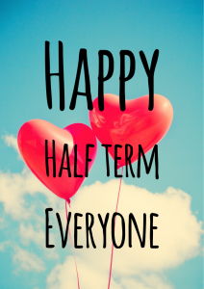
A very ‘Happy Birthday’ to Emily for Saturday!
Have a great week everybody, take care

p.s. Don’t forget, Sunday is Valentine’s Day and Tuesday is Shrove Tuesday!
