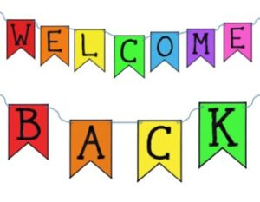

Hello everyone! We hope you’ve had a lovely, relaxing half term break and you are ready to start our new topic…
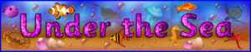

During this topic we will be learning about lots of different animals that live in water – and studying the life cycle of some of them very closely too. We will also be investigating materials that float and materials that sink and creating some wonderful ocean-themed art work. It’s going to be lots of fun!

Home Learning: Monday 22nd February
Phonics/Handwriting: We’re going to start by singing all of the sounds we’ve learnt so far by clicking on the Jolly Phonics link; all of the songs up to and including ng. We need to make sure we can remember them all, before starting on our new sounds tomorrow!
Afterwards we’re going to practise writing the next set of letters that are in the same ‘family’: The Zigzag Monsters! The Zigzag Monsters are all made of straight lines and look a bit like zigzag shapes. The letters in this family are: v, w, x, z. You can either practise these letters in your book (several times each) or use the Zigzag Monster Letter worksheet.

Maths: Start by singing one of our numbers to 20 song. Then this week we are going to be learning about money.
**For all the practical activities this week it would be great if you could use real coins (if not possible though it doesn’t matter – you could use pretend coins or you could make your own paper coins). We will acknowledge all coins just so that the children are aware of them, but we will only be actually using the following coins at this stage: 1p, 2p, 5p and 10p, so you won’t need need to make or find any of the others to use. Here is a British Coins template sheet you can use if you need to make your own!
First watch my introduction to coins video and then see if you can do exactly the same at your house – sort coins into 1ps, 2ps, 5ps and 10ps – talking about what they look like and comparing their sizes as you go.

Topic: Today we are starting our new topic: Under the Sea! Watch the Seashore Life song on Espresso and then have a little chat about what you already know about the sea – have you ever been to the seaside? Have you ever swum in the sea? Everyone will have different experiences, so please can you think of one simple sentence of what the seaside means to you (e.g. “I like making sandcastles” or “We go to Blackpool every Summer”), then write it down and add a picture to go with it.
Our story for our first week is a lovely one: The Rainbow Fish by Marcus Pfister.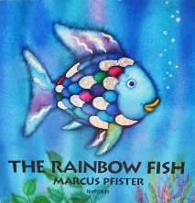
Finish your afternoon by reading (or watching) this story together.

Home Learning: Tuesday 23rd February
Phonics/Handwriting: Start by playing the Grab a Giggling Grapheme game on Phonics Play. Select ‘+ch sh th ng’ to practise the right sounds for us. Then we’re going to start on our new phonics path to learn our next set of sounds. First go to Polly’s Phonics on Espresso and then click on the first sound: ai – this a digraph (two letters that make one sound). Watch the video together and then listen to and learn the Jolly Phonics ai song.
Can you make the ‘ai’ sound, using different things from around your house? You can use anything – bricks, cars, toy figures, biscuits… we can’t wait to see what you use!

Maths: First watch the Coins up to 10p song. What do remember about coins from yesterday? Discuss colour and size as well as value. Then play the Toy Shop game on Topmarks. Make sure to select the following options: One coin and 1p (up to 10p)

Topic: For our computing activity this week we’re going to change a very plain looking fish into a wonderful, colourful fish – just like the Rainbow Fish! Go to the Fish Art activity on Purple Mash and create your own master piece!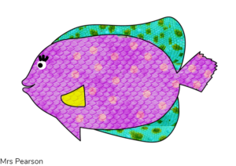
Here is the one that I did, I can’t wait to see yours! *Don’t forget to save it in the Reception: ‘Fish’ folder with your name!

***Reception class Zoom ‘drop in’ session 2.30pm ***
Details will be sent to you via Tapestry.

Home Learning: Wednesday 24th February Happy Birthday to Beatrice P!
Phonics/Handwriting: Start by singing the Jolly Phonics ai song. Then watch the ‘ai’ reading words video, can you read the words?
Finally see if you can remember any of the ai words from the video (or any others of your own!), e.g. rain, pain, mail, aim, snail. Can you write some of these words down, using your best handwriting? Please just make sure that the a is formed correctly every time!

Maths: First watch our Coins up to 10p song. Then we’re going to play shopkeepers!
Collect 10 different items from around your house (whatever kind of shop you think would be most fun – it could be 10 items of food, it could be 10 toys, it could be 10 books – anything you like!) then make 10 price tags, ranging from 1p – 10p and allocate 1 label to each of your 10 objects. Your activity is then to do some role play – taking it in turns to be both the shop keeper and the customer. Can you choose an item and pay for it using the correct amount?
***At this stage most children will feel more confident to just use 1p coins. If your child needs more of a challenge though, you can try using the other coins up to 10p. Let us know how they get on with this activity

Topic: Re-read or watch The Rainbow Fish by Marcus Pfister. 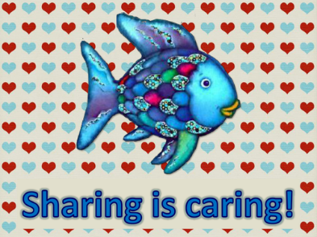Then today we’re going to think about how the Rainbow Fish changed during the story: At the start he didn’t want to share at all, but then he did a very kind thing – he shared. Sharing is a very important thing to do with your friends and family to make them feel happy and to show them that you are a kind and caring person.
Have a discussion about the kinds of things that children can share with others. Can they think of a time that they have shared something with someone else? – how did it make them feel?
Using an idea of a time that they have already shared, or an idea of something they are going to do with a friend once we are all back in school together, complete the Rainbow Fish Sharing Activity sheet (or just do your own version on paper).

Home Learning: Thursday 25th February
Phonics/Handwriting: Start by going back to Polly’s Phonics path on Espresso, and today we’re going to learn the next digraph along the path: ee. Start by clicking on this step on the path and watching the video together. Then listen and learn the Jolly Phonics ee song (you will notice this song also contains the ‘or’ sound, which we will be learning soon)!
Try completing the ee Worksheet – you need to carefully read each word and then match it to the right picture! (if you don’t have a printer it doesn’t matter, just use this worksheet to give you an idea of some ee words to try writing down).

Maths: First watch a new Coins song on Espresso. Then today we’re going to try counting and making different amounts (using coins from 1p-10p). First go through the How Much In My Piggy Bank? powerpoint (remember to click on ‘slide show’ and ‘from beginning’ to watch it properly). Then complete the My Piggy Bank sheet (or if you don’t have access to a printer just use this sheet to give you the idea of what to set up – basically piggy bank pictures with some different amounts in them (up to 10p) and ask your child to count how much the total amount is. Afterwards they can try making the right amounts shown on the labels by using different coins.

Topic: First watch or read our story of the week: The Rainbow Fish by Marcus Pfister. Then read the Special Letter to the class from The Rainbow Fish! Your craft challenge is to help Rainbow Fish look beautiful and colourful – you could decorate The Rainbow Fish template or you can use different materials from around your house to create your very own Rainbow Fish, be as creative as you like!
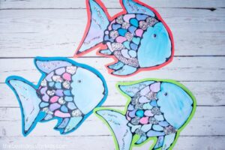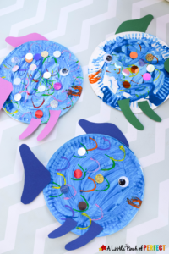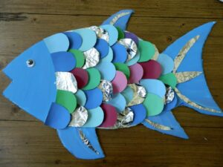

Home Learning: Friday 26th February
Key skills: Friday is our weekly chance to focus on our key words and name writing skills.
Start by watching the tricky words song video again. Then practise reading your own set of key words. *
*Every child is on a different set of key words. If your child has already passed set 8 then they will be now working on their spellings too! *
Please let us know how your child is doing with their key words (and spellings if they are at this level) – remember that to move onto the next set of words the child must be able to read their current words confidently and instantly (not by trying to sound them out or guess them)! If they are ready for their next set let me know and I will send them to you via Tapestry.
Finally, use this session to practise writing your (first) name, making sure that every letter is formed correctly and that it always starts with a capital letter!

Maths: First watch the Coins song on Espresso. Then have a go at the EYFS Money Matching PowerPoint Activity Up To 10p
(remember to click on ‘slide show’ and play ‘from beginning’ to be able to watch it properly).

*** Reception class Zoom ‘drop in’ session 11.am ***
Details will be sent to you via Tapestry.

Forest Fun: The weather is unpredictable at the moment – but wrap up warm and get outside whenever you can and just enjoy the time to explore – whether it be in your garden, your nearest park or on a big hike with your family! Take photographs of anything interesting that you see or do – we love to see what you’ve been up to in the great outdoors!

End of the week activity: Underwater adventure yoga session!

Have a happy and safe weekend everyone!

