How to Draw a Face
*You will need your picture prompt sheet and your instructions word bank to help you.*
Try not to use ‘draw’ too many times - what bossy verbs could you use instead?
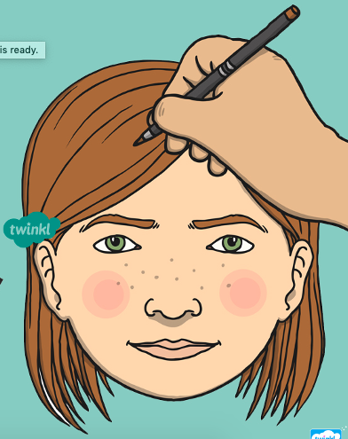
1. First sketch a faint oval .
2. Then mark on some faint lines with a ruler and a pencil .
3. Next __________________________
4. _______________________________
5. _______________________________

6. _______________________________
7. _______________________________
8. _______________________________
9. _______________________________
_______________________________
10. ______________ colour your face in, adding any details you have missed.

