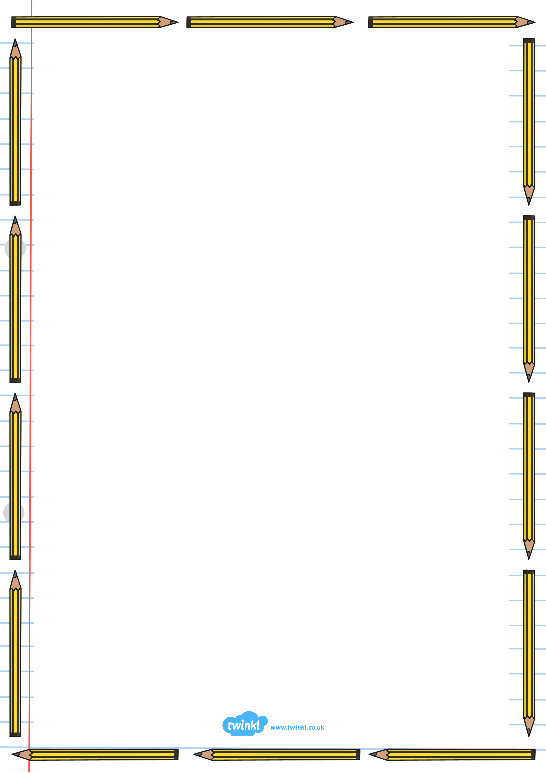

Conclusion– What happens at the end?

Introduction – What is the hat for?

What do I need?

What do I need to do?

**How to Make a Magic Hat**

# L1 – To listen and respond to a set of instructions

**Just like Miss Barron did, you need to draw/colour pictures to make your instructions map**. Make them clear – you will need them to help you answer some questions later. *\* Keep it safe for tomorrow! \**



