WALT: Locate places on the map of St. Lucia and distinguish between human and physical features.

**Physical Features**

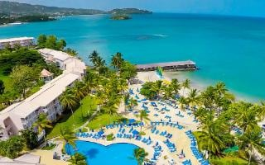 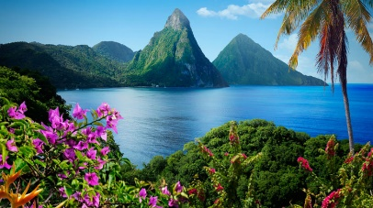 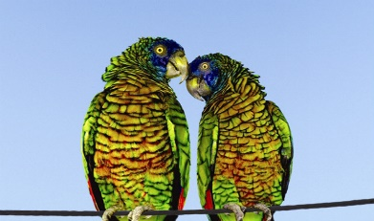

**Human Features**

p