WILF in a story re-tell  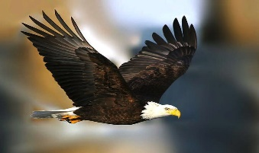 | What do I think? | What does my grown up think?
Have I used a capital letter and a full stop in every sentence?

Have I used expanded noun phrases?

Have I used time openers e.g One morning, the next day, after that?

Have I used some examples of the past progressive tense? (Use was or were) e.g The farmer was walking….The chicks were sitting in the nest with their mum….

Have I used adverbs e.g quickly, carefully, slowly?

