WALT: write a description of the weather in St. Lucia.

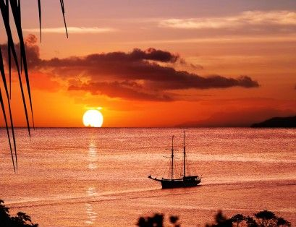Use these words to help yo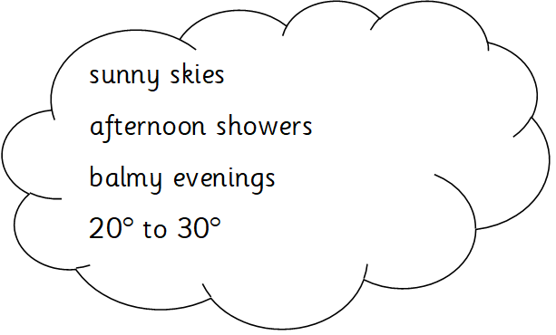u make your sentences

December to April

May to July

August to December

clear skies warm seas

heavy rain over mountains

coastal areas dry

hurricanes are rare

wwwwwwwwww

clear

clear skies

mid 30°s

humid air

refreshing breeze