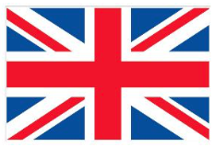 The United Kingdom – Places I have visited

Make a list of the places you have visited
in the United Kingdom.
Put a tick to show which country it is in – England, Scotland, Wales or Northern Ireland.
List as many places as you can. Do not include Shaw!

REMEMBER - Place names start with a capital letter!

Places I have visited  in the UK | England | Scotland | Wales | Northern Ireland
Manchester example

Now complete the sentences. Copy each sentence into your book. Only use each country once.

Choose from:

England | Scotland | Wales | Northern Ireland

- I live in _________________
- I have been to _________________
- I have never been to _________________
REMEMBER – put a full stop at the end of each sentence.

