Fair or Unfair? 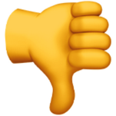

Look at these ideas – do you think they are fair or unfair?
Work with a partner to sort them into the right group.

Fair | Unfair

