The 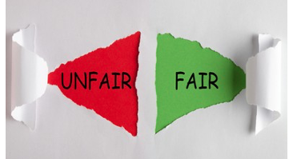 Game

What you need:
- 2 sheets of paper and a pen
- Choice cards – see lesson resources
How to Play:
- First, you need 2 sheets of paper … write Fair on one and Unfair on the other.
- Now stick Fair on the wall on one side of the room and Unfair on the other.
- Next stand in the middle of the room.
- Then pick a card - you can print out and cut them up, or you can just close your eyes and point to the screen). Decide if what’s on the card is fair or unfair.
- Now vote by running, hopping, skipping or jumping to the fair wall or the unfair wall, depending on what the card says.
- Then run, hop, skip or jump back to the middle of the room.
- Repeat! Do this 10 times in total.

Have fun!!!

