
^{The United Kingdom}
PART 2 - FLAG TASK – Do you recognise this flag?
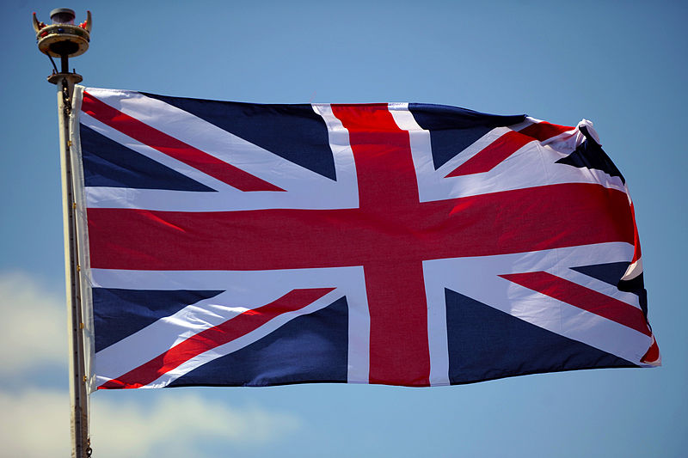

This is the flag of the United Kingdom – the U.K.

Here are today’s key questions:
- Can you think where you might have seen if before?
- Do you know what it is called?
- What colours and shapes can you see on the flag?

It is often called the Union Jack but it can also be referred to as the Union Flag.

FYI grown-ups – in case you’re wondering / interested!!:
Sometime around 1674 the British flag became formally known as the 'Union Jack' when mounted on a warship and the ship was not in harbour. At the same time the British flag was referred to as the 'Union flag' on land. .The Union Jack was amended in 1801 to incorporate the cross of St. Patrick (Ireland).

