BBC Bitesize - Exploring Locations – The United Kingdom

https://www.bbc.co.uk/bitesize/articles/z2ksxbk
Here you will find videos and activities about the United Kingdom. Try them out, and then test your knowledge with a short quiz before exploring the rest of the collection.

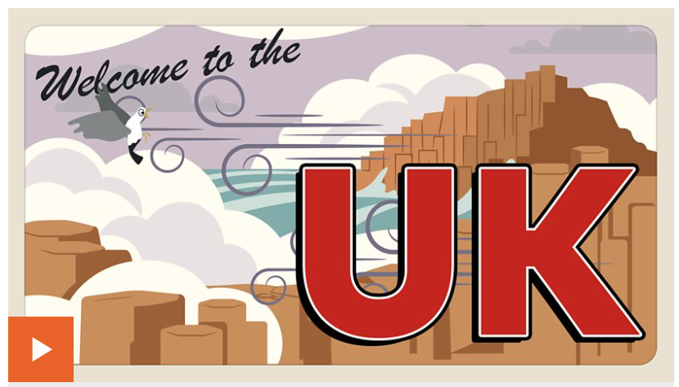 1. Watch the video.

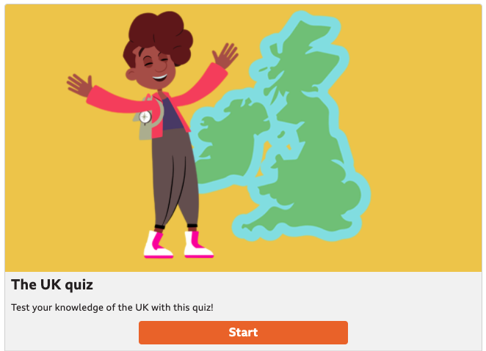 2. Take the quiz.

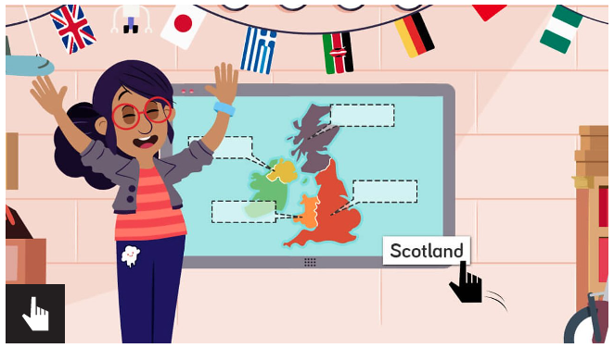 3. Label the countries on the map.

Now complete your follow-up activity – Where have you visited in the UK? See separate sheet.

