JANUARY - Week 3 (w/b 18.1.21)
This week’s overview:
English: Recounts / Diary Writing (Oak National Academy) - Overview for the next 2 weeks:
https://classroom.thenational.academy/units/recount-diary-entry-060a
Spellings: Spellings Spring 3 18.1.21 Please continue to practise these on the sheet in your spelling folder. Remember – your test day is Friday ... good luck! 🍀 Don't forget to let us how you've gone on. We had some super spellers last week! 🥳
Maths: Addition and Subtraction (within 20)
Topics this week: Great Fire of London (history) / Materials (science) /Algorithms (computing)

Monday 18th January
English:
Today we are starting another new topic – recounts / diaries. Do you know what a recount is? Do you know what a diary is? (Recount = retelling - in order - what has happened; Diary = a written record of thoughts, feelings and events – it is usually handwritten).
The focus of our recount / diary work for the next two weeks is the story of The Magic Paintbrush, which is another traditional tale. This work should lead us nicely to the last week of the half-term, when we will be looking at the diary of Samuel Pepys.
Some of you might already know the story of The Magic Paintbrush, others might not. It is a story based on a Chinese folk tale. It shows that goodness and kindness are rewarded over greed.
To familiarise yourself with the story, here is a beautiful animated version for you to watch:
https://www.youtube.com/watch?v=iy2TUvycfeg
Your task today is to find out more about the story. Please record your ideas like this: The Magic Paintbrush.background You will need to look at a world map for question 4 – first find us (UK), then find the place where the story is set. Have a look on a globe if you’ve got one – or you can use this map: WorldMap.
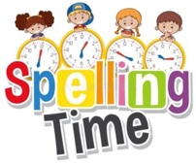🤩 Please spare a little time to practise your spellings - see above. 🤩

Phonics:
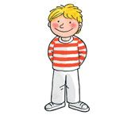Kippers – Mrs. Leavy’s group 3.Mon.phase3. Sh
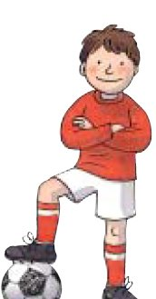 Chips – Miss Platt /Mrs. Tetlow’s group Mon 3.phase4 (1)
Biffs – Mrs. Kulczycki’s group 3.Mon.phase5.wh & activity - 3.Question.words.poster.Phase 5.wh
Maths:
Warm-up – This is part of the White Rose Home Learning Video.
Addition and Subtraction within 20 - Today we are looking at the video about adding by counting on (the second video)
Please find the link to the learning today here https://whiterosemaths.com/homelearning/year-1/spring-week-2-number-addition-and-subtraction-within-20/
The warm up is also part of the learning on the video clip.
When the video pauses you will need to complete the sections on the worksheet which is here. Y1 Spring Block 1 WO1 Add By Counting On 2019
Do as many questions as you can. As you can see question 3 is the most challenging, but I'm sure most children would like to give it a try!
Answers can be written on the sheets if you can print them off or written in your books.
Helpful Tips : As you can see number lines and ten frames are a popular resource that the children use and are familiar with.
History / Art (Sketching):
Today’s key question:
🔥 Who was Samuel Pepys and why was he important?
Today we are going to find out all about Samuel Pepys, who was famous for keeping a diary – he wrote in his diary about what happened during the Great Fire of London in 1666.
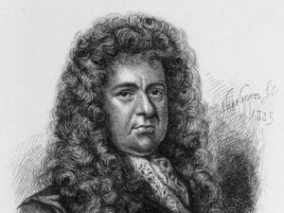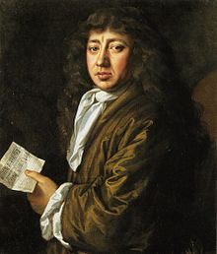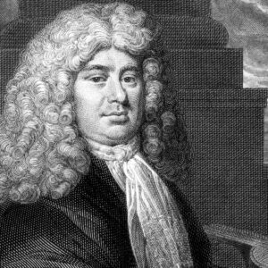
First, watch the episode of Magic Grandad … we will go back in time and ‘meet’ Samuel Pepys!
https://www.youtube.com/watch?app=desktop&feature=share&v=VarSSAwiimU
Now, complete today’s task - a sketch of Samuel Pepys. Here are some Pepys Images to help you. Please think carefully about these key questions:
🔥 What did he look like?
🔥 How do we know he lived a long time ago?
🔥 Why do you think there are no photographs of him?
Choose one of the sketches / paintings to copy … remember, you should take your time and sketch lightly (tickling the paper!). Make sure your sketch fills the page. You can sketch on here Pepys.border, on a plain piece of paper, or even in your book. Looking forward to seeing your sketches!!!
😊 Enjoy your daily reading too - maybe complete one of your Spring reading challenges today? 😊

Tuesday 19th January
English: ** Today we are starting our Oak National Academy English lessons. Please pause the lessons whenever it suits you best. It’s also best to watch the lessons with no subtitles.**
Lesson 1 - To listen to a recount - In this lesson, we will meet Ma Liang, the painter from the Magic Paintbrush story, who will recount the events of the story from his point of view.
https://classroom.thenational.academy/lessons/to-listen-to-a-recount-cnjpcc
Task (1) - at 2:44 in the lesson you will be looking at spelling some of our Year 1 tricky words. Follow Mrs. Howley’s lead, but when you write them in your book, but please write them in your best Buckstones writing. Make sure you form your letters correctly – use our letter formation mat to help you: Buckstones.letter Formation.mat
Task (2) – Make your own MagicPaintbrush.story.map.Tues
🤩 Please spare a little time to practise your spellings - see above. 🤩
Phonics:
Kippers – Mrs. Leavy’s group 3.Tues.phase3.ch & activity for this lesson: Sh Or Ch
Chips – Miss Platt /Mrs. Tetlow’s group Tues 3.phase4 19.1.21
Biffs – Mrs. Kulczycki’s group 3.Tues.phase5.ea.head

Maths:
Warm-up – Warm-up – https://www.youtube.com/watch?v=-74-_3WSrD0 Number Bond Song
Addition and Subtraction within 20 - Today we are looking at the video about adding ones using number bonds (the third video.)
Please find the link to the learning today here https://whiterosemaths.com/homelearning/year-1/spring-week-2-number-addition-and-subtraction-within-20/
The warm up is also part of the learning on the video clip. The tasks will be the first part of the worksheet below.
When the video pauses you will need to complete the sections on the worksheet which is here. Y1 Spring Block 1 WO Add Ones Using Number Bonds 2020 (1) Weds
Answers can be written on the sheets if you can print them off or written in your books.
Helpful Tips : With addition we know that it doesn't matter which way round the numbers are in the calculation sentence (commutative law), so always start with the biggest number first. It is so much easier! Eg. 2 + 16 = 18 is the same as or equal to.... 16+ 2 = 18
Number bond help sheet available here Number Bonds Help Sheet

Music: It's music time again! 🥁 🎼 🎺 Today we are starting our Oak National Academy music lessons. The focus for our next set of lessons is timbre. is a quality of sound. It is what makes two different musical instruments sound different from each other, even when each instrument plays the same musical note.
We will start today with Lesson 1 – exploring different ways to use your voice:
https://classroom.thenational.academy/units/timbre-3b9d
- Please watch and join in as directed. One of the activities is to decide which instruments are being played … pause the lesson at this point. You might want to have a look at this Musical Instruments. Bank to help you make your choices. When you are ready, press Play again.
- Follow-up task: 1.Explore And Create Task
Have fun! 🥁 🎼 🎺🥁 🎼 🎺🥁
😊 Enjoy your daily reading too - what would you like to read today? 😊

Wednesday 20th January
English: ** We continue with our Oak National Academy English lessons. Please pause the lessons whenever it suits you best. It’s also best to watch the lessons with no subtitles.**
Lesson 2 - To tell a recount from memory - In this lesson, we will hear, map, step and speak a recount.
https://classroom.thenational.academy/lessons/to-tell-a-recount-from-memory-6wtk0r
Task – You will need your story map from yesterday to help you retell the story in your own words. Don’t forget to use words like First, Then, After that, In the end etc. to link your ideas together, and make sure you talk about how you feel too. Remember that you will need to pretend that you are Ma Liang – you can even dress up as an artist if you wish to help you get into character!!!
🤩 Please spare a little time to practise your spellings - see above. 🤩
Phonics:
Kippers – Mrs. Leavy’s group 3.Weds.phase3.we.me.be.x
Chips – Miss Platt /Mrs. Tetlow’s group Weds 3.phase4 20.1.21
Biffs – Mrs. Kulczycki’s group 3. Weds.phase5.keywords

Maths:
Warm-up – This is part of the White Rose Home Learning Video.
Addition and Subtraction within 20 - Today we are looking at the video about adding ones using number bonds part two (the fourth video.)
This will be the second part of the worksheet from yesterday.
Please find the link to the learning today here https://whiterosemaths.com/homelearning/year-1/spring-week-2-number-addition-and-subtraction-within-20/
The warm up is also part of the learning on the video clip.
When the video pauses you will need to complete the sections on the worksheet which is here. Y1 Spring Block 1 WO Add Ones Using Number Bonds 2020 (1) Weds
Do as many questions as you can. As you can see questions 5 and 6 are the most challenging, because they have missing numbers.
Answers can be written on the sheets if you can print them off or written in your books.
Helpful Tips : With addition we know that it doesn't matter which way round the numbers are in the calculation sentence (commutative law), so always start with the biggest number first. It is so much easier! Eg. 2 + 16 = 18 is the same as or equal to.... 16+ 2 = 18

History / Computing: Think back to Monday’s lesson about Samuel Pepys. What can you remember about him? On the night the Great Fire broke out, what might he have seen from his window? What might he have written in his diary? Use PurpleMash (2Do) to create a picture of what Samuel might have seen – please draw buildings as well as flames.
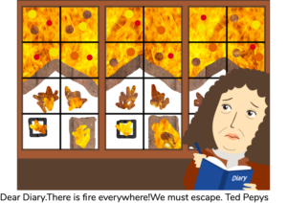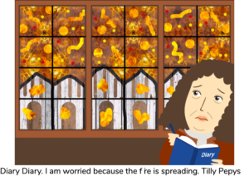
Your instructions are as follows: PurpleMash.Samuel.Pepys
😊 Enjoy your daily reading too - what would you like to read today? 😊
Thursday 21st. January
English: ** We continue with our Oak National Academy English lessons. Please pause the lessons whenever it suits you best. It’s also best to watch the lessons with no subtitles.**
During today’s lesson, you will be asked to come up with questions to ask Ma Liang. To help you with this, go through this Y1 Using Question Marks Warmup Powerpoint first. Play the PowerPoint – click on Start SlideShow then work your way through the slides.
Lesson 3 - To deepen understanding of a recount through role play - In this lesson, we will take on the role of the painter Ma Liang using drama.
https://classroom.thenational.academy/lessons/to-deepen-understanding-of-a-recount-through-roleplay-cgv38c
Task (1) – at 3:08 in the lesson you will be reminded of this week’s tricky words. Put some of the tricky words into sentences. No need to write them down; instead, say your sentences out loud to a partner or a grown-up. Remember to say capital letter when you start and full stop as you end each sentence.
Task (2) – at 3:47 in the lesson you will be asked to come up with some questions to ask Ma Liang. Make a list of questions you might like to ask:
Kippers – 1 question
Chips – 2 questions
Biffs – 3 questions
Say each question first, then write them down carefully. Remember to start with a capital letter (H, W, T etc.) and end with a question mark (?). Don’t forget your finger spaces and lovely letters too! :)
Task (3) – at 7:10 in the lesson you will be asked to sit in the 'hot seat' and pretend you are Ma Liang! Again, dress up if that helps you. Ask a grown-up or a partner to ask you (Ma Liang) questions. Think carefully about your answers; say them out loud, no need to write anything down!
Riddle – can you solve Mrs. Howley's riddle, ready for the next lesson?
🤩 Please spare a little time to practise your spellings - see above. 🤩

Phonics:
Kippers – Mrs. Leavy’s group 3.Thurs.phase3.th
Chips – Miss Platt /Mrs. Tetlow’s group Thurs 3.phase4 21.1.21
Biffs – Mrs. Kulczycki’s group 3.Thurs.phase5.oe Toe.ou Shoulder
Maths:
Warm-up – This is part of the White Rose Home Learning Video.
Addition and Subtraction within 20 - Today we are looking at the video about finding and making number bonds (the fourth video.)
Please find the link to the learning today here https://whiterosemaths.com/homelearning/year-1/spring-week-2-number-addition-and-subtraction-within-20/
The warm up is also part of the learning on the video clip.
When the video pauses you will need to complete the sections on the worksheet which is here. Y1 Spring Block 1 WO2 Find And Make Number Bonds 2019
Do as many questions as you can.
Answers can be written on the sheets if you can print them off or written in your books.
Helpful Tips : Number bond help sheet available here Number Bonds Help Sheet

Science:
What are objects made of?
Watch the video here https://classroom.thenational.academy/lessons/what-are-objects-made-from-61gp8d?step=2&activity=video
and when the video pauses you will need to complete the sections on the worksheet, which is here Science Ks1 Lesson Sci Y1 U1 L2
This sheet has the answers on for you.
Or there is this one which uses less paper space What Are Objects Made Of
😊 Enjoy your daily reading too - what would you like to read today? 😊

Friday 22nd. January
English:** We continue with our Oak National Academy English lessons. Please pause the lessons whenever it suits you best. It’s also best to watch the lessons with no subtitles.**
During today’s lesson, you will be learning about the past tense. The past tense is when something has already happened. e.g. I liked my breakfast this morning. I went to the shop. I had a yummy breakfast. I felt poorly yesterday .To help you with this, have a look at these PastTense.verb.examples first.
Lesson 4 - To use the past tense - In this lesson, we will practise writing in the past tense which will help us to recount events later in this unit.
https://classroom.thenational.academy/lessons/to-use-the-past-tense-69k30d
Task – complete the Past Tense Verb Sorting Activity. Don’t worry if you don’t have a printer; just write the matching pairs in your book. Remember to put the headers Past / Present at the top of the page.

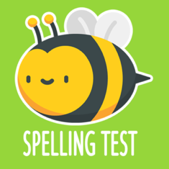 🍀 🍀 🍀 Good luck with your spelling test 🍀 🍀 🍀

Phonics:
Kippers – Mrs. Leavy’s group 3.Fri.phase3.ng
Chips – Miss Platt /Mrs. Tetlow’s group
Today we are going to look at a video from Letters and Sounds again. Today it is all about adjacent consonants and short vowels. The pace is slow but the video is useful in showing how we teach counting phonemes/sounds in words by segmenting eg. b-e-n-ch is 4 phonemes/sounds when we split the word up(segment sounds) and then we blend to read eg. bench. Eventually your child will become confident in just looking at the word and saying it from sight. Until then looking for the different sounds in words is crucial when learning to read with speed and fluency.
The link is here https://www.youtube.com/watch?v=qDBRiSU6zSg&feature=youtu.be
Enjoy!
Biffs – Mrs. Kulczycki’s group 3.Fri.phase5.ow Snow
Maths:
Warm-up – https://www.youtube.com/watch?v=-74-_3WSrD0 Number Bond Song
Addition and Subtraction within 20 - Today we are looking at the powerpoint activity about adding by making 10.
Please follow the power point through to complete all the activities that are mainly practical. Spr1.3.1 Add By Making 10 Activity 1
Answers can be written on the sheets if you can print them off or written in your books. Mostly these activities are practical.
Helpful Tips : Remember number bonds are the two numbers that make 10 or 20 - 2 +8 = 10 or 12 + 8 = 20.
Ten frame template available here 10 Frame Template

Computing:
We are still learning about what algorithms are. We need to understand that when we put our instructions on digital devices they need to be clear and correct. Otherwise all sorts of things may go wrong and we will have to debug it!
Let's take a look at exactly what are computer bugs. http://www.bbc.co.uk/guides/ztgjq6f
Now we can play a game - Save the Potato King activity – write instructions for the potato to save the Potato King
You will need
1 Potato
✘ Blutack
✘ Masking tape
✘ Scissors
✘ Paper
✘ Color pencils/crayons
✘ Printed cutouts of arrows Arrows
✘ Blindfold (optional for more excitement)
A partner
https://uploads.strikinglycdn.com/files/9a604433-682f-4799-86d1-52ae3497c4d1/Preschool%20(4%20to%206)%20Presentation.pdf
This is the presentation to print if you so wish Computing Presentation To Print
😊 Enjoy your daily reading too - what would you like to read today? 😊

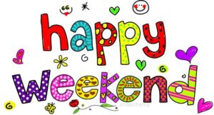

💫 Wishing you all a lovely weekend and a well-earned rest! 💫

