FEBRUARY - Week 6 (w/b 8.2.21)
This week’s overview:
English: 😊😁🥰 We had some lovely feedback from our PSHE activities last week, so we are going to continue with that theme this week. 😊😁🥰

Spellings: - Please see top of page for words for tomorrow's Grand Spelling Test. :)
Maths: Place Value to 50
Topics this week: Great Fire of London (history) / Printing (art/computing) / Algorithms (computing)

Monday 8th February
PSHE / English: This week's English activities follow on from our PSHE activities last week.
Following on from our Something.to.look.forward.to.task last week, today I’d like you to have a think about what you miss about school and what you are most looking forward to doing when you come back.
IMPORTANT ... Today's task – please draw / paint a picture and write a little message to your class mates. 👭👫👬 Please could this be done ready to share at today’s Zoom meeting? Many thanks! The children in school are also going to share their ideas with you at home.
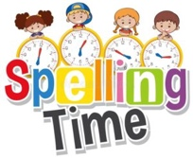🤩 Please spare a little time to practise your Week 1 spellings - see above. 🤩

Phonics:
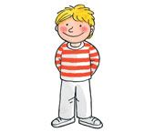Kippers – Mrs. Leavy’s group - 6.Mon.ur Resource for this lesson - 6.Mon.ur Picture Board
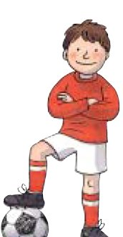 Chips – Miss Platt /Mrs. Tetlow’s group -
This week we are going to look at a videos from Letters and Sounds phase 4. These videos are reviews of the whole of phase 4 to recap on before we start phase 5.
The link is here: https://www.youtube.com/watch?v=KtORLbwPB8U&feature=youtu.be
This video is lesson 25 . I have also added a little phase 4 activity as a follow up to the video. This activity can be found here Find And Write The Cl Words
Biffs – Mrs. Kulczycki’s group - 6.Mon.phase5.oe Ow(show) Resources for this lesson - Mon6.oe Read&write.PowerPoint / Mon6.oe Add The Sound Buttons / Mon6.alt Pron Ow Low.Powerpoint
Maths: - Place Value to 50.
Today we are representing numbers to 50. The video is the last one of week 5.
The video and warm up is here https://whiterosemaths.com/homelearning/year-1/spring-week-5-number-place-value-within-50/
The activity sheet to accompany the video is here Y1 Spring Block 2 WO3 Represent Numbers To 50 8.2.21

Computing / Art: Today we are going to be doing our art on the computer / iPad! We are going to create our own printed pattern using Purple Mash. Follow the instructions attached: PurpleMash.Printing You can create as many patterns as you wish … have fun!!! Remember to send us a copy of your fabulous work!
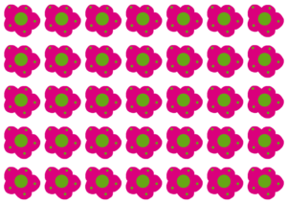
😊 Enjoy your daily reading too - how are you getting on with your Spring reading challenges? 😊
Monday's song: Trolls – Move your Body - https://www.youtube.com/watch?v=Zb4bsHgCdSE

Tuesday 9th February
PSHE / English:
Lesson 1 – Identifying Feelings
- Why is it important to be able to identify how we feel?
- What can happen if we bottle up our feelings?
1. Identifying Feelings Work your way through today’s feelings activities – Start with Tasks 1 and 2; you can record your ideas in your book if you wish. Task 3 (feelings diary) is optional – you can keep a feelings diary for the coming week if you wish.
🤩 Please spare a little time to practise your Week 2 spellings - see above. 🤩
Phonics:
Kippers – Mrs. Leavy’s group - 6.Tues.ow Resources for this lesson - 6.Tues.ow Read And Reveal Activity
Chips – Miss Platt /Mrs. Tetlow’s group -
This week we are going to look at a videos from Letters and Sounds phase 4. These videos are reviews of the whole of phase 4 to recap on before we start phase 5.
The link is here: https://www.youtube.com/watch?v=xNCZQjTqJhU&feature=youtu.be
This video is lesson 26 . I have also added a little phase 4 activity as a follow up to the video. This activity can be found here In The Tent
Biffs – Mrs. Kulczycki’s group - 6.Tues.phase5.ue Ew Resource for this lesson: Tues6.ue Ew.sort
Maths: - Place Value to 50.
Place Value to 50.
Today we looking at one more and one less. The video is the first one of week 6.
THE ACTIVITY TASK FOR THIS VIDEO IS THE FIRST PART OF THE WORKSHEET ATTACHED.
The video and warm up is here https://whiterosemaths.com/homelearning/year-1/spring-week-6-number-place-value-within-50/
The activity sheet to accompany the video is here (first part of sheet only!) Y1 Spring Block 2 WO4 One More One Less Tues And Weds

Computing: - Algorithms - To be able to write, use and decode an algorithm.
To conclude our work on algorithms we are going to be working with a partner, or if you are at home an adult to complete the challenge with 😊
Let's recap as to what an algorithm is https://www.youtube.com/watch?v=Da5TOXCwLSg
The task today looks simple enough, but if those instructions aren't clear, who knows what we all could be drawing! 😉
Your challenge starts here Algorithms
Enjoy yourselves! 👏👏😊
If you have an I pad at home you can download Daisy the Dinosaur app for free and have a go at the challenges. See if you can make her jump or spin!
😊 Enjoy your daily reading too - what would you like to read today? 😊
Tuesday's song: Go Noodle – Trolls - Can’t Stop the Feeling - https://www.youtube.com/watch?v=KhfkYzUwYFk

Wednesday 10th February
PSHE / English:
Lesson 2 – Naming Feelings
- What do we mean by ‘feelings’?
- Is it possible to feel more than one thing at a time?
- How are you feeling today? Can you sum it up in one word?
2. Naming Feelings Work your way through today’s feelings activities. Start with Task 1, talking through your ideas with someone at home / in class … you can draw and write your ideas if you wish OR you can simply talk about them. Your follow-up task is to play the Emotions Board Game with a sibling / grown-up / classmate.
🤩 Please spare a little time to practise your Week 3 spellings - see above. 🤩
Phonics:
Kippers – Mrs. Leavy’s group - 6.Weds.Phase 3. You Resource for this lesson - Phase 3.you.umbrella
Chips – Miss Platt /Mrs. Tetlow’s group -
This week we are going to look at a videos from Letters and Sounds phase 4. These videos are reviews of the whole of phase 4 to recap on before we start phase 5.
The link is here: https://www.youtube.com/watch?v=l_pjSSJ6VKE&feature=youtu.be
This video is lesson 27 . I have also added a little phase 4 activity as a follow up to the video. This activity can be found here Find And Write The Fl Words
Biffs – Mrs. Kulczycki’s group - 6.Weds.phase5.wh Ph Resources for this lesson: 6.Weds.whPowerPoint/ 6.Weds.phPowerPoint
Maths: - Place Value to 50.
Today we looking at one more and one less again . The video is the second one of week 6.
THE ACTIVITY TASK FOR THIS VIDEO IS THE SECOND PART OF THE WORKSHEET ATTACHED.
The video and warm up is here https://whiterosemaths.com/homelearning/year-1/spring-week-6-number-place-value-within-50/
The activity sheet to accompany the video is here (first part of sheet only!) Y1 Spring Block 2 WO4 One More One Less Tues And Weds

History: Today we are going to finish our Great Fire of London topic. Our final key question is: How did London change after 1666?
To help us answer this question, start by discussing what we know about 1666. Watch video clip – ‘Rebuilding London’ - https://central.espresso.co.uk/espresso/primary_uk/subject/module/video/item980566/grade1/module976473/index.html Login details are on Tapestry.
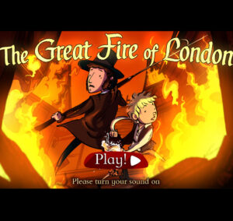
There is no written follow-up task today. Instead, play the final part of the Great Fire of London game (from Wednesday 4th September onwards) – the end of the fire / how London changed. http://www.fireoflondon.org.uk/game/
Click on the small arrow at the bottom of the page so that a timeline appears. Skip through to Wednesday 4th September.
There are more challenges to complete … once you have completed them all, you get a reward from King Charles II for fighting the fire! If you cannot print off your certificate, let me know via Tapestry which certificate you want (1, 2, or 3) and I will print one off in school for you. :)
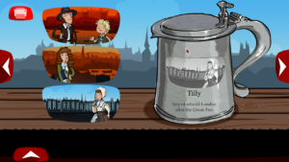
😊 Enjoy your daily reading too - what would you like to read today? 😊
Wednesday's song: Despicable Me 2 - Happy - https://www.youtube.com/watch?v=Q2E5RSJhDHI

Thursday 11th February
PSHE / English:
Lesson 3 – Sharing Feelings
- Why is it sometimes difficult to talk about our feelings?
- Who do you talk to about your emotions?
3. Sharing Feelings Work your way through today’s feelings activities – Start with Tasks 1 and 2; you can record your ideas in your book if you wish OR you can simply talk about them. Task 3 is optional.
🤩 Please spare a little time to practise your Week 4 spellings - see above. 🤩
Phonics:
Kippers – Mrs. Leavy’s group - 6.Thurs.oi
Chips – Miss Platt /Mrs. Tetlow’s group -
This week we are going to look at a videos from Letters and Sounds phase 4. These videos are reviews of the whole of phase 4 to recap on before we start phase 5.
The link is here: https://www.youtube.com/watch?v=dFqFWbIV-vo&feature=youtu.be
This video is lesson 28 . I have also added a little phase 4 activity as a follow up to the video. This activity can be found here Find And Write The Fr Words
Biffs – Mrs. Kulczycki’s group - 6.Thurs.phase5.au Aw Resource for this lesson: Or Au Aw Which Is The Correct Spelling Powerpoint
Maths: - Place Value to 50.
Today we are comparing objects within 50. The video is the third one of week 6.
The video and warm up is here https://whiterosemaths.com/homelearning/year-1/spring-week-6-number-place-value-within-50/
The activity sheet to accompany the video is here Thursday 11.2.21 Maths
Science: - Materials
Which material is best for different objects?
To conclude our science topic on materials, we are going to look at which material is best for different objects.
Here is the link below for the lesson. As always it starts off with a little quiz.
https://classroom.thenational.academy/lessons/which-material-is-best-for-different-objects-60vkar
Follow the lesson through and use this as your activity sheet to save paper and don't forget to do the quiz at the end if you can.
Science 11.2.21
😊 Enjoy your daily reading too - what would you like to read today? 😊

Friday 12th February
PSHE / English:
Lesson 4 – Strategies for Coping with Feelings
- Do you know what the word ‘strategy’ means?
- Why is it useful to have strategies to help us cope with our feelings?
4. Strategies For Coping With Feelings Work your way through today’s feelings activities – instead of sitting in a circle, find a quiet place to sit with a family member or class mate. For Tasks 1 and 2, talk through your ideas, there is no need to write them down. Follow-up task - Instructions / Flashcards. Task 3 (letter) is optional.
Phonics: NO PHONICS TODAY ... Instead, it's our Grand Spelling Test - good luck 🍀!
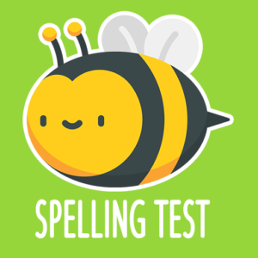 Spellings for each group:
Canaries: tbc
Blackbirds: tbc
Bluebirds: tbc
Robins: tbc
Don't forget to let us know how you got on with your test - you can send us a photo on Tapestry if you wish 😊.
Maths: - Place Value to 50.
Today we are comparing numbers within 50. The video is the fourth one of week 6.
The video and warm up is here https://whiterosemaths.com/homelearning/year-1/spring-week-6-number-place-value-within-50/
The activity sheet to accompany the video is here Friday 12.2.21 Maths
Golden Afternoon: - Take some time this afternoon to do whatever makes you happy 😊 ... it's been a long half-term and it's time to take a well-deserved rest 🥳😉!
😊 Enjoy your daily reading too - what would you like to read today? 😊

💫 Wishing you all a lovely weekend and a well-earned rest! 💫

