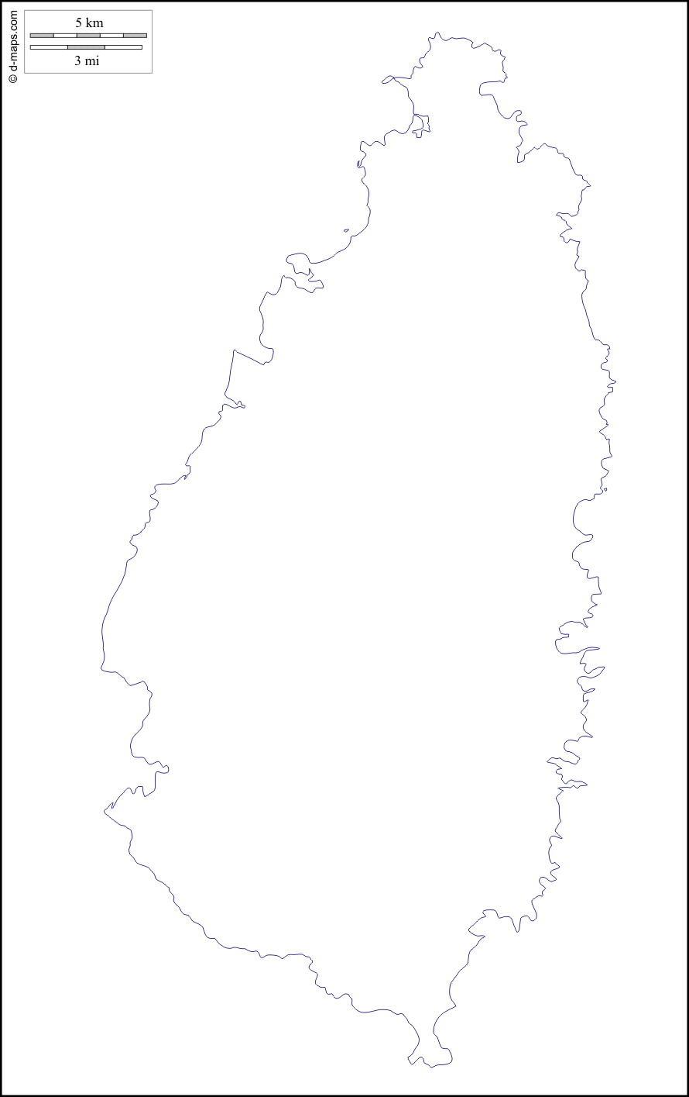

WALT: identify features of the island of St.Lucia