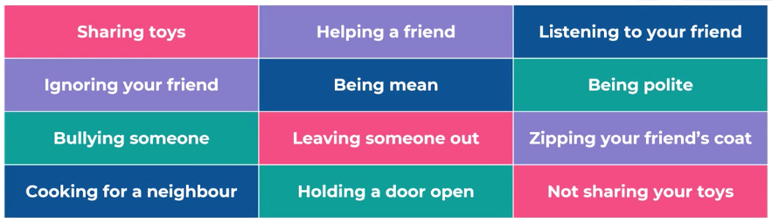

ONLY 1 SET PER CHILD NEEDED

