**Thursday 4th March**

**W.A.L.T.: identify different parts of a toy car and understand their function.**

**The following diagrams show toy cars in different stages of construction. They share some features or parts in common.**

***It is not necessary to print out these sheets but you can if you wish. Alternatively, you can practise drawing the diagrams to gain experience of drawing 3D objects.***

**Task 1:**

**Find out what the following words mean and their function in the car:**

**axle chassis cams pulley rivet**

**Task 2:**

**Using these words label the following diagrams.**

**Task 3:**

**The car will be powered by an electrical circuit which requires 2 cells. Think back to our topic about electricity and draw a rectilinear diagram showing the components needed to power the car and turn it on and off. (Diagram 2 & 3)**

**Diagram 1**

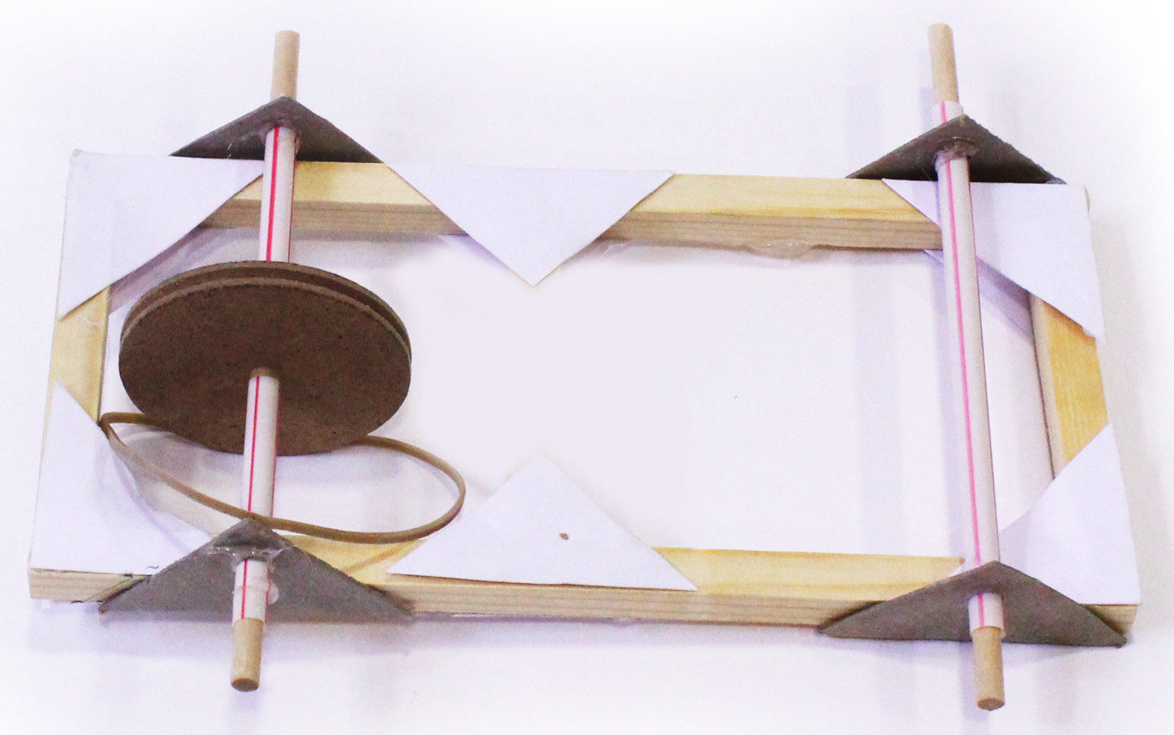

**Diagram 2**

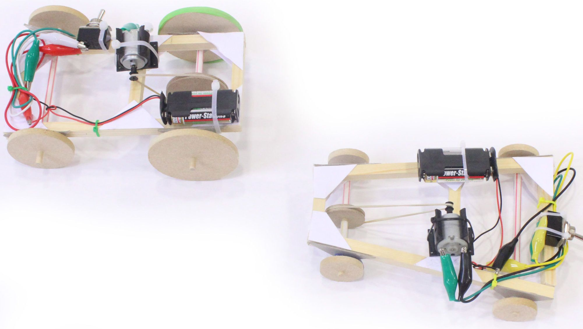

**Diagram 3**

