Home Learning: Monday 1st March
Phonics/Handwriting: We're going to start by singing all of the sounds we've learnt so far by clicking on the Jolly Phonics link; all of the songs up to and including ee.
Afterwards we're going to practise our handwriting skills by focussing on the letters in our own names. Make sure you have a capital letter at the start and that all letters are formed correctly. If you are now able to do your first name perfectly then you can try your surname too!

Maths: Start by singing one of our numbers to 20 songs. Then this week we are going to be learning about capacity. Capacity sounds like a fancy word but it just means the amount that something (e.g. a container) can hold.
Today we're going to start by focusing on the terms full, empty and half-full. Go through the Eyfs Potions Capacity Powerpoint together (click on 'slide show' and play 'from beginning). Then see if you can use 3 containers (glasses, jugs, mugs etc) to demonstrate full, empty and half full -using water, sand, pasta - anything you like! Remember to take a photo for us to see what you do 👍

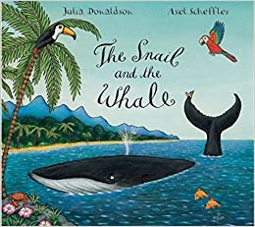Topic: This week our focus story is The Snail and the Whale by Julia Donaldson (we will be watching the BBC short film version of this story at the end of the week). Read or watch the story and discuss which part you liked the best?
Draw, paint or colour your favourite part of the story. Here are some colouring sheets you could choose from if you wish: Helping The Whale Colouring Whale Colouring Whale Colouring 2

Home Learning: Tuesday 2nd March
Phonics/Handwriting: Start by singing the ee song again. Then watch the Geraldine Giraffe ee video together.
Finally we're going to play the Buried Treasure game on Phonics Play, click on Phase 3 and +ee to practise the right sounds for us.

Maths: Start with a numbers to 20 song. Then we're going to carry on with our work on capacity.
Yesterday we looked at the words full, empty and half full. Today we're going to do a capacity search of our homes! See if you can find at least 3 things that are full (e.g. a new box of cereal), 3 things that are half-full (e.g. half a bottle of squash) and 3 things that are empty (a milk bottle that you finished at breakfast time)... don't forget to take a photograph for us!

Topic: Start by watching and joining in with the Seashore Life song on Espresso. Then today we're going to use our computing skills to draw a sea creature of our choice. Go to the Sea Creature activity in Purple Mash and see what you can create!
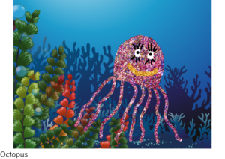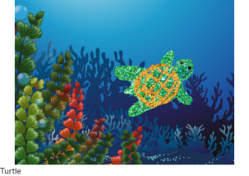Here are some examples for you, I can't wait to see yours! *Don't forget to save it in the Reception: 'Sea Creatures' folder with your name!

***Reception class Zoom 'drop in' session 2.30pm ***
Details will be sent to you via Tapestry.

Home Learning: Wednesday 3rd March
Phonics/Handwriting: Start by going back to Polly's Phonics path on Espresso, and today we're going to learn the next sound along the path: igh. This is a trigraph - it just means there are three letters making one sound when they go together!
Start by clicking on this step on the path and watching the video together. Then listen to and learn the Jolly Phonics igh song * start at 9.25 mins (for this sound it is really tricky to find a video with shows igh (rather than ie), therefore I've used our original link, but you don't need to go through all the sounds, just start it at 9.25mins!) Finish by playing the Find the 'igh' words game on Espresso.

Maths: Start with one of our numbers to 20 songs. Then, cntinuing our work on capacity, start by watching the Monster Milkshake Cafe Capacity Powerpoint (click on 'slide show' and play 'from beginning). Afterwards we're going to try and draw 5 different amounts in the glasses on the Monster Milkshake Activity Sheet - if you don't have access to a printer it's absolutely fine, just draw 5 empty glasses and ask your child to draw:
- full 2. nearly full 3. half full 4. nearly empty 5.empty 🥤

Topic: Watch the Under the sea video on Espresso. Discuss the different animals that you've seen and which ones you like the best?
Today we're going to see if we can sort animals that live in the sea and animals that live on land. You can either use this Land And Sea Sorting Activity Sheet or simply use two pages; on one make a list (by drawing and labelling) of animals that live in the sea and on the other page make a list of animals that live on land.
Finish by re-reading or watching our story of the week: The Snail and the Whale by Julia Donaldson.

Home Learning: Thursday 4th March Happy Birthday to Jack! 🎉🎂🤩

**Today is officially World Book Day but we wanted to celebrate together as a class,

so we are postponing this special day until Friday 12th March, when we can all be together 😃**
Phonics/Handwriting: Start by singing the Jolly Phonics igh song * start at 9.25 mins. Then watch the Geraldine Giraffe igh video together.
Finally, practise writing the igh sound in some different words, such as night, light etc. Remember to make sure that all of your letters are formed correctly!

Maths: Start with a numbers to 20 song. Then today we're going to finish our work on capacity by choosing one or more of the Capacity Home Learning Challenges! There are several different ideas on here, choose whichever you think is most practical/ fun! We can't wait to see what you do 👍

Topic: Start with music time! Listen to any or all of the sea-themed songs below - don't forget to join in with the actions! 😉
- The Seashore Life song on Espresso
- Under the Sea from the Little Mermaid
- Have you ever seen a penguin come to tea? -actions are essential for this one!
- Finally, (and this one is optional because we know how annoying this one can be)... no 'Under the Sea' topic would be complete without doing the Baby Shark song!
Then it's our last home craft session today! Use this time to create your very own under the sea creature - it could be anything you like, here are some examples to give you some ideas... we can't wait to see what you do!
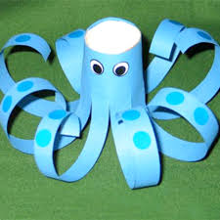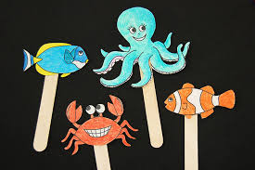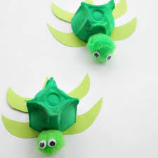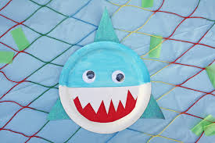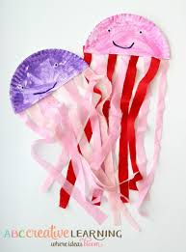

Home Learning: Friday 5th February
Key skills: Key Word Practise time!
Start by watching the tricky words song video again. Then practise reading your own set of key words. *
*Every child is on a different set of key words. If your child has already passed set 8 then they will be now working on their spellings too! *
Please let us know how your child is doing with their key words (and spellings if they are at this level) - remember that to move onto the next set of words the child must be able to read their current words confidently and instantly (not by trying to sound them out or guess them)!
If they are ready for their next set let me know and I will send them to you via Tapestry. 👍

Maths / Forest Fun: Today we're going to set you a fun challenge for your forest/outdoor time: We want you to collect some objects that you find in your outdoor environment, such as a leaf, a stick, a stone, a petal, a pebble etc. Then when you get home can you test them in some water to see if they float at the top or if they sink to the bottom? Try to guess first what they will do! Make two groups - the objects that float in one pile and the objects that sink in the other. Take a photograph for us to see, were your guesses right or were there any that surprised you?

*** Reception class Zoom 'drop in' session 11.am ***
Details will be sent to you via Tapestry.

***Very important end of the week activity ***
As we are returning to school next week we are very aware that some of our pupils might be feeling nervous/anxious about this. In particular it can be really hard for a young child to leave a grown-up that they've been with for such an intense period of time. To help with this (even if you don't think this will be an issue for your child) we'd love all children in the class to read/watch a special story (which we will also read with them on Monday to ease the transition process) called The Invisible String by Patrice Karst. This book deals with the issue of attachment anxiety and reminds children that their parents love them and think of them all the time - even when they're not together.
Read this today (or over the weekend), discuss with your child about the return to school next week - and please do let us know if you have any particular concerns regarding the return to school, so that we are able to help you through it.
The Invisible String Powerpoint
The Invisible String Story video

Then finish the week by snuggling up and watching The Snail and the Whale film on bbc iPlayer together 😊

Have a happy and safe weekend everyone, we are so excited to know that we'll be seeing you all back in school next week! 🌈
