Religious Buildings in Oldham

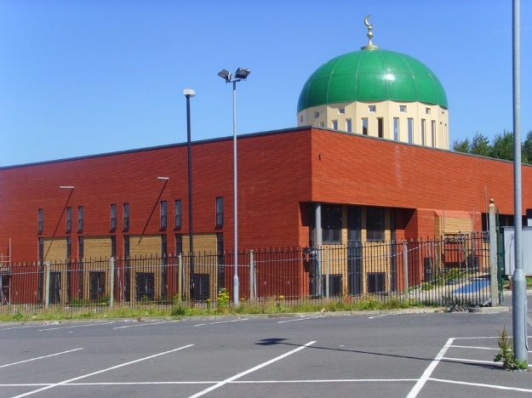
Oldham Parish Church Oldham Central Mosque

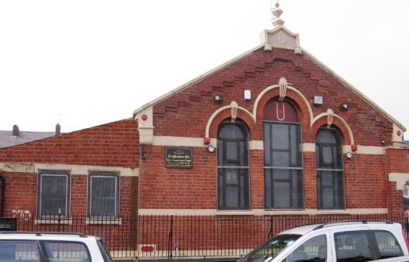
Shri Swaminarayan Mandir, Oldham

