Year 1's updates

Our next zoom get-togethers will be on Monday 1st March @ 11.30am / Thursday 4th March @ 11am 🙃 Hope to see you there! 🙃

4.3.21 Some information from Oldham's EHMW Team re. return to school, which you may find useful: How To Help Your Child As They Go Back To School / Recognising And Responding To Anxiety

Spellings Spring 8 1.3.21

Spellings Spring 7 22.2.21

11.2.20 Grand Spelling Test words for tomorrow:
Canaries Grand Spelling Test Spring 21
Blackbirds Grand Spelling Test Spring21
Bluebirds Grand Spelling Test Spring21
Robins Grand Spelling Test Spring21

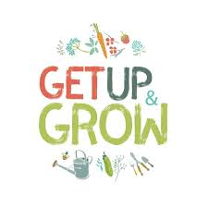6.2.20 Some lovely new outdoors resources to try - Naturemobile/ Mandalas / Birds / Great Outdoors / Do You Know Where You Live

6.2.20 Some new PE resources to try - Oldham Sports Development PE Dance Links Feb21 / New Motivation Monday KS1 Challenges (3) plus please see Tapestry for one of our children's PE recommendations.
1.2.21 - This week is Children's Mental Health Week. You will find below a variety of wellbeing sessions and activities to complement our regular curriculum. 💃🎶🕺🎶 At the end of each day we have included a daily 'feel good song' for the children to sing along to if they wish - please keep your eyes peeled! 💃🎶🕺🎶
On Friday afternoon this week, our timetable will be different to normal as we have decided that the whole school should forget formal lessons and instead snuggle down and watch a family film that will make them feel good. In school we are all going to watch ‘Inside Out’ as this film deals with emotional well-being, but obviously at home you can choose to watch any film – just one that you feel you and your family will all enjoy together! 😊
30.1.21 - Boden (the clothing store) has produced a lovely range of fun activities - 'Mini Missions' - for children to try out ... they are well worth a look!
https://www.boden.co.uk/en-gb/mini-missions#nav
27.1.21 - **NEW READING SCHEME - EPIC!** - Buckstones have signed up to an American online reading scheme, which is currently available during this difficult time. Please see details here: Epic! Reading Scheme Info

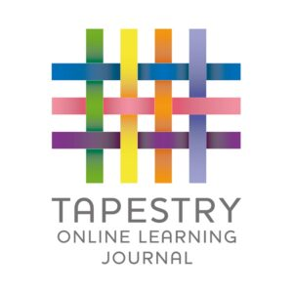21.1.21 *Tapestry is back!* This should make communication easier than previously with the email system. 🤞 For those children learning remotely, please share what you have been up to at home and for the parents of those children in school, please keep your eyes peeled for what they children have been doing in school. :)

18.1.21 *Key Word Lists* Changing word lists is obviously tricky at the moment ... the resources below may help 🤞 Here is the list of Year 1 Common Exception Words that our children are expected to be able to read and spell by the end of the year; all 45 of these words appear on our word lists. Feel free to work on these alongside your home reading if you choose to do so. *Please see phonics groups info below for word lists relating to each of our Phonics Phases.*

17.1.21 *National Literacy Trust activities for children* https://wordsforlife.org.uk/activities/filter/?age=5-8 as well as *support for parents* https://wordsforlife.org.uk/parent-support/

16.1.21 *Some lovely new wellbeing activities* https://www.partnershipforchildren.org.uk/what-we-do/childrens-wellbeing-activities-for-teaching-staff-and-families.html

11.1.21 *New PE resource* - KS1 PE Challenges 1 W.b.11.1.21

11.1. 21 *Oxford Owl update - list of additional books to try* - Read Write Inc Suggested Books (linked To ORT) ✨ Please continue to record home reading in your child's reading record - online books as well as regular reading books - these home reads will count towards stickers on your child's home reading bookmark. ✨

