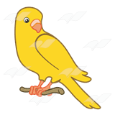 Group: Budgies
The Canaries now have 6 words to learn each week. Most words will follow a pattern, and there will be some of our Year 1 common exception words too. Words marked like * this * are our Y1 common exception words.

Summer 4 | Year 1 Spelling Practice  Summer Term: w/b 10/5/21 |  |  |  |  | Spelling Pattern: _ a n (recap)  Test: **Monday 17th May**
 | Look | Say | Cover | Write | Check |  | Write | Check | Write | Check
 | e x a m p l e |  |  | e x a m p e l | × |  | e x a m p l e |  | e x a m p l e
1 | f a n
2 | m a n
3 | p a n
4 | r a n
5 | g r a n
6 | * you *
 | I scored ___ out of 6 on this test.

*NEW* Now choose 2 of the words and write them in 1 sentence. PLEASE WRITE IN PENCIL, IN YOUR NEATEST HANDWRITING.
____________________________________________________________________________________________________________
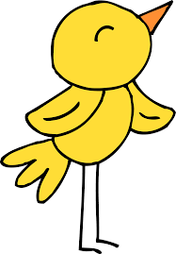 Group: Canaries
The Canaries now have 6 words to learn each week. Most words will follow a pattern, and there will be some of our Year 1 common exception words too. Words marked like * this * are our Y1 common exception words.

Summer 4 | Year 1 Spelling Practice  Summer Term: w/b 10/5/21 |  |  |  |  | Spelling Pattern: ar  Test: **Monday 17th May**
 | Look | Say | Cover | Write | Check |  | Write | Check | Write | Check
 | e x a m p l e |  |  | e x a m p e l | × |  | e x a m p l e |  | e x a m p l e
1 | ar m
2 | f ar
3 | f ar m
4 | p ar t
5 | s t ar
6 | * you *
 | I scored ___ out of 6 on this test.

*NEW* Now choose 2 of the words and write them in 1 sentence. PLEASE WRITE IN PENCIL, IN YOUR NEATEST HANDWRITING.
____________________________________________________________________________________________________________

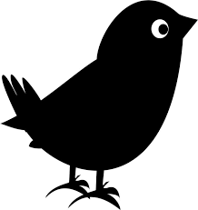Group: Blackbirds
The Blackbirds now have 8 words to learn each week. Most words will follow a pattern, and there will still be some of our Year 1 common exception words too. Words marked like * this * are our Y1 common exception words.

Summer 4 | Year 1 Spelling Practice  Summer Term: w/b 10/5/21 |  |  |  |  | Spelling Pattern: tch  Test: **Monday 17th May**
 | Look | Say | Cover | Write | Check |  | Write | Check | Write | Check
 | e x a m p l e |  |  | e x a m p e l | × |  | e x a m p l e |  | e x a m p l e
1 | catch
2 | match
3 | patch
4 | fetch
5 | itch
6 | ditch
7 | witch
8 | * says *
 | I scored ___ out of 8 on this test.

*NEW* Now choose 2 of the words and write them in 1 sentence. PLEASE WRITE IN PENCIL, IN YOUR NEATEST HANDWRITING.
____________________________________________________________________________________________________________
Group: Bluebirds
The Bluebirds now have 9 words to learn each week. Most words will follow a pattern, and there will still be some of our Year 1 common exception words too. Words marked like * this * are our Y1 common exception words.

Summer 4 | Year 1 Spelling Practice  Summer Term: w/b 10/5/21 |  |  |  |  | Spelling Pattern: ou (x2)  Test: **Monday 17th May**
 | Look | Say | Cover | Write | Check |  | Write | Check | Write | Check
 | e x a m p l e |  |  | e x a m p e l | × |  | e x a m p l e |  | e x a m p l e
1 | about
2 | mouth
3 | pound
4 | mouse
5 | you
6 | soup
7 | group
8 | * were *
9 | * they *
 | I scored ___ out of 9 on this test.

*NEW* Now choose 2 of the words and write them in 1 sentence. PLEASE WRITE IN PENCIL, IN YOUR NEATEST HANDWRITING.
____________________________________________________________________________________________________________
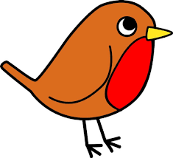Group: Robins
The Robins now have 10 words to learn each week. ALL WORDS WILL NOW FOLLOW A PATTERN –
WE HAVE COVERED ALL 45 COMMON EXCEPTION WORDS.
Summer 4 | Year 1 Spelling Practice  Summer Term: w/b 10/5/21 |  |  |  |  | Spelling Pattern: ou (x2)  Test: **Monday 17th May**
 | Look | Say | Cover | Write | Check |  | Write | Check | Write | Check
 | e x a m p l e |  |  | e x a m p e l | × |  | e x a m p l e |  | e x a m p l e
1 | about
2 | mouse
3 | count
4 | cloudy
5 | around
6 | ground
7 | soup
8 | group
9 | youth
10 | wound
I scored ___ out of 10 on this test.

*NEW* Now choose 2 (or even 3!) of the words and write them in 1 sentence. PLEASE WRITE IN PENCIL, IN YOUR NEATEST HANDWRITING.
____________________________________________________________________________________________________________

