

Sunday 27th June

Saturday 26th

June

Friday 25th

June

Thursday 24th

June

Wednesday 23rd

June

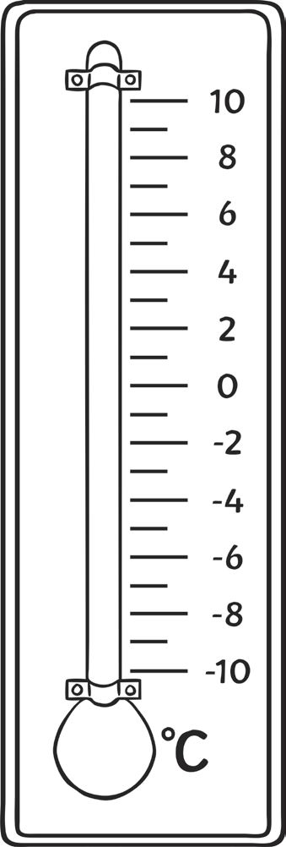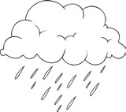

**Five Day Thermometer Temperature**

**visit twinkl.com**

30

28

26

24

22

20

18

16

14

12

10

8

6

4

2

0

-2

-4

30

28

26

24

22

20

18

16

14

12

10

8

6

4

2

0

-2

-4

30

28

26

24

22

20

18

16

14

12

10

8

6

4

2

0

-2

-4

30

28

26

24

22

20

18

16

14

12

10

8

6

4

2

0

-2

-4

30

28

26

24

22

20

18

16

14

12

10

8

6

4

2

0

-2

-4



**visit twinkl.com**

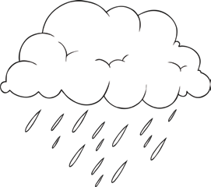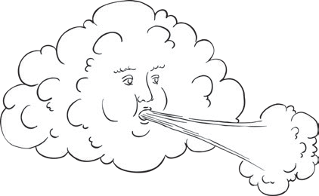

**Five Day Temperature** Questions

When you have filled in your results, answer the following questions.

1. On which day did your thermometer record the **warmest** temperature? What was the temperature?

˚C

2. On which day did your thermometer record the **coolest** temperature? What was the temperature?

˚C

3. What was the difference between the warmest and coolest temperatures, in degrees Celsius? ˚C

4. How many times did you record a temperature **greater** than 20˚C?

5. How many times did you record a temperature **greater** than 10˚C?

6. How many times did you record a temperature **less** than 20˚C?

7. How many times did you record a temperature **less** than 10˚C?

8. Was it **warmer** on Wednesday or Friday?

9. Was it **cooler** on Thursday or Saturday?

**visit twinkl.com**