WALT: solve 1 step word problems involving capacity. Date________
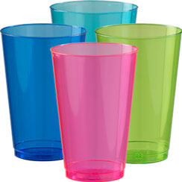
1. Tom had a 60ml bottle of water. She drank half of it at playtime. How much is left?

2. Rose has to take three 5ml spoons of medicine a day. How much medicine is this?

3. If Ben drinks 2 litres of water in one day. how much will he drink in a week?

4. A cup of tea is 50ml and a mug of tea is 70ml. Lee drinks one of each. How much tea does he drink?

5. There are 2 litres of water in a fish bowl. How many litres are in 7 bowls?

6. There are 30 litres of water in a fish tank. There is a crack in the glass and 8 litres of water leak out. How many litres of water are left in the tank?

7. At the summer fair, there are 80 litres of orange juice to share between 10 groups of children. How many litres of juice can each group have?

