WALT: solve 1 and 2 step word problems involving capacity. Date________ Name____________________
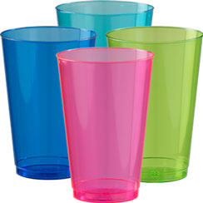
1. Amy had a 600ml bottle of water. She drank half of it at playtime. How much is left?

2. Laila has to take three 5ml spoons of medicine a day. How much medicine is this?

3. If Ben drinks 2 litres of water in one day. how much will he drink in a week?

4. A cup of tea is 50ml and a mug of tea is 70ml. Louis drinks one of each. How much tea does he drink?

5. There are 5 litres of water in a fish bowl. How many litres are in 10 bowls?

6. A bath holds 63 litres of water. There is a leak and the bath loses 21 litres of water. How much water is left? The next day it loses another 21 litres. How much water is left now?
Step 1______________________________________________________
Step 2______________________________________________________
7. I have 80ml milk to share between my 10 kittens. How many ml can they drink each? How much milk will 2 kittens drink?
Step 1_______________________________________________________
Step 2_______________________________________________________

