WALT: To solve a problem involving kg.
How many ways can you fill your shopping trolley with exactly
12kg fruit and vegetables? 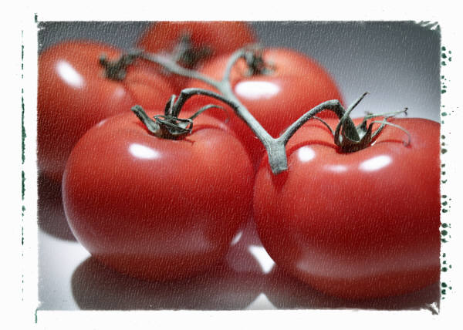 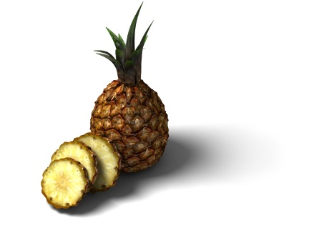
tomatoes 8kg pineapples 3kg strawberries 1kg
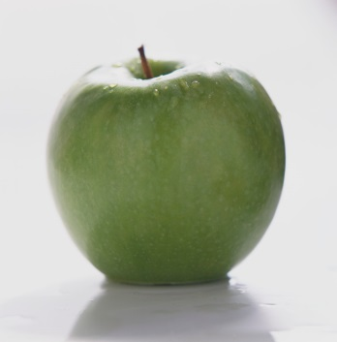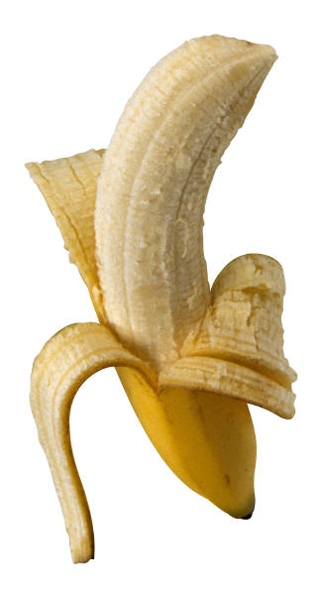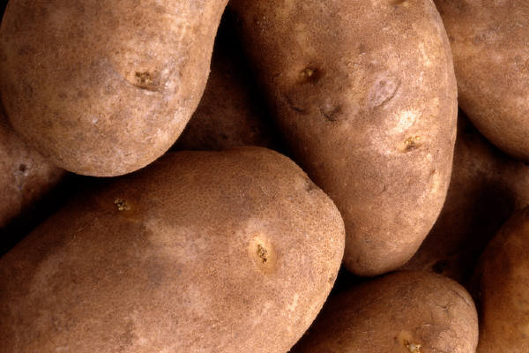
apples 6kg bananas 5kg potatoes 10kg

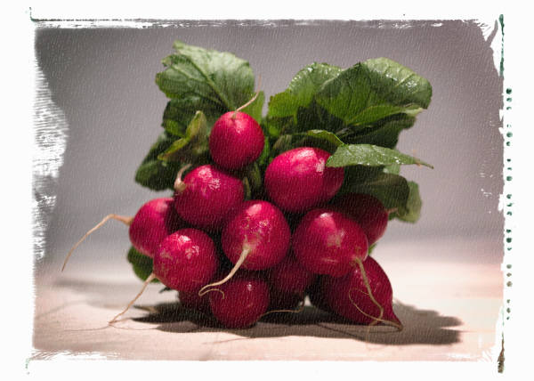
peppers 7kg radishes 4kg
You can choose as many different fruit and vegetables as you can, as long as the total is 12kg. You can use the same fruit or vegetables more than once!!
Record your answers on a piece of paper like this e.g
5kg + 5kg + 1kg +1kg = 12kg

