Thursday 1st July

Today, just try to keep up with your regular activities:

English

Read your scheme reading book and complete a book review. If you have not got your book, please read one from Oxford Owl. The link is below.

http://www.oxfordowl.co.uk

Here is a book review template that you might wish to use. If not, use your reading journal or plain paper.

Book Review Template(1)

Spellings

Please practise your spellings by creating a word-search. You could make your own up on paper or you could make on using the following website and complete it:

SEN Teacher ⋆ Wordsearch Maker ⋆ Printable Puzzle Maker

Here are your spellings for this week if you have not got them with you.

Diamonds Spellings 28.6.21

Spellings For 28.6.21 Emeralds (Autosaved)

Spellings For 28.6.21 Rubies (Autosaved)

Maths

Warm Up: 10-15 minutes of times tables using TTRockstars or Hit the Button.

https://play.ttrockstars.com/ (Your login details are in your journal)

https://www.topmarks.co.uk/maths-games/hit-the-button

Place Value Activity: Play Who Wants To Be A Millionaire?

Math Millionaire Games (math-play.com)

There are plenty of exciting games on this website- how much money can you earn? Today, try the place value game.

PE

Play a game in your garden with one of your family members.

PSHE /Wellbeing Time

Take some time to do something you enjoy. I am sure you are all a little upset that we are having to isolate again, wo make sure you do something that makes you feel happier. You could play with your pets for a while, you could draw a picture, watch one of your favourite films or complete some colouring in. Here is a colouring in page if you want to colour.

British Wildlife Mindfulness Colouring Sheets

Positive Minds Mindfulness Colouring

Friday 2nd July

English

Spellings

Test day: ask someone to test you on your spellings. Good luck! 🤞😁😁

Here are your spellings for this week if you have not got them with you.

Diamonds Spellings 28.6.21

Spellings For 28.6.21 Emeralds (Autosaved)

Spellings For 28.6.21 Rubies (Autosaved)

Reading Comprehension

Complete the reading comprehension on coasts. Choose a suitable level of challenge for yourself : Coasts Comprehension

Maths

Warm Up: 10-15 minutes of times tables using TTRockstars or Hit the Button.

https://play.ttrockstars.com/ (Your login details are in your journal)

https://www.topmarks.co.uk/maths-games/hit-the-button

WALT understand and calculate volume.

Follow the link to find out about volume: https://www.bbc.co.uk/bitesize/articles/zrdcbqt

Then complete the activity sheet here using the method you have learnt: Volume Of Prisms Activity Sheet

Guided Reading

Complete the task here: Diary As Andy At The End Of The Book

Golden Time 👧👦🤸‍♀️🤸‍♂️

Play some games, watch a film, relax or have fun in the garden!

Have a lovely weekend everyone. Take care and stay safe.

Miss Rooney 🖐

Monday 5th July

I hope you all had a lovely weekend.

To start the week we have: Storytime Zoom at 9:30am with Miss Rooney 👩‍🏫

The link too the Zoom is on Tapestry

English

Spellings

Task 1: Complete the look, cover, write, check sheet carefully. Make sure you copy your spellings carefully and then check when you try whilst covering. If you cannot print, please just practise in the same way by creating your own grid.

Diamonds Spellings 5.7.21

Spellings For 5.7.21 Emeralds

Spellings For 5.7.21 Rubies

Task 2: Copy your spellings into your spelling homework book very carefully.

Task 3: Write 10 spelling sentences using the words from your list. Underline the word that is your spelling. Use a dictionary to help you to understand the meaning of any words that you do not know.

Maths

Warm Up: 10-15 minutes of times tables using TTRockstars or Hit the Button.

https://play.ttrockstars.com/ (Your login details are in your journal)

https://www.topmarks.co.uk/maths-games/hit-the-button

WALT estimate and calculate volume

What can you remember from Friday?
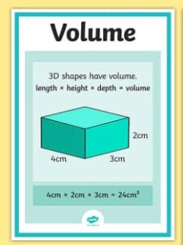

Play the game on the PowerPoint Below and then answer the questions on the activity sheet.

When opening PowerPoints, click "enable editing" then "slideshow" then "from beginning" to work the game properly. Good Luck!

Volume Of Shapes Powerpoint Game

WALT Estimate and Calculate Volume Activity Sheet

Dinner Time 🍴

Reading

Spend 30 minutes reading. Use either your scheme reading book, a silent reading book of your choice, Epic or Oxford Owl.

Music

Mrs Cermak has posted your lesson on YUMU entitled "Monday 5th July"

Login details were posted on Tapestry last week if you need them.

Log in to YUMU and click on the music lesson that Mrs Cermak has created for you. The link is here: Log In — Greater Manchester Music Hub (gmmusiconline.co.uk)

PE

Try to complete a short physical activity whilst at home. Here are a few ideas:

Option 1: Sports Development resources and video links: Facebook Links For PE With Sports Development

Option 2: Joe Wicks https://www.youtube.com/playlist?list=PLyCLoPd4VxBsXs1WmPcektsQyFbXTf9FO Find Joe on the channel in the link. There are various kids channels as well.

Option 3: Change4Life https://www.nhs.uk/change4life/activities

Option 4: You could create a dance routine to one of your favourite songs and perform the dance to your family or participate in another form of exercise with your family.

Option 5: 'Dance Videos with Mrs K'. Go to 'School Life' on the school website and you will find the link in there.

Option 6: PE links. There are lots of free resources for athletics, cricket and tennis on the links. There are also youtube video sessions for an after school activity option:

https://funetics.co.uk/for-parents/funetics-home/

Complete PE Home Learning Resource Videos - YouTube

http://LTA Youth Home Tennis Training For Kids | LTA

https://www.youtube.com/playlist?list=PLnwoPgo24bhnWi_Y7rIS4CZnFQNLyJm9b

Staying active during the COVID-19 outbreak | Chance to Shine

Tuesday 6th July

Assembly at 10am - link is on Tapestry

English

Spellings

Use your weekly spellings to create a word-search full of your spellings. You could draw one yourself using a blank 100 square grid or you could use this website to make one: https://www.senteacher.org/printables/Literacy/8/Create-Custom-Wordsearch-From-Word-Lists.html

Diamonds Spellings 5.7.21

Spellings For 5.7.21 Emeralds

Spellings For 5.7.21 Rubies

Assembly at 10am - link is on Tapestry

WALT use commas to clarify meaning.

Watch the video here to learn about commas for clarifying the meaning in a sentence: https://www.bbc.co.uk/bitesize/topics/zvwwxnb/articles/zc773k7

Look at the PowerPoint below and then complete the activity sheet.

Lesson Presentation On Commas Tues 6th July

Activity WALT Draw Pictures To Show Meaning When Commas Are Used

Maths

WALT recognise square numbers (revision)

Warm Up: 10-15 minutes of times tables using TTRockstars or Hit the Button.

https://play.ttrockstars.com/ (Your login details are in your journal)

https://www.topmarks.co.uk/maths-games/hit-the-button

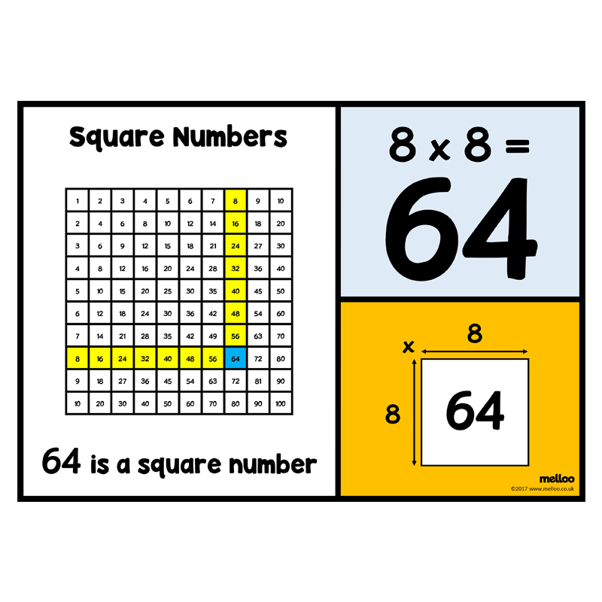

Watch the video below to find out more about square numbers:

https://youtu.be/63qQOYbZS0g

Complete the activity sheet here: WALT Recognise And Calculate Square Numbers

Dinner Time 🍴

Reading

Spend 30 minutes reading. Use either your scheme reading book, a silent reading book of your choice, Epic or Oxford Owl.

Science

WALT interpret data about babies' growth.

Complete the activity sheet below on babies and their growth. Look carefully at the data in the graph and answer the questions.

Growing Baby Science Data

2:15pm ZOOM story time with Miss Rooney 👩‍🏫

PE

Make sure you get some physical exercise again today. Use the links above or go outside and play a game in your garden.

Wednesday 7th July

9:30am ZOOM story time with Miss Rooney 👩‍🏫

English

Spellings

Mock spelling test day. Ask someone to test you on your spellings and complete column 2 of your spelling homework book.

Diamonds Spellings 5.7.21

Spellings For 5.7.21 Emeralds

Spellings For 5.7.21 Rubies

WALT understand the life of Sir David Attenborough

Complete the reading comprehension her. Choose the appropriate level of challenge. This is cross-curricular learning (part of your science work too). Uks2 David Attenborough Differentiated Reading Comprehension

Maths

WALT recognise square numbers (revision)

Warm Up: 10-15 minutes of times tables using TTRockstars or Hit the Button.

https://play.ttrockstars.com/ (Your login details are in your journal)

https://www.topmarks.co.uk/maths-games/hit-the-button

Building on your knowledge, complete the word problems here.

Remember to answer the question clearly.

WALT Solve Word Problems Involving Square Numbers

extension: why not try these word problems on cubed numbers. Remember cubed means multiplied by itself 3 times.... e.g. 2cubed is 2x2x2= 8 3 cubed is 3x3x3 = 27

Ext Cube Number Problems

Dinner Time 🍴

Reading

Spend 30 minutes reading. Use either your scheme reading book, a silent reading book of your choice, Epic or Oxford Owl.

Geography

WALT recognise features of the coast

First, watch these videos:

https://www.bbc.co.uk/bitesize/clips/z7fr87h

https://www.bbc.co.uk/bitesize/clips/z8tyr82

Then, follow the powerpoint to learn more about coastal features.

Lesson Presentation Coastal Features

Then label the features of the coast using this sheet or you could draw your own diagram and label the features of the coast.

Features Of Coastline Labelling Activity Sheet

PE

Make sure you get some physical exercise again today. Use the links above or go outside and play a game in your garden.

Thursday 8th July

Today we will have a 2:15am ZOOM story time with Miss Rooney 👩‍🏫

English

Spellings

Task: Put your spellings in alphabetical order. Here are the lists:

Diamonds Spellings 5.7.21

Spellings For 5.7.21 Emeralds

Spellings For 5.7.21 Rubies

English

WALT use dashes for drama and parenthesis

Watch the videos on the link here: https://www.bbc.co.uk/bitesize/topics/zvwwxnb/articles/zg8gbk7

Then have a look at the PowerPoint here: Lesson Presentation Dashes To Indicate Parenthesis

Complete the activity sheet here: The Dramatic Dash Activity Sheets

Maths

WALT find factors of numbers and solve problems using factors, squares and multiples

Warm Up: 10-15 minutes of times tables using TTRockstars or Hit the Button.

https://play.ttrockstars.com/ (Your login details are in your journal)

https://www.topmarks.co.uk/maths-games/hit-the-button
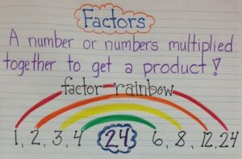

If you remember, we used rainbow factors in school to find factors and common factors.

Watch the videos on multiples and factors in this link. https://www.bbc.co.uk/bitesize/articles/zqc9bqt

Activity: complete the questions on factors here: WALT Find Factors Of Numbers And Solve Problems Using Factors, Squares And Multiples

Dinner Time 🍴

Reading

Spend 30 minutes reading. Use either your scheme reading book, a silent reading book of your choice, Epic or Oxford Owl.

Topic

WALT create a poster for a coastal resort in the UK.

PowerPoint: Research A Coastal Resort In The UK

Use the PowerPoint and your own research to find out all you can about a coastal resort in the UK. Once you have found your information (see the list below for what to include), you are going to create a poster all about it. Try to persuade everyone to go- perhaps you will be that persuasive that your parents will take you there one day.

What to include:

-Location in the UK (N, NE, E, SE, S, SW, W, NW) which county in the UK etc.

-What human features are there? (caravan sites, fairgrounds, piers etc.)

-What physical features are there? (arches, stacks, stumps, caves, coastal paths, white cliffs etc.)

-Images either copied and pasted or drawn yourself of the coastal resort

-Any historical references e.g. Jurassic Coast is famous for its fossils

2:15pm ZOOM story time with Miss Rooney 👩‍🏫

PE

Make sure you get some physical exercise again today. Use the links above or go outside and play a game in your garden.

Well done Everyone! I will see you back in school tomorrow for TREAT DAY! 🥳

