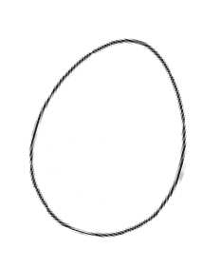
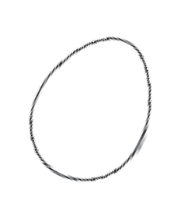
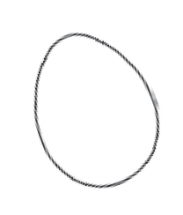
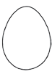
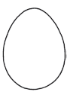
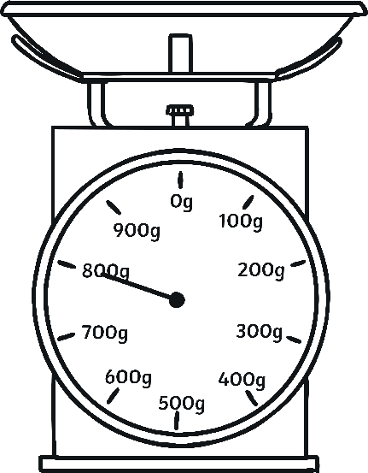
Egg Basket Weight Measurement
WALT: read scales in grams
Read the scales of each basket and record the weight.
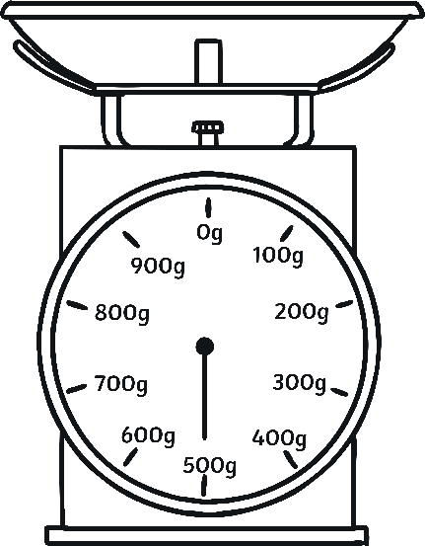
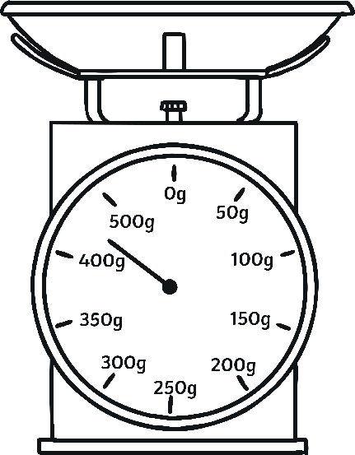
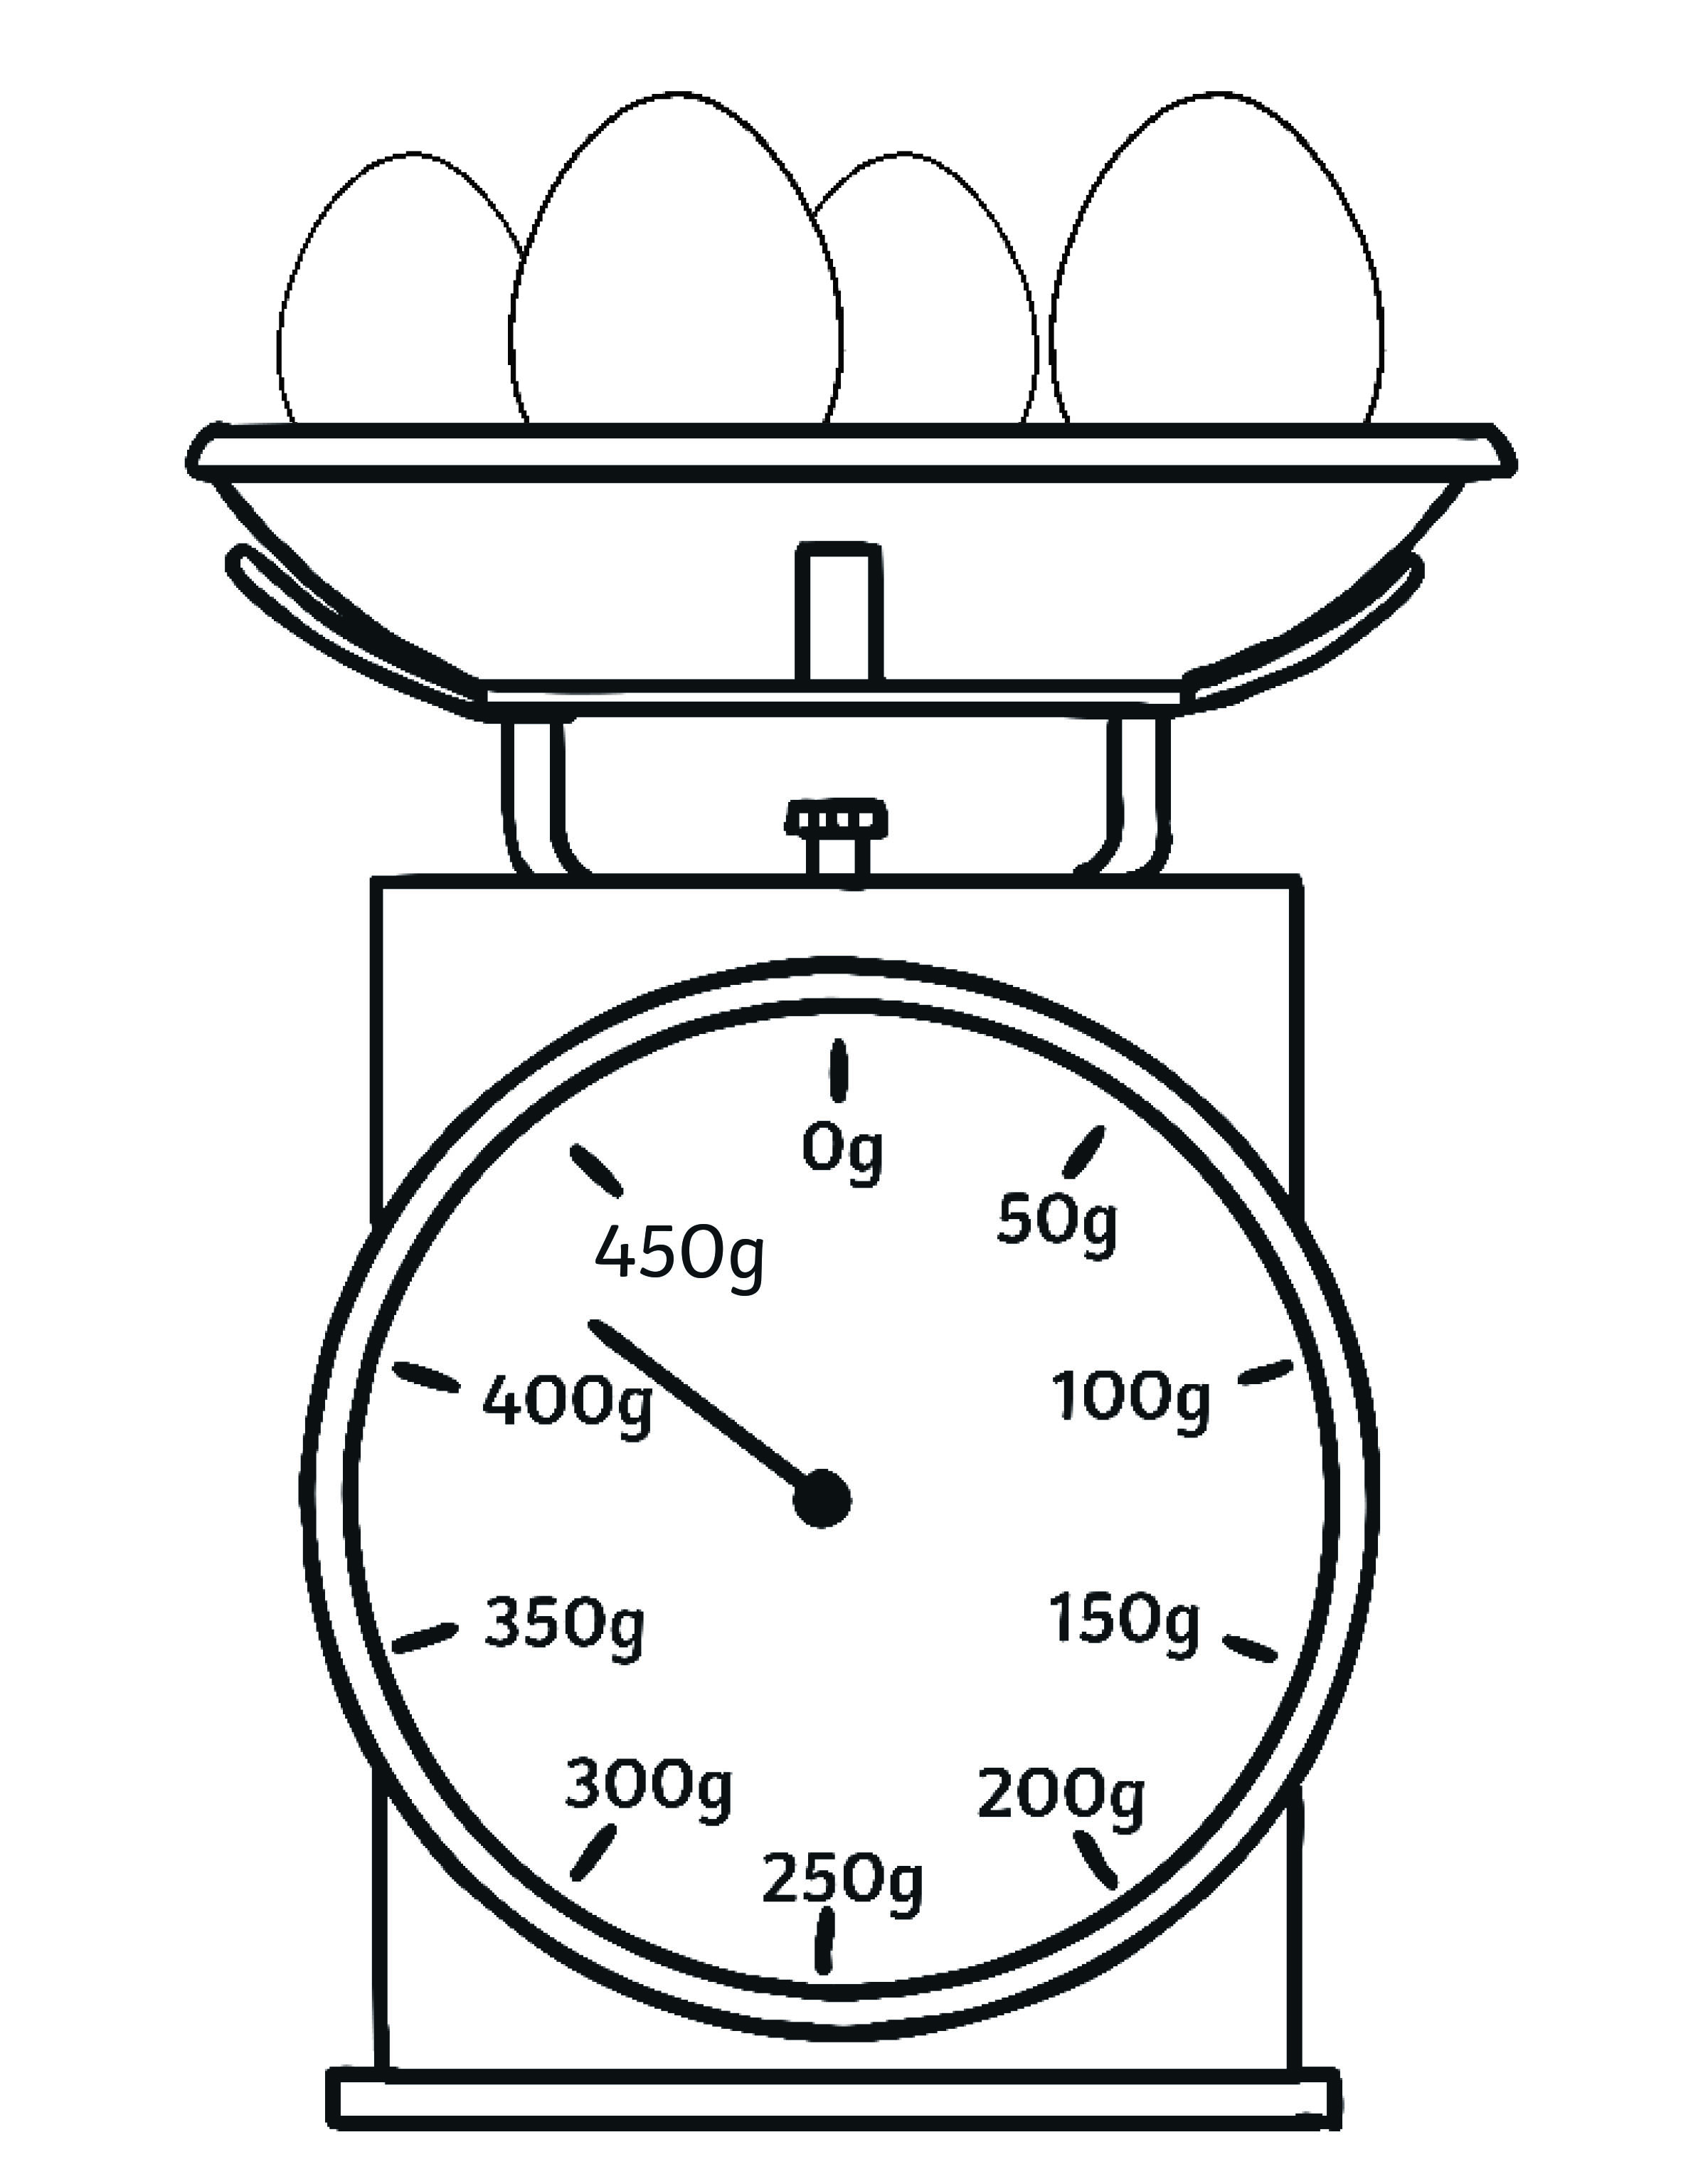

a. b. c.
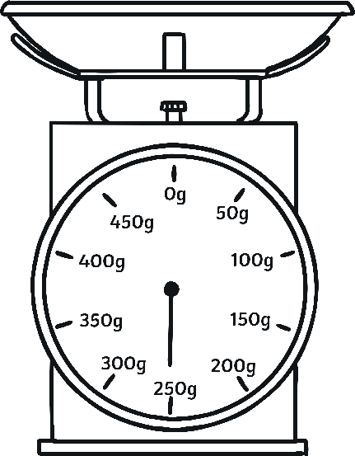
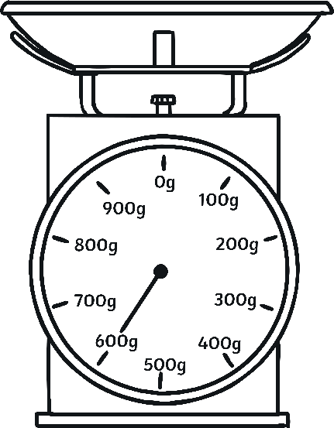
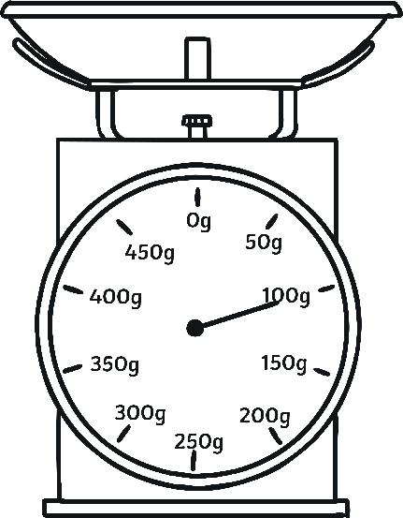

d. e. f.

Order the Easter baskets from lightest to heaviest.

lightest heaviest
Egg Basket Weight Measurement Answers
- 800g
- 500g
- 425g
- 250g
- 600g
- 100g

Order the baskets from lightest to heaviest.
F, D, C, B, E, A

