Buckstones Community Primary School

Policy for Safeguarding and Child Protection

Written and agreed by staff: 29.11.21
Adopted by Governors: 3.11.21
Signed by the Chair: S.Beckley

PHILOSOPHY:
To provide a fun, stimulating and excellent education which enables each child to achieve their full potential, academically, spiritually, emotionally and socially in a safe, environment.

Healthy School
Buckstones is a Healthy School with healthy attitudes embedded in the curriculum and extra-curricular activities. Children are encouraged to be active and maintain healthy relationships with their peers and adults as well as making other choices about healthy lifestyles.

1.0 Introduction
At Buckstones Primary School, the Governors and staff fully recognise the contribution the school makes to safeguarding children. We recognise that the safety and protection of all pupils is of paramount importance and that all staff, including volunteers, have a full and active part to play in protecting pupils from harm.
We believe that the school should provide a caring, positive, safe and stimulating environment which promotes all pupils’ social, physical, emotional and moral development.

This policy has been devised in accordance with Oldham Local Safeguarding Children’s Board (LSCB) guidelines and with the following legislation and guidance:

- ‘Working Together to Safeguard Children: A guide to inter-agency working to safeguard and promote the welfare of children’, DfE (2018)
- ‘Keeping Children Safe in Education’, DfE (2021)
- https://assets.publishing.service.gov.uk/government/uploads/system/uploads/attachment_data/file/1014224/Sexual_violence_and_sexual_harassment_between_children_in_schools_and_colleges.pdf DfE (2021)
- Guidance for Safer Working Practices for Adults who work with Children and Young People in Education Settingshttps://www.saferrecruitmentconsortium.org/GSWP%20Sept%202019.pdf (May 2019)
- ‘What to do if you're worried a child is being abused’, DfE (March 2015)
- ‘Information Sharing: Advice for practitioners’, DfE (July 2018)
- ‘The Prevent duty: Departmental advice for schools and childcare providers’, DfE (2015)
- https://assets.publishing.service.gov.uk/government/uploads/system/uploads/attachment_data/file/811796/Teaching_online_safety_in_school.pdf (DFE June 2019)

The terms “must” and “should” are used throughout the policy. The term “must” when the person in question is legally required to do something and “should” when the advice set out should be followed unless there is good reason not to.

2.0 PURPOSE AND AIMS:

The purpose of Buckstones Primary School’s safeguarding policy is to ensure every child who is a registered pupil at our school is safe and protected from harm. This means we will always work to:
- Protect children and young people at our school from maltreatment;
- Prevent impairment of our children’s and young people’s mental and physical health or development;
- Ensure that children and young people at our school grow up in circumstances consistent with the provision of safe and effective care;
- Undertake that role so as to enable children and young people at our school to have the best outcomes.

This policy applies to and gives clear direction to: staff, governors, volunteers, visitors and parents about expected behaviour and our legal responsibility to safeguard and promote the welfare of all children at our school.

Our school fully recognises the contribution it can make to protect children from harm and supporting and promoting the welfare of all children who are registered pupils at our school. The elements of our policy are prevention, protection and support.

We recognise that our safeguarding responsibilities are clearly linked to our responsibilities for ensuring that appropriate safeguarding responses are in place for children who are absent from school or who go missing from education. We also recognise that safeguarding against radicalisation and extremism is no different to safeguarding against any other vulnerability in today’s society.

3.0 ROLES and RESPONSIBILITIES:

Safeguarding and promoting the welfare of children is defined as ‘protecting children from maltreatment; preventing impairment of children’s health or development; ensuring that children grow up in circumstances consistent with the provision of safe and effective care; and taking action to enable all children to have the best outcomes.’ (Keeping Children Safe in Education – statutory guidance for schools and colleges Sept 2021)

Named Personnel with designated responsibility for Safeguarding

Academic Year | Designated Safeguarding Lead | Deputy Designated Safeguarding Lead | Nominated Governor | Chair of Governors
2021 - 2022 | Sarah Healey | Melanie Platt | Sue Gee | Steve Beckley

It is the responsibility of every member of staff, governor, volunteer and regular visitor to our school to ensure that they carry out the requirements of this policy and, at all times, work in a way that will safeguard and promote the welfare of all of the pupils at this school. This includes the responsibility to provide a safe environment in which children can learn.

3.1 The Governing Body

The Governing Body of Buckstones Primary School takes leadership responsibility for their school’s safeguarding arrangements.

They are accountable for ensuring the effectiveness of this policy and our compliance with it. Although our Governing Body takes collective responsibility to safeguard and promote the welfare of our pupils, we also have a named Governor who champions safeguarding within the school.

The Governing Body will ensure that:
- the safeguarding policy in place, is reviewed annually and is available on our school website;
- they have a named governor for child protection and children looked after: Mrs. Sue Gee ;
- has a member of the governing body nominated to liaise with the local authority on issues of child protection and in the event of allegations of abuse made against the headteacher or member of governing body: Steve Beckley;
- a member of the senior leadership team is designated to take the lead responsibility for safeguarding and child protection and that there is an alternate and appropriately trained member of staff identified to deal with any issues in the absence of the Designated Safeguarding Lead (DSL). There will always be cover for this role;
- all staff receive a copy of the Safeguarding and Child Protection Policy and the Safer Working Practices Policy / Code of Conduct and Keeping Children Safe In Education Part 1;
- all staff to undergo regular updated safeguarding training, including online safety and the requirement to ensure children are taught about safeguarding, including online safety, that safeguarding training for staff, including online safety training, is integrated, aligned and considered as part of the whole school or college safeguarding approach and wider staff training and curriculum planning;
- procedures are in place for dealing with allegations against members of staff and volunteers in line with statutory guidance;
- safer recruitment practices are followed in accordance with the requirements of ’Keeping Children Safe in Education’ DfE (2021) and makes appropriate staff and volunteer checks and has procedures for dealing with allegations against staff and volunteers that all comply in accordance with Oldham Safeguarding Partnership procedures;
- at least one member of an appointing panel will have attended safer recruitment training;
- ensures the school keeps an up to date Single Central Record (SCR);
- are aware of the Prevent Strategy, and understand the Prevent Duty and the responsibilities of the school;
- it recognises that neither it, nor individual governors, have a role in dealing with individual cases or a right to know details of cases (except when exercising their disciplinary functions in respect of allegations against staff);
- this policy and practice complements other policies e.g. anti-bullying including cyber bullying, health and safety, to ensure safeguarding.

3.2 Head teacher
The Head teacher will ensure that:
- the policies and procedures adopted by the Governing Body are followed by all staff;
- the policy will be updated annually, and be available on the school website;
- all staff be appropriately trained and a list of their safeguarding training dates is maintained;
- give sufficient resources and allocated time to enable staff to discharge their responsibilities: including taking part in strategy discussions and other multi-agency meetings, to contribute to the assessment and support of children and young people, and be appropriately trained;
- ensure all staff understand the role of the DSL and are aware of systems within the school which support safeguarding;
- ensure appropriate filters and appropriate monitoring systems are in place to safeguard pupils from potentially harmful and inappropriate online material;
- all staff and volunteers feel able to raise their concerns about poor and unsafe practice in regard of pupils, and such concerns are addressed in a timely manner in accordance with agreed policies;
- there is a designated person for Children Looked After Miss Sarah Healey and an up to date list of children is regularly reviewed. There is a named Governor for Children Looked After Mrs. Sue Gee;
- liaise with the Local Authority Designated Officer (LADO) in the event of an allegation of abuse being made against a member of staff;
- safer recruitment practices are followed and has the responsibility of verifying the identity, qualifications, suitability and DBS checks for all staff employed by school, Governors and volunteers;
- a Single Central Record is held in the School Office, and electronically, which includes all members of staff;
- ensure staff are aware of the risks to children and young people of being radicalised and provide awareness of Prevent Duty training;
- ensure staff and governors are aware of how to identify and respond to risks to children from extreme or radical views;
- be the identified single point of contact (SPOC) for any Prevent concerns raised within the school;
- refer any child/ren at risk of being radicalised or extremism through the Local Authority Channel Referral and Intervention processes;
- ensure that information is passed to a new school if a child on the Child Protection Register transfers and informs the social worker;
- ensure emergency contact details for more than one parent or designated carer are held in school.
- with the support of the Site Manager, School Business Manager and School Administrator

- ensures the safety and security of the school site and screening visitors in regards to the purpose of their visit.

- 3.3 The Designated Safeguarding Lead (DSL)
The Governing Body appoints the Safeguarding Lead for the school and this is always a senior member of staff.
Miss Sarah Healey is the designated lead for child protection. In her absence, Miss Melanie Platt is the deputy designated leads for safeguarding. The designated safeguarding lead (and any deputies) are most likely to have a complete safeguarding picture and be the most appropriate person to advise on the response to safeguarding concerns.

The Designated Safeguarding Lead(s) will carry out their role in accordance with the responsibilities outlined in Annex B of ‘Keeping Children Safe in Education’. The DSL will provide advice and support to other staff on child welfare and child protection matters. Any concern for a child’s safety or welfare will be recorded and logged on CPoms.

The DSL at Buckstones Primary School will represent our school at child protection conferences and core group meetings. Through appropriate training, knowledge and experience our DSL will liaise with the three safeguarding partners (Oldham local authority, Oldham clinical commissioning group, Greater Manchester police) and work with other agencies. They will refer to the guidance: NPCC- When to call the police where appropriate.
https://www.npcc.police.uk/documents/Children%20and%20Young%20people/When%20to%20call%20the%20police%20guidance%20for%20schools%20and%20colleges.pdf

The DSL is responsible for ensuring that all staff members and volunteers are aware of our policy and the procedure they need to follow. They will ensure that all staff, volunteers and regular visitors have received appropriate child protection information during induction and relevant training as appropriate.

All Induction for Staff will include a copy of the following policies:

- child protection policy;
- behaviour policy;
- Staff Code of Conduct (Safer Working Practices) the safeguarding response to children who go missing from education; included in Child Protection Policy
- the role of the designated safeguarding lead (including the identity of the designated safeguarding lead and any deputies).
- a copy of Part one Keeping Children Safe In Education

All Volunteers Induction will include:

- safeguarding and child protection policy;
- the role of the designated safeguarding lead (including the identity of the designated safeguarding lead and any deputies).
- a copy of Part one Keeping Children Safe In Education

The DSL will ensure that:
- Records of concerns are kept, even if there is no immediate need for referral; and monitored using CPoms.
- All child protection records are kept securely and accessible only by the head teacher/designated leads or Class Teacher as appropriate.
- Where children leave the school, the designated safeguarding lead should ensure their child protection file is transferred to the new school as soon as possible, ensuring secure transit, and confirmation of receipt should be obtained. For schools, this should be transferred separately from the main pupil file. Receiving schools should ensure key staff such as designated safeguarding leads and SENCOs are aware as required.
- In addition to the child protection documents, the designated safeguarding lead should also consider if it would be appropriate to share any information with the new school or college in advance of a child leaving. For example, information that would allow the new school or college to continue supporting victims of abuse and have that support in place for when the child arrives.
- Where verbal referrals are made to social care, the referral is confirmed in writing within 24 hours. Should a Prevent referral be made then an investigation/reflection will follow to identify and respond to any recommendations.

3.4 Teaching Staff, Support Staff and Volunteers

All staff and volunteers need to be alert to the signs of abuse as detailed in this policy. They should report any concerns immediately to Miss Healey or Miss Platt.

At Buckstones the responsibilities for teaching, non-teaching staff and volunteers;

- to know who the DSL is.
- understand that all school staff have a responsibility to provide a safe environment in which children can learn;
- maintain an attitude of ‘it could happen here’;
- adhere to this policy in line with the Behaviour Policy, Online Policy and Staff Conduct Policy.
- refer to the signs of abuse outlined in the Department Of Education publication ‘what to do if you’re worried a child is being abused: advice for practitioners’ March 2015 - see Appendix 2 for key extracts. In addition there is good advice provided on the NSPCC website.
- knowing what to look for is vital to the early identification of abuse and neglect. If staff members are unsure they should always speak to a Designated Safeguarding Lead. In exceptional circumstances, such as in an emergency or a genuine concern that appropriate action has not been taken, staff members can speak directly to Children’s Social Care.
- be aware that behaviours linked to the likes of drug taking, alcohol abuse, truanting and sexting put children in danger;
- know how to respond to their duty when they have concerns or when a pupil discloses to them and to act. When concerned about the welfare of a child, staff members should always act in the best interests of the child.
- know what and how to record concern;
- be aware of Oldham’s Early Help process and their role in it.
- undergo child protection training which is updated regularly, in line with advice from the LSCB. (Whole staff training every three years)
- know the safeguarding response to children who go missing from education.
- know that there is a mandatory duty to report cases of FGM to the police.
- complete training so that they understand that Prevent is a safeguarding issue, and know how to recognise and refer students who may be vulnerable to radicalisation (the on-line Channel training package at http://course.ncalt.com/Channel_General_Awareness
- understand that Teachers’ Standards 2012 state that teachers, including headteachers, should safeguard children’s wellbeing and maintain public trust in the teaching profession as part of their professional duties.
- ensure that curriculum plans provide opportunities for children to develop their skills, knowledge and understanding of safe practices including e-safety.

Abuse of position of trust
All school staff are aware that inappropriate behaviour towards pupils is unacceptable and that their conduct towards pupils must be beyond reproach. Staff understand that under the Sexual Offences Act 2003 it is an offence for a person over the age of 18 to have a sexual relationship with a person under the age of 18, where that person is in a position of trust, even if the relationship is consensual. This means that any sexual activity between a member of the school staff and a pupil under 18 may be a criminal offence.

Disqualification from Childcare Act 2018
All schools providing childcare must ensure that appropriate checks are carried out to ensure that individuals employed are not disqualified from working in these settings under the 2018 Childcare Disqualification Regulations. Under the 2018 Regulations, schools are no longer required to establish whether a member of staff providing, or employed to work in, childcare is disqualified by association. Regulation 9 does not apply to staff in a relevant school setting; disqualification by association is only relevant where childcare is provided in domestic settings (e.g. where childminding is provided in the home) or under registration on domestic premises. Accordingly, we will not ask staff questions about cautions or convictions of someone living or working in their household. In support of this we will take an opportunity, for example through appraisal, or other staff discussions, to create the right culture and environment so that staff feel comfortable, where it is appropriate, to discuss matters outside of work, which may have implications for the safeguarding of children in the workplace. Staff should feel able to discuss issues where their relationships and associations both within and outside of the workplace (including online) may have implications for the safeguarding of children in school. These discussions will help us to safeguard our employees’ welfare and contribute to our duty of care towards our staff. Where appropriate, it will help us to identify whether arrangements are needed to support these staff. These discussions can also help us to manage children’s safety, providing them with information that will help them consider whether there are measures that need to be put in place to safeguard children (e.g. by putting arrangements in place to stop or restrict a person coming into school where a potential risk to children has been identified).

- WHAT SCHOOL STAFF SHOULD LOOK OUT FOR

4.1 Types of abuse
Extract from Keeping Children Safe in Education – Statutory guidance for schools and colleges – September 2021
All staff should be aware that abuse, neglect and safeguarding issues are rarely stand-alone events that can be covered by one definition or label. In most cases, multiple issues will overlap with one another.

Abuse: a form of maltreatment of a child. Somebody may abuse or neglect a child by inflicting harm, or by failing to act to prevent harm. They may be abused by an adult or adults or another child or children.

Physical abuse: a form of abuse which may involve hitting, shaking, throwing, poisoning, burning or scalding, drowning, suffocating or otherwise causing physical harm to a child. Physical harm may also be caused when a parent or carer fabricates the symptoms of, or deliberately induces, illness in a child.

Emotional abuse: the persistent emotional maltreatment of a child such as to cause severe and adverse effects on the child’s emotional development. It may involve conveying to a child that they are worthless or unloved, inadequate, or valued only insofar as they meet the needs of another person. It may include not giving the child opportunities to express their views, deliberately silencing them or ‘making fun’ of what they say or how they communicate. It may feature age or developmentally inappropriate expectations being imposed on children. These may include interactions that are beyond a child’s developmental capability as well as overprotection and limitation of exploration and learning, or preventing the child participating in normal social interaction. It may involve seeing or hearing the ill-treatment of another. It may involve serious bullying (including cyberbullying), causing children frequently to feel frightened or in danger, or the exploitation or corruption of children. Some level of emotional abuse is involved in all types of maltreatment of a child, although it may occur alone.

Sexual abuse: involves forcing or enticing a child or young person to take part in sexual activities, not necessarily involving a high level of violence, whether or not the child is aware of what is happening. The activities may involve physical contact, including assault by penetration (for example rape or oral sex) or non-penetrative acts such as masturbation, kissing, rubbing and touching outside of clothing. They may also include non-contact activities, such as involving children in looking at, or in the production of, sexual images, watching sexual activities, encouraging children to behave in sexually inappropriate ways, or grooming a child in preparation for abuse (including via the internet). Sexual abuse is not solely perpetrated by adult males. Women can also commit acts of sexual abuse, as can other children

Neglect: the persistent failure to meet a child’s basic physical and/or psychological needs, likely to result in the serious impairment of the child’s health or development. Neglect may occur during pregnancy as a result of maternal substance abuse. Once a child is born, neglect may involve a parent or carer failing to: provide adequate food, clothing and shelter (including exclusion from home or abandonment); protect a child from physical and emotional harm or danger; ensure adequate supervision (including the use of inadequate care-givers); or ensure access to appropriate medical care or treatment. It may also include neglect of, or unresponsiveness to, a child’s basic emotional needs.

All staff should be aware that safeguarding incidents and/or behaviours can be associated with factors outside the school and/or can occur between children outside of these environments. All staff, but especially the designated safeguarding lead (and deputies) should consider whether children are at risk of abuse or exploitation in situations outside their families. Extra-familial harms take a variety of different forms and children can be vulnerable to multiple harms including (but not limited to) sexual exploitation, criminal exploitation, and serious youth violence.

OPERATION ENCOMPASS
Buckstones School is part of Operation Encompass. This is a police and education early intervention safeguarding partnership which supports children and young people who experience Domestic Abuse.
Operation Encompass means that the police will share information about Domestic Abuse incidents with our school prior to the start of the next school day when they have been called to a domestic incident.
The Designated Safeguarding Lead – (DSL) has attended an Operation Encompass briefing and has cascaded the principles of Operation Encompass to the Deputy Designated Safeguarding Lead.
The Key Adults are: Miss Sarah Healey and Miss Melanie Platt
Parents are aware that we are an Operation Encompass school and have been informed by letter.
The Operation Encompass information is stored in line with all other confidential safeguarding and child protection information.
The Key Adult has also led training for all school staff and has informed Governors about Operation Encompass, the prevalence of Domestic Abuse and the impact of this abuse on children. We have also discussed, as a school, how we can support our children following the Operation Encompass notification.
We are aware that we must do nothing that puts the child/ren or the non-abusing adult at risk.
The Head teacher and/or Safeguarding Governor provide safeguarding updates at the Full Governing Body meetings and provide an annual report to Governors. All information is anonymised.
The DSL has used the Operation Encompass Toolkit to ensure that all appropriate actions have been taken by the school and will complete an action report following any incident and upload this information to CPoms. (See appendix 1 for the report and links to additional advice)

4.2 Specific safeguarding issues

All staff should have an awareness of safeguarding issues that can put children at risk of harm. Behaviours linked to issues such as drug taking, alcohol abuse, deliberately missing education and sexting (also known as youth produced sexual imagery) put children in danger.

4.2.1 Peer on Peer Abuse:

ALL staff must be aware that safeguarding issues can manifest themselves via peer on peer abuse. Staff should recognise that children are capable of abusing their peers.
Peer on peer abuse can take on many forms, including:
- bullying (including cyberbullying, prejudice-based and discriminatory bullying);
- abuse in intimate personal relationships between peers;
- physical abuse which can include hitting, kicking, shaking, biting, hair pulling, or otherwise causing physical harm;
- sexual violence, such as rape, assault by penetration and sexual assault;
- sexual harassment, such as sexual comments, remarks, jokes and online sexual harassment;
- non-consensual sharing of nude and semi-nude images and/or videos (also known as sexting or youth produced sexual imagery):
- causing someone to engage in sexual activity without consent, such as forcing someone to strip, touch themselves sexually, or to engage in sexual activity with a third party;
- upskirting (which is a criminal offence37), which typically involves taking a picture under a person’s clothing without their permission, with the intention of viewing their genitals or buttocks to obtain sexual gratification, or cause the victim humiliation, distress, or alarm; and
- initiation/hazing type violence and rituals.
* (For further information see Annex A of KCSIE 2021 )

Staff must challenge any form of derogatory and sexualised language or behaviour. Staff should be vigilant to sexualised/aggressive touching/grabbing. Behaviours by children should never be passed off as ‘banter’ or ‘part of growing up’. Different gender issues can be prevalent when dealing with peer on peer abuse, for example girls being sexually touched/assaulted or boys being subject to initiation/hazing type violence. Whilst any report of sexual violence or sexual harassment should be taken seriously, staff should be aware it is more likely that girls will be the victims of sexual violence and sexual harassment and more likely it will be perpetrated by boys.

The DFE states ‘peer on peer abuse should be taken as seriously as abuse by adults and should be subject to the same child protection procedures. Professionals should not dismiss abusive behaviour as normal between young people and should not develop high thresholds before taking action.’

Child on Child Sexual Violence and Sexual Harassment Sexual violence and sexual harassment can occur between two children of any age and sex. It can also occur through a group of children sexually assaulting or sexually harassing a single child or group of children.
Children who are victims of sexual violence and sexual harassment will likely find the experience stressful and distressing. This will, in all likelihood, adversely affect their educational attainment. Sexual violence and sexual harassment exist on a continuum and may overlap, they can occur online and offline (both physical and verbal) and are never acceptable. It is important that all victims are taken seriously and offered appropriate support. Staff should be aware that some groups are potentially more at risk.

Evidence shows girls, children with SEND and LGBT children are at greater risk. Staff should be aware of the importance of:
- making clear that sexual violence and sexual harassment is not acceptable, will never be tolerated and is not an inevitable part of growing up;
- not tolerating or dismissing sexual violence or sexual harassment as “banter”, “part of growing up”, “just having a laugh” or “boys being boys”; and
- challenging behaviours (potentially criminal in nature), such as grabbing bottoms, breasts and genitalia, flicking bras and lifting up skirts. Dismissing or tolerating such behaviours risks normalising them. Staff also need to be aware that a child displaying harmful sexual behaviour (HSB) may be an indication that they are a victim of abuse themselves.
Prevention of Any Peer on Peer Abuse

As a school we will minimize the risk of allegations against other pupils by:-

- Providing a developmentally appropriate PSHE, RSE, SMSC and British Values curriculum which develops pupils understanding of acceptable behaviour and keeping themselves safe;
- Having a robust e–safety programme which develops pupils’ knowledge, understanding and skills, to ensure personal safety and self-protection when using the internet and social networking;
- Having robust monitoring and filtering systems in place to ensure pupils are safe and act appropriately when using information technology in school;
- Having systems in place for any pupil to raise concerns with staff, knowing that they will be listened to, believed and valued;
- Delivering targeted work on assertiveness and keeping safe to those pupils identified as being at risk;
- Developing robust risk assessments and providing targeted work for pupils identified as being a potential risk to other pupils;
- having an open and honest environment where young people feel safe to share information about anything that is upsetting or worrying them;
- ensure that the school is well supervised, especially in areas where children might be vulnerable.
All concerns should be referred to the Designated Safeguarding Lead (DSL), and logged on CPoms and the DSL should also refer to the School’s Anti Bullying Policy.

Information gathering
- When an allegation is made by a child against another child, members of staff should consider whether the complaint raises a safeguarding concern. If there is a safeguarding concern the designated safeguarding lead (DSL) should be informed.
- A factual record should be made of the allegation, but no attempt at this stage should be made to investigate the circumstances.
- Children, staff and witnesses will be spoken with as soon as possible to gather relevant information quickly to understand the situation and assess whether there was intent to cause harm. We will try to manage reports with two members of staff present, (preferably one of them being the designated safeguarding lead or a deputy). However, this might not always be possible.
- All concerns, discussions, decisions and reasons for decisions should be recorded (written or electronic).

Victims of peer on peer abuse should be supported by the school and referred to specialist agencies including, as examples, CAMHs, Barnardos, MASH , Sexual Violence Specialists. A written risk assessment may also need to be in put place and will be reviewed regularly.

Decide on action
There are four likely scenarios to consider when managing any reports of sexual violence and/or sexual harassment. It will be important in all scenarios that decisions and actions are regularly reviewed and that relevant policies are updated to reflect lessons learnt. It is particularly important to look out for potential patterns of concerning, problematic or inappropriate behaviour. Where a pattern is identified, the school or college should decide on a course of action. Consideration should be given to whether there are wider cultural issues within the school or college that enabled the inappropriate behaviour to occur and where appropriate extra teaching time and/or staff training could be delivered to minimise the risk of it happening again. The four scenarios are:
1. Manage internally
2. Early Help
3. Referrals to children’s MASH team
4. Reporting to the Police

- The DSL should contact the MASH to discuss the case.
- The DSL will follow through the outcomes of the discussion and make a referral where appropriate.
- If the allegation indicates that a potential criminal offence has taken place, the DSL will refer the case to the multi-agency agency safeguarding hub where the police will become involved.
- The DSL will make a record of the concern, the discussion and any outcome and keep a copy in the files of both children’s files.
- It may be appropriate to exclude the child being complained about for a period of time according to the school’s behaviour policy and procedures.
- Where neither social services nor the police accept the complaint, a thorough school investigation should take place into the matter using the school’s usual disciplinary procedures.
- In situations where the school considers a safeguarding risk is present, a risk assessment should be prepared along with a preventative, supervision plan.
- The plan should be monitored and a date set for a follow-up evaluation with everyone concerned.

Where allegations of sexual violence or sexual harassment are made, the school will act in accordance with the guidance set out in Part 5 of Keeping Children Safe in Education (2021).

4.2.2 Self-Harm
If it comes to the attention of a member of staff that a child is self-harming, they should alert the DSL as soon as possible, who may take action by contacting the following:

- Parents or carers;
- Child Mental Health Services;
- MASH Team, if the child meets the referral criteria;
- Early Help Team.

4.2.3 Serious violence
All staff should be aware of indicators, which may signal that children are at risk from, or are involved with serious violent crime. These may include increased absence from school, a change in friendships or relationships with older individuals or groups, a significant decline in performance, signs of self-harm or a significant change in wellbeing, or signs of assault or unexplained injuries. Unexplained gifts or new possessions could also indicate that children have been approached by, or are involved with, individuals associated with criminal networks or gangs.

All staff should be aware of the associated risks and understand the measures in place to manage these. Advice for schools and colleges is provided in the Home Office’s Preventing youth violence and gang involvement and its Criminal exploitation of children and vulnerable adults: county lines guidance

* (For further information KCSIE 2021)

4.2.4 Female Genital Mutilation
All school staff is aware of the range of potential indicators that a girl may be at risk of FGM. Warning signs that FGM may be about to take place, or may have already taken place, can be found in the Multi-Agency Practice Guidelines – (see Appendix 3 for relevant extract.)

Whilst all staff should speak to the designated safeguarding lead (or deputy) with regard to any concerns about female genital mutilation (FGM), there is a specific legal duty on teachers. If a teacher, in the course of their work in the profession, discovers that an act of FGM appears to have been carried out on a girl under the age of 18, the teacher must report this to the police.

4.2.5 Forced Marriage
Forced Marriage became a criminal offence in June 2014. It is a form of child, adult and domestic abuse and, in line with statutory guidance, is treated as such by the School. The School is sensitive to differing family patterns and lifestyles and child-rearing patterns that vary across different racial, ethnic and cultural groups. However, child abuse cannot be condoned for religious or cultural reasons.

Information about Forced Marriage will be incorporated into staff safeguarding and child protection training and briefings and this policy will be followed to protect a victim or potential victim of forced marriage. If a case of forced marriage is suspected it will be viewed as a safeguarding and child protection concern, and parents and carers will not be approached or involved about a referral to any External Agency.
(Refer also to ‘honour-based abuse)

4.2.6 Children Missing From Education

Children who go missing
All measures are taken to monitor attendance and provide guidance to all staff when a pupil is missing from education. A child going missing from education is a potential indicator of abuse or neglect. The appropriate safeguarding procedures will be used for children who go missing from school, particularly on repeat occasions.
Staff are aware of potential triggers such as travelling to conflict zones, FGM, forced marriages etc.
If a child is failing to attend school regularly or has been absent without the school’s permission for a continuous period of 10 school days, and then the local authority will be notified of the absence.
The local authority will be notified when a pupil is deleted from the admission register / school register.

Guide to actions for a pupil whose whereabouts are unknown (Missing Pupils)

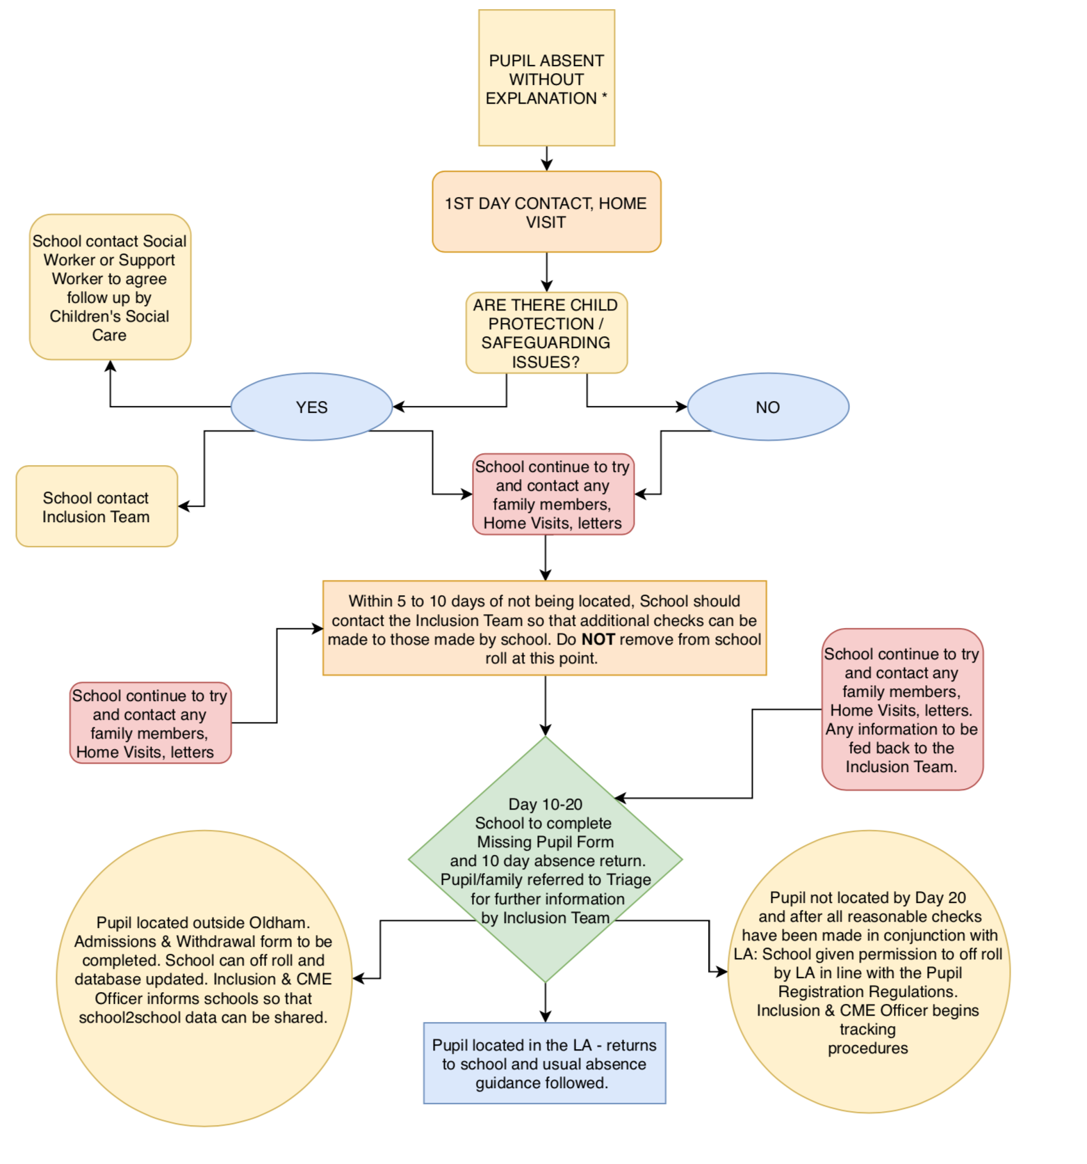
.
* Early Help assessment / Social Care Referrals should also be considered when pupils have absences from school.
Following the completion of the above the Access Service will undertake the task of ‘tracking’ the pupil. This will include checks on benefits /council tax/ health etc. as well as contacting other boroughs. It is essential that the above process is completed before the missing pupil form is sent in.
Vulnerable Groups Officer (CME team) are on 0161 770 4201/3665 cme@oldham.gov.ukEducation Attendance Service (EAS team) are on 0161 770 6620 sais@oldham.gov.uk
4.2.6 Radicalisation/Extremism

The identified strategic lead for Prevent is the DSL and this is the single point of contact for the school.

What is extremism? - Extremism is vocal or active opposition to fundamental British Values, including democracy, the rule of law, individual liberty and mutual respect and tolerance of different faiths and beliefs. We also include in our definition of extremism: calls for the death of members of our armed forces, whether in this country or overseas. (Keeping children safe in education – Statutory guidance for schools and colleges Sept 2019) Extremism can be both violent and non-violent.

What is radicalisation? - Radicalisation refers to the process by which a person comes to support terrorism and forms of extremism. (Keeping children safe in education – Statutory guidance for schools and colleges Sept 2019)

The link between radicalisation/extremism and safeguarding - Protecting children from the risk of radicalisation is part of schools’ wider safeguarding duties, and is similar in nature to protecting children from other forms of harm and abuse. As with managing other safeguarding risks, staff should be alert to changes in student’s behaviour which could indicate that they may be in need of help or protection. If staff has any concerns about a young person’s safety they should speak to a Designated Lead.

Procedures in place for protecting students at risk of radicalisation

Teaching British Values within the curriculum
We teach a broad and balanced curriculum which promotes the spiritual, moral, cultural, mental and physical development of pupils and prepare them for the opportunities, responsibilities and experiences of life. We actively promote community cohesion and British Values across all curriculum areas including RE, PSHE, RSE and English.

Visiting speakers
All visiting speakers that visit school should be fully checked to ensure they are suitable. All staff who wish to invite visiting speakers into school must get permission from the Head teacher or Deputy Head teacher who will ensure necessary checks are carried out. All visiting speakers must be supervised by at least one member of school staff.

After School Activities
All afterschool activities and groups must have approval from the Head teacher or Deputy Head teacher, and have relevant certificates of training and/or qualifications and DBS checks.

ICT
Our internet controls in school ensure all students are safe from terrorist and extremist material when accessing the internet in school.
Our E-safety education with pupils, parents and staff includes the risks of online radicalisation.

Staff Training
Understanding the risk factors and signs of radicalisation is part of the ongoing safeguarding training of all staff and is updated regularly. The Designated Safeguarding Lead(s) have had Prevent Awareness Training and are able to provide advice and support to other members of staff on protecting children from the risk of radicalisation.

Where we have concerns
If we have safeguarding concerns regarding a young person the Designated Safeguarding Leads will make an appropriate referral. This could include a referral to Channel or Children’s Social Care. The same procedures would apply if the concern related to a parent, member of staff or Governors. In these instances a referral would be made to Channel, the LA, and Social Services.

The contact details for referrals are
Children:child.mash@oldham.gov.uk
Adults:adult.mash@oldham.gov.uk
MASH Tel 0161 770 7777
Or GMP Prevent office on 0161 856 6345.

Where any concerns are raised about radicalisation/extremism whether for a child or adult a referral must be completed using C Poms.

Should a referral be made then an investigation/reflection will follow to identify and respond to lessons learnt.

4.2.7 Child Sexual Exploitation (CSE) and Child Criminal Exploitation (CCE)

School staff are made aware of the signs of child sexual exploitation and child criminal exploitation. Both CSE and CCE are forms of abuse and both occur where an individual or group takes advantage of an imbalance in power to coerce, manipulate or deceive a child into sexual or criminal activity. Whilst age may be the most obvious, this power imbalance can also be due to a range of other factors including gender, sexual identity, cognitive ability, physical strength, status, and access to economic or other resources. In some cases, the abuse will be in exchange for something the victim needs or wants and/or will be to the financial benefit or other advantage (such as increased status) of the perpetrator or facilitator. The abuse can be perpetrated by individuals or groups, males or females, and children or adults. The abuse can be a one-off occurrence or a series of incidents over time, and range from opportunistic to complex organised abuse. It can involve force and/or enticement-based methods of compliance and may, or may not, be accompanied by violence or threats of violence. Victims can be exploited even when activity appears consensual and it should be noted exploitation as well as being physical can be facilitated and/or take place online. (See Appendix 4 for further information and support).

Attendance is closely monitored and all staff understand that pupils who go missing from education are potentially vulnerable to CSE and CCE and therefore should be reported to the Safeguarding Lead

4.2.8 Mental Health
All staff are aware that mental health problems can, in some cases, be an indicator that a child has suffered or is at risk of suffering abuse, neglect or exploitation. Only appropriately trained professionals should attempt to make a diagnosis of a mental health problem. Staff however, through day-to-day observations should look to identify those whose behaviour suggests that they may be experiencing a mental health problem or be at risk of developing one.

Where children have suffered abuse and neglect, or other potentially traumatic adverse childhood experiences, this can have a lasting impact throughout childhood, adolescence and into adulthood. Staff should be aware of how these children’s experiences, can impact on their mental health, behaviour and education.

Where staff have a mental health concern about a child that is also a safeguarding concern, immediate action should be taken by speaking to the designated safeguarding lead or a deputy and making a log on cpoms.

Further resources and information to support staff and pupils can be found in appendix 5

4.2.9 On-line Safety
The use of technology has become a significant component of many safeguarding issues. Child sexual exploitation; radicalisation; sexual predation: technology often provides the platform that facilitates harm. At Buckstones we have an effective approach to online safety which educates the whole school community in their use of technology and we have robust systems in place to identify, intervene in and escalate any incident as appropriate.

At Buckstones we recognise that there are three main areas which can place our pupils at risk:
• content: being exposed to illegal, inappropriate or harmful material;
• contact: being subjected to harmful online interaction with other users; and
• conduct: personal online behaviour that increases the likelihood of, or causes, harm.

To ensure that we are doing all that we reasonably can to limit children’s exposure to the above risks we have appropriate filters and monitoring systems in place. At Buckstones we do not permit the use of personal mobile technology such as mobile phones. In addition we actively promote and teach on line safety in a variety of ways as part of providing a broad and balanced curriculum. This includes covering relevant issues through personal, social, health and economic education (PSHE), and Relationships Sex Education (RSE) We also take part in an annual e-safety week to teach pupils how to stay safe online and buy in outside support through the LCSB to teach older pupils the dangers of being on line e.g. Darth Vader presentation (led by E Weeldon)
Staff are regularly updated and undergo safeguarding training including, online safety training

The e- safety policy also gives further information with regard to sexting. Sexting is where young people share sexual images of themselves. Where this happens, images have usually been shared with a partner or intended partner as a form of flirtation or - in the eyes of the young person - ‘safe sex’.
This act itself poses a risk to the young person in the image: once it has been shared it is liable to be distributed further. This action may also place both the sender and the recipient in a position of having committed an offence under the Protection of Children Act 1978.Young people of an age likely to consider such actions should be educated about the risks. In the event of sexting Child Protection procedures should follow.

Education at home
Where children are being asked to learn online at home staff have paid due diligence to the guidance outlined in the link below
https://www.gov.uk/guidance/safeguarding-and-remote-education-during-coronavirus-covid-19

In addition the school website directs parents to further information on how to keep pupils safe including the following websites:
www.thinkuknow.co.uk
www.saferinternet.org.uk
www.internetmatters.org

Other safeguarding risks
In addition to being vigilant of the all signs of neglect, sexual abuse and child exploitation, physical abuse and emotional abuse (see appendix 2) all staff should also understand the risks presented by:-

- Children missing from home or care
- Child sexual exploitation
- Bullying including cyber bullying
- Drugs
- Fabricated or induced illness
- Faith abuse
- Gangs and youth violence
- Gender based violence/violence against women and girls
- Mental illness
- Private fostering
- Sexting
- Teenage relationship abuse
- Trafficking

Further information on these issues can be found on the NSPCC website and via the GOV.UK website.

Safeguarding incidents and/or behaviours can be associated with factors outside the school and/or can occur between children outside the school. All staff, but especially the designated safeguarding lead (and deputies) should be considering the context within which such incidents and/or behaviours occur. This is known as contextual safeguarding, which simply means assessments of children should consider whether wider environmental factors are present in a child’s life that are a threat to their safety and/or welfare. Children’s social care assessments should consider such factors so it is important that schools provide as much information as possible as part of the referral process. This will allow any assessment to consider all the available evidence and the full context of any abuse. Additional information regarding contextual safeguarding is available here: Contextual Safeguarding.

5.0 Children with Special Educational Needs and Disabilities
Children with special educational needs and disabilities (SEND) can face additional safeguarding challenges. The school treats pupils with SEND with the same degree of professional concern accorded to non-SEND children. This means that safeguarding arrangements need to take into account a pupil’s specific needs e.g. as set out in their education, health and care (EHC) plans.

Staff should recognise that additional barriers can exist when recognising abuse and neglect in this group of children. These can include:
- assumptions that indicators of possible abuse such as behaviour, mood and injury relate to the child’s disability without further exploration;
- the potential for children with SEN and disabilities being disproportionally impacted by behaviours such as bullying, without outwardly showing any signs; and
- communication barriers and difficulties in overcoming these barriers.

It is particularly important that staff are aware of the different ways in which pupils with SEN or disabilities might try to express that something is wrong. For example, pupils (especially those who are non-verbal) may try to communicate a problem through art or music therapy, or sign language. For other pupils, changed or inappropriate behaviour may indicate that something is wrong. It is therefore important that staff know pupils well and are alert to these signs to ensure that problems are identified. Staff should also take into account what other pupils say about a pupil with SEN or a disability, as well as any known changes in a child's home circumstances

6.0 Children Looked After and Previously Children Looked After
We understand that the most common reason for children becoming looked after is as a result of abuse and/or neglect.

The designated teacher for Children Looked After is Miss Sarah Healey.

The designated teacher will have the information they need in relation to a child’s looked after legal status (whether they are looked after under voluntary arrangements with consent of parents or on an interim or full care order) and contact arrangements with birth parents or those with parental responsibility. We will also have information about the child’s care arrangements and the levels of authority delegated to the carer by the authority looking after him/her. The DSL will also have details of the child’s social worker and the name of the virtual school head in Oldham Local Authority that looks after the child.

6.1 Children with a social worker
Children may need a social worker due to safeguarding or welfare needs. Children may need this
help due to abuse, neglect and complex family circumstances. A child’s experiences of adversity
and trauma can leave them vulnerable to further harm, as well as educationally disadvantaged in
facing barriers to attendance, learning, behaviour and mental health.
Where children need a social worker, this should inform decisions about safeguarding (for example,
responding to unauthorised absence or missing education where there are known safeguarding
risks) and about promoting welfare (for example, considering the provision of pastoral and/or
academic support, alongside action by statutory services).
7.0 Discriminatory Behaviour

All governors and staff recognise our duties under the Equality Act 2010 to:

- eliminate discrimination, bullying and harassment aimed at protected characteristics as defined in the Act.
- promote equality of access and opportunity within our school and within our wider community.
- promote positive attitudes to difference and good relationships between people with different backgrounds, genders, cultures, faiths, abilities and ethnic origins.

Repeated incidents that involve discriminatory behaviour or a single serious incident may lead to consideration under child protection procedures.

8.0 CHILD PROTECTION PROCEDURES

Our school procedures for safeguarding children are in line with Oldham LSCB child protection procedures.

8.1 How staff should respond to a child protection concern

Any member of staff, volunteer or visitor to the school who receives a disclosure of abuse, an allegation or suspects that the abuse may have occurred must report it immediately to the appropriate Designated Safeguarding Lead. This initial concern should be done immediately verbally and then be followed up by a written statement on CPoms.

All staff can make referrals of suspected abuse to the appropriate Local Authority Children’s Social Care or police if they feel this is necessary.

8.2 Early Help

All school staff should be prepared to identify children who may benefit from Early Help. Early Help means providing support as soon as a problem emerges at any point in a child’s life, from the foundation years onwards. In the first instance, staff should discuss Early Help requirements with the designated safeguarding lead. If Early Help is appropriate, the designated safeguarding lead (or deputy) will generally lead on liaising with other agencies and setting up an inter-agency assessment as appropriate. Staff may be required to support other agencies and professionals in an Early Help assessment, in some cases acting as the lead practitioner. Any such cases should be kept under constant review and consideration given to a referral to children’s social care for assessment for statutory services, if the child’s situation does not appear to be improving or is getting worse.

Any child may benefit from Early Help, but all school staff should be particularly alert to the potential need for Early Help for a child who:
- is disabled and has specific additional needs
- has special educational needs (whether or not they have a statutory Education, Health and Care Plan)
- is a young carer
- is showing signs of being drawn in to anti-social or criminal behaviour, including gang involvement and association with organised crime groups
- is frequently missing/goes missing from care or from home
- is at risk of modern slavery, trafficking or exploitation
- is at risk of being radicalised or exploited
- is in a family circumstance presenting challenges for the child, such as drug and alcohol misuse, adult mental health issues and domestic abuse
- is misusing drugs or alcohol themselves
- has returned home to their family from care
- is a privately fostered child

8.3 Actions of the Designated Safeguarding Lead
The Designated Safeguarding Lead will assess any child protection concerns using the following flow chart from ‘Keeping Children Safe in Education. 2019’

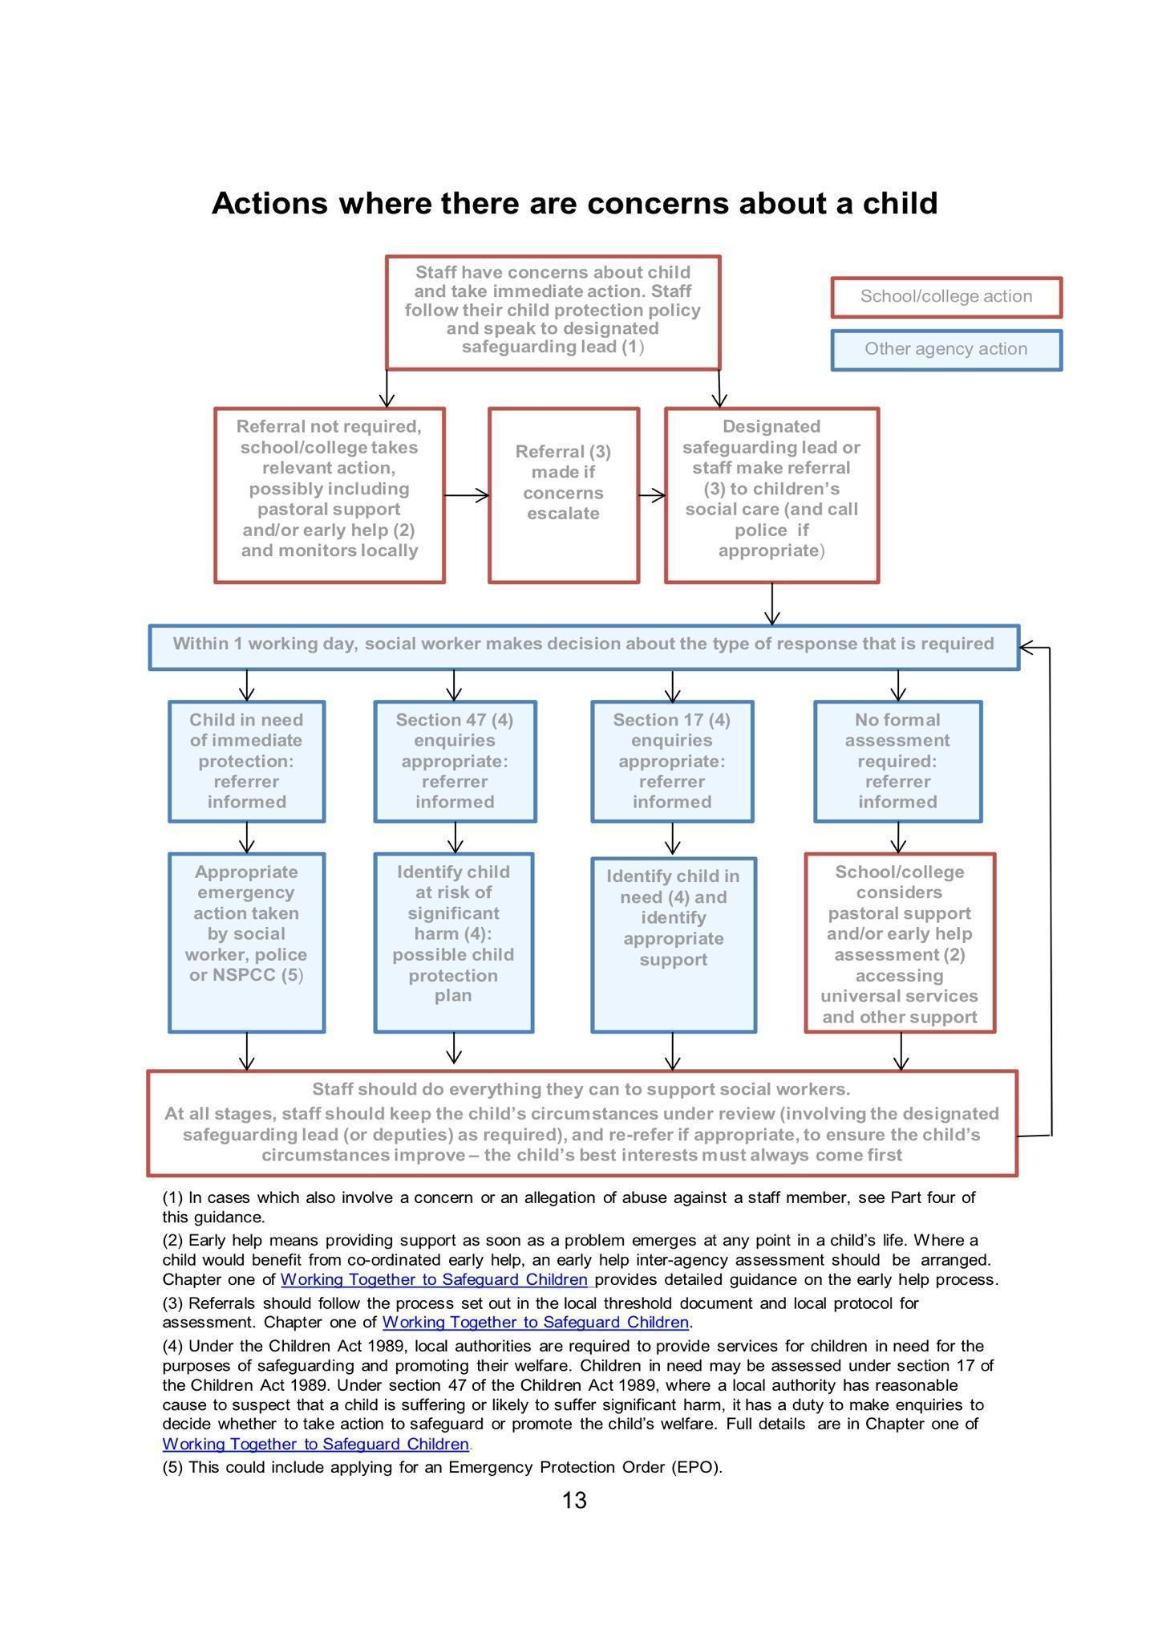

If it is decided that a referral is necessary the Safeguarding Lead will immediately refer cases of suspected abuse or allegation to the Multi-Agency Safeguarding Hub (MASH team) on tel: 0161 770 7777. A telephone referral should be followed by a written record of the referral which will be emailed to the MASH team (using the LSCB multi-agency referral form) as soon as possible and within the school day. http://www.oldham.gov.uk/lscb/info/4/referralsandassessments

If students are from out of borough then the relevant Social Services Safeguarding Team will be contacted.

8.4 Sharing information with parents
The school will always undertake to share information with parents/carers where there is an intention to refer a child to statutory services unless to do so could place the child/ young person at greater risk or harm or impede an investigation by statutory services. (See LSCB Guide to ‘Making a Child Protection Referral’)

9.0 WHAT TO DO IF A PUPIL TALKS TO YOU ABOUT ABUSE

It should be recognised that a child or young person may seek you out to share information about abuse or neglect, or talk spontaneously individually or in group when you are present. In these situations you should:
  - Listen carefully to the student; do not directly question them.
  - Allow the pupil the time to give an account; do not stop a pupil from recalling events.
  - Make an accurate record of concerns by logging into CPoms and reporting the incident.
  - Reassure the student that they were right to tell.
  - Explain that you cannot promise not to speak to others, but will only pass on the information to those who need to know.
  - Pass the concern directly to the Designated Safeguarding lead.

If, at any point, there is a risk of immediate serious harm to a child a referral should be made to children’s social care immediately. Anybody can make a referral.

10.0 RECORD KEEPING

Any members of staff receiving a disclosure of abuse or noticing signs or indicators of abuse, must make an accurate record as soon as possible noting what was said or seen, putting the event in context, and stating the date, time and location. All records of concerns or disclosures of abuse should be made by logging the cause for concern as an incident on CPoms. If it is an observation of bruising or an injury try to record detail, e.g. “right arm above elbow” Do not take photographs! Actions from the safeguarding lead will then be added.

All safeguarding records are kept confidentially, securely and chronological.

An indication of further record keeping is marked on pupil records.
If a pupil transfers from the school those files will be copied and forwarded within five working days to the pupil’s new school, marked confidential and for the attention of the receiving school’s designated safeguarding lead person, or transferred securely via CPoms, if the receiving school is using this system.

Confidentiality
The personal information about all pupils’ families is regarded by those who work in this school as confidential. All staff and volunteers need to be aware of the confidential nature of personal information and will aim to maintain this confidentiality.

11. 0 OPPORTUNITIES TO TEACH SAFEGUARDING

As part of providing a broad and balanced curriculum we teach all pupils about safeguarding. This is done through a range of subjects including PSHE, RSE and ICT. This includes teaching pupils about responsible and safe use of the internet and social media. It also includes guidance and support on developing healthy relationships. As part of developing a healthy, safer lifestyle, pupils are taught to, for example:
- safely explore their own and others’ attitudes.
- develop a trusting climate so that children feel able to talk and share their thoughts and feelings.
- recognise and manage risks in different situations and how to behave responsibly.
- judge what kind of physical contact is acceptable and unacceptable.
- recognise when pressure from others (including people they know) threatens their personal safety and well-being and develop effective ways of resisting pressure.
- including knowing when and where to get help.
- E-Safety.

12.0 TRAINING AND SUPPORT

The Head teacher and all other staff who work with children will undertake appropriate child protection awareness training to equip them to carry out their responsibilities for child protection effectively, that is kept up to date by refresher training at ‘regular’ intervals as set out in “Keeping Children Safe in Education”. All staff must read part one of Keeping Children Safe in Education

The school will ensure that the designated persons undertake refresher safeguarding training every two years to keep knowledge and skills up to date. In addition they will also keep up to date through networks and bulletins.

All staff (including governors) will receive child protection/safeguarding training when first appointed as part of their induction.

We recognise that staff working in school who may have become involved with a child who has suffered harm or appears likely to suffer harm may find the situation upsetting. We will support such staff by providing an opportunity to talk through their anxieties with the Designated Safeguarding Lead and to seek further support if required.

13 .0 ALLEGATIONS AGAINST A MEMBER OF STAFF, SUPPLY STAFF OR VOLUNTEER

There is an LSCB procedure for investigating allegations which may indicate a person would pose risk of harm if they continue to work in regular or close contact with children in any capacity in school.

If staff have safeguarding concerns, or an allegation is made about another member of staff (including supply staff and volunteers) posing a risk of harm to children, then:

• this should be referred to the head teacher;
• where there are concerns/allegations about the head teacher, this should be referred to the chair of governors,

Issues of concerns reported to the Head teacher or the Chair of Governors should contact the Local Authority Designated Officer (LADO) TEL: 0161 770 8870.
Action must be taken where it is alleged that anyone working in the school, including supply teachers and volunteers has:
• behaved in a way that has harmed a child, or may have harmed a child;
• possibly committed a criminal offence against or related to a child;
• behaved towards a child or children in a way that indicates he or she may pose a risk of harm to children; or
• behaved or may have behaved in a way that indicates they may not be suitable to work with children.

Schools as employers have a duty of care to their employees. They should ensure they provide effective support for anyone facing an allegation and provide them with a named contact if they are suspended

(Refer to section 4 of Keeping Children Safe in Education 2021 for further detailed guidance)

There are two levels of allegation/concern:
1. Allegations that may meet the harms threshold.
2. Allegation/concerns that do not meet the harms threshold – referred to as ‘low level concerns’.

Allegations concerning staff who no longer work at the school, or historical allegations will be
reported to the police. This is also applicable to supply staff and volunteers.

Allegations against supply staff
In some circumstances school will have to consider an allegation against an individual not directly employed by us, where our disciplinary procedures do not fully apply, for example, supply teachers provided by an employment agency.

Whilst school is not the employer of supply teachers and teaching assistants, we will ensure allegations are dealt with properly. School will not decide to cease to use an individual member of supply staff due to safeguarding concerns, without finding out the facts and liaising with the local authority designated officer (LADO) to determine a suitable outcome. We will discuss with the agency whether it is appropriate to suspend the supply teacher or teaching assistant, or redeploy them to another part of the school, whilst they carry out their investigation.

School should be fully involved and co-operate in any enquiries from the LADO, police and/or children’s social services. The school will usually take the lead because agencies do not have direct access to children or other school staff, so they will not be able to collect the facts when an allegation is made, nor do they have all the relevant information required by the LADO as part of the referral process. Supply teachers and teaching assistants, whilst not employed by the school, are under the supervision, direction and control of the governing body when working in the school. They should be advised to contact their trade union representative if they have one, or a colleague for support.

The allegations management meeting which is often arranged by the LADO should address issues such as information sharing, to ensure that any previous concerns or allegations known to the agency are taken into account by the school during the investigation.

When using an agency, school will inform the agency of its process for managing allegations. This includes inviting the agency’s human resource manager or equivalent to meetings and keeping themup to date with information about its policies.

14.0 SAFER WORKING PRACTICE

We understand that staff should have access to advice on the boundaries of appropriate behaviour. The document “Guidance for Safer Working Practice for Adults who work with Children and Young People” provides advice on this and circumstances which should be avoided in order to limit complaints against staff of abuse, and/or allegations of physical or sexual abuse. These matters are referred to in the School’s Safer Working Practice Policy.

This school is committed to safer recruitment and the suitability of all staff at the school. The Head teacher and Governors have undertaken approved safer recruitment training in line with statutory requirements.

School ensures that there is safe practice followed in checking the suitability of staff to work at the school. All school staff, Governors and volunteers have undertaken an enhanced DBS check. School ensures that visitors or contractors who visit the school premises are appropriately ‘risk assessed’. The identity of visitors/contractors are checked on arrival. School seeks assurances from employers that visitors/contractors have undergone a DBS check where appropriate, and for those for whom a DBS check has not been undertaken, are supervised.

If school has concerns about a member of staff (including supply staff and volunteers) suitability to work with children, school will carry out all relevant checks as if the person were a new member of staff.
School has a legal duty to refer to the DBS anyone who has harmed, or poses a risk of harm, to a child or vulnerable adult where:
- the harm test is satisfied in respect of that individual;
- the individual has received a caution or conviction for a relevant offence, or if there is reason to believe that the individual has committed a listed relevant offence;
- the individual has been removed from working (paid or unpaid) in regulated activity, or would have been removed had they not left.

Under the regulations in the Disqualification from Childcare Act 2018, schools are no longer required to establish whether a member of staff providing, or employed to work in, childcare is disqualified by association. Regulation 9 does not apply to staff in a school setting; disqualification by association is only relevant where childcare is provided in domestic settings (e.g. where childminding is provided in the home) or under registration on domestic premises. Accordingly, we will not ask staff questions about cautions or convictions of someone living or working in their household.

However in support of this amendment we will take every opportunity to create the right culture and environment so that staff feel comfortable, where it is appropriate, to discuss matters outside of work, which may have implications for the safeguarding of children in the workplace. For example through appraisal, or other staff discussions. Staff should feel able to discuss issues where their relationships and associations both within and outside of the workplace (including online) may have implications for the safeguarding of children in school. These discussions will help us to safeguard our employees’ welfare and contribute to our duty of care towards our staff. Where appropriate, it will help us to identify whether arrangements are needed to support these staff. These discussions can also help us to manage children’s safety, providing them with information that will help them consider whether there are measures that need to be put in place to safeguard children (e.g. by putting arrangements in place to stop or restrict a person coming into school where a potential risk to children has been identified). The school will always refer to the Lado where there is any cause for concern or need for further advice.

Photographing and Videoing

The school has a school photography policy statement which outlines for staff and parents the school policy with regard to the taking of photographs and digital images. Staff are only permitted to take photographs in ‘school or educational provision settings’ and may only use school approved cameras and/or media. Full parental consent is sought at the beginning of each year for their child to be photographed or videoed for school purposes, publicity and/or use on the school web site. Parents are permitted to take photographs at school events such as Nativity performances and Sports Day but are reminded of their responsibilities with regard to their safe use and circulation.

15.0 WHISTLEBLOWING
What school staff should do if they have concerns about safeguarding practices within the school.

All staff and volunteers should feel able to raise concerns about poor or unsafe practice and potential failures in the school’s safeguarding regime, and know that such concerns will be taken seriously by the senior leadership team.

Any initial concerns should be raised with the school’s senior leadership team (SLT). Where a staff member feels unable to raise an issue with the SLT or feels that their genuine concerns are not being addressed, should refer to the school’s whistleblowing policy.

The NSPCC’s what you can do to report abuse dedicated helpline is available as an alternative route for staff who do not feel able to raise concerns regarding child protection failures internally or have concerns about the way a concern is being handled by their school. Staff can call 0800 028 0285 – line is available from 8:00 AM to 8:00 PM, Monday to Friday and email: help@nspcc.org.uk.

16.0 SAFER RECRUITMENT
Our school complies with the requirements of Keeping Children Safe in Education (DfE 2021) and
Oldham Safeguarding Partnership by carrying out the required checks and verifying the applicant’s
identity, qualifications and work history. The school has adopted Oldham Council’s Staff
Recruitment policy and procedures.
- A section 128 direction will show on an enhanced DBS check with barred list information.
- Governors will have a section 128 check.
- The Teaching Regulation Agency will be used to verify any award of qualified teacher
status (QTS) and the completion of teacher induction or probation periods.
- We ensure that a candidate to be employed to carry out teaching work is not subject to a
prohibition order issued by the secretary of state, or any sanction or restriction imposed
(that remains current) by the GTCE before its abolition in March 2012.
- Individuals who have lived or worked outside the UK must undergo the same checks as all
other staff in schools. This includes obtaining (via the applicant) an enhanced DBS
certificate (including barred list information, for those who will be engaging in regulated
activity) even if the individual has never been to the UK. In addition, schools must make any
further checks we think appropriate so that any relevant events that occurred outside the
- UK can be considered. These checks could include, where available:
• criminal records checks for overseas applicants, and for teaching positions;

• obtaining a letter of professional standing from the professional regulating authority in
the country in which the applicant has worked.

- Where available, such evidence will be considered together with information obtained through other pre-appointment checks to help assess their suitability. Where this information is not available to schools we will seek alternative methods of checking suitability and or undertake a risk assessment that supports informed decision making on whether to proceed with the appointment. Although sanctions and restrictions imposed by another regulating authority do not prevent a person from taking up teaching positions in England, school will consider the circumstances that led to the restriction or sanction being imposed when considering a candidate’s suitability for employment.

- When any information about past disciplinary action or allegations is disclosed through references, it will be considered as part of the suitability assessment.

- The school maintains a single central record of recruitment checks undertaken. The Single Central Register is in paper and electronic format.

- Trainee teachers will be checked either by the school or by the training provider, from whom written confirmation will be obtained.

- The school obtains written confirmation from supply agencies or third-party organisations that agency staff or other individuals who may work in the school have been appropriately checked.

- At least one member of each recruitment panel will have attended safer recruitment training.

- We will refer to the DBS when someone is suspended or moved out of regulated activity to another post, if they meet the 'harm' criteria.

- We will record risk assessments when deciding whether to get an enhanced DBS check for any volunteer not engaging in regulated activity.

- Should our school need to place a pupil with an alternative provision provider, we will continue to be responsible for the safeguarding of that pupil, and should be satisfied that the provider meets the needs of the pupil. We will get written confirmation from the alternative provider that appropriate safeguarding checks have been carried out on individuals working at the establishment.

Volunteers
Volunteers, including governors, will undergo checks commensurate with their work in the school, their contact with pupils and the supervision provided to them. Under no circumstances will a volunteer who has not been appropriately checked be left unsupervised.

Work Experience
The school has detailed procedures to safeguard pupils undertaking work experience, including arrangements for checking people who provide placements and supervise pupils on work experience which are in accordance with the guidance in Keeping Children Safe in Education (2021).

Contractors
The school checks the identity of all contractors working on site and requests DBS with barred list checks where required by statutory guidance. Contractors who have not undergone checks will not be allowed to work unsupervised during the school day.

Site security
Visitors to the school, including contractors, are asked to sign in and are given a badge, which confirms they have permission to be on site. Parents who are simply delivering or collecting their children do not need to sign in. All visitors are expected to observe the school’s safeguarding and health and safety regulations. The headteacher will exercise professional judgement in determining whether any visitor should be escorted or supervised while on site.

Extended school and off-site arrangements
All extended and off-site activities are subject to a risk assessment to satisfy health and safety and safeguarding requirements. Where extended school activities are provided by and managed by the school, our own child protection policy and procedures apply. If other organisations provide services or activities on our site on behalf of our school we will check that they have appropriate procedures in place, including safer recruitment procedures.

When our pupils attend off-site activities, including day and residential visits, we will check that effective child protection arrangements are in place.

Use of school premises for non-school activities
Where the governing body hire out school facilities/premises to organisations or individuals (for example to community groups, uniformed organisations sports associations, and service providers to run community or extra-curricular activities) we will ensure that appropriate arrangements are in place to keep children safe.

When services or activities are provided by the governing body, under the direct supervision or management of school staff, school arrangements for child protection will apply. However, where services or activities are provided separately by another body this is not necessarily the case. The governing body will therefore seek assurance that the body concerned has appropriate safeguarding and child protection policies and procedures in place (including inspecting these as needed); and ensure that there are arrangements in place to liaise with the school on these matters where appropriate. The governing body will also ensure safeguarding requirements are included in any transfer of control agreement (i.e. lease or hire agreement), as a condition of use and occupation of the premises; and that failure to comply with this would lead to termination of the agreement.
17 .0 LINKS TO OTHER POLICIES
This policy should be read in conjunction with other related school policies and procedures:
- Anti-Bullying Policy
- Behaviour Policy, including violence and aggression
- First Aid and Medicine Policies
- Health and Safety Policy
- PSHE Policy
- Relationships Sex Education Policy
- Safer Working Practices / Code of Conduct Policy
- Single Equality Policy
- E- Safety Policy (which includes DFE guidance Teaching Online Safety June 2019)
- Confidentiality Policy
- EVC Policy
- Whistle Blowing Policy
This policy will be reviewed on an annual basis or earlier if legislation should change

18 .0 DATA PROTECTION – Managing and Storing Information

Staff should not assume a colleague or another professional will take action and share information that might be critical in keeping children safe. They should be mindful that early information sharing is vital for effective identification, assessment and allocation of appropriate service provision. Information Sharing: Advice for Practitioners Providing Safeguarding Services to Children, Young People, Parents and Carers supports staff who have to make decisions about sharing information. This advice includes the seven golden rules for sharing information and considerations with regard to the Data Protection Act 2018 and General Data Protection Regulation (GDPR). If in any doubt about sharing information, staff should speak to the designated safeguarding lead or a deputy. Fears about sharing information must not be allowed to stand in the way of the need to promote the welfare, and protect the safety, of children. However, in a situation where a child is in a refuge, this could mean that schools can withhold education data under the GDPR, where the serious harm test is satisfied. (See ICO).

The procedures and practice created by this policy have been reviewed in the light of our Data Protection Policy.

All documents stored are in accordance with legal requirements where appropriate, and guidance from the Records Management Toolkit for Schools.

a) All safeguarding records are kept confidentially and securely on CPoms
b) If a pupil transfers from the school those files will be copied and forwarded within five working days to the pupil’s new school marked confidential and for the attention of the receiving school’s designated safeguarding lead person or sent securely via CPoms
c) All safeguarding records for pupils will be retained for DoB +25 years and then securely disposed (documents must be deleted)
d) Any allegations against staff will be retained until the staff member retires or 10 years from the allegation. Any malicious allegations must be removed. All documents should be securely disposed (documents must be shredded)

Reference should be made to each related policies for specific details on how information is managed and store in this area.

This policy:

Has Few / No Data Compliance Requirements | Has A Moderate Level of Data Compliance Requirements | Has a High Level Of Data Compliance Requirements
 |  | ✔

Appendix 1

Child’s name, age & DOB
Police Reference Number |  | Date:
Date and time of incident

Address of incident
Circumstances of incident

Additional school information including other Operation Encompass calls

Actions taken and Impact

https://www.nspcc.org.uk/preventing-abuse/child-abuse-and-neglect/domestic-abuse/signs-symptoms-effects/
http://www.refuge.org.uk/get-help-now/what-is-domestic-violence/effects-of-domestic-violence-on-children/
http://www.safelives.org.uk/knowledge-hub/spotlights/spotlight-3-young-people-and-domestic-abuse
CHILD PROTECTION RECORD – Report of a Concern

Date of record:
Date of incident:

Name of referrer: |  | Role of referrer:
Child name: |  | Year Group / class:
Details of concern: | - use body map if appropriate (with advice of Designated Lead)  - use initials for other children / young people involved, unless there is a specific need to name them in full  - contemporaneous notes, if taken, may be attached to this form
Reported to: |  | Role of person reported to:
Signed:

Action taken: |  | Advice sought:  (from whom and what was advice given)
Concern / referral discussed with parent / carer? |  | If not, state reasons why – if yes, note discussion with parent
Referral made: |  | If not, state reasons why – if yes, record to whom and any action agreed
Feedback to referring member of staff: |  |  | By whom
Response to / action taken with pupil: |  |  | By whom
Name and contact number of key workers:

Name and contact details of GP:

Other notes / information / concerns:

Any other action required:

Appendix 2

Definitions and signs of Abuse

(Extracts from Department Of Education publication ‘what to do if you’re worried a child is being abused: advice for practitioners’ March 2015)

There are a number of warning indicators which might suggest that a child may be being abused or neglected.

Some of the following signs might be indicators of abuse or neglect:

- Children whose behaviour changes – they may become aggressive, challenging, disruptive, withdrawn or clingy, or they might have difficulty sleeping or start wetting the bed;
- Children with clothes which are ill-fitting and/or dirty;
- Children with consistently poor hygiene;
- Children who make strong efforts to avoid specific family members or friends, without an obvious reason;
- Children who don’t want to change clothes in front of others or participate in physical activities;
- Children who are having problems at school, for example, a sudden lack of concentration and learning or they appear to be tired and hungry;
- Children who talk about being left home alone, with inappropriate carers or with strangers;
- Children who reach developmental milestones, such as learning to speak or walk, late, with no medical reason;
- Children who are regularly missing from school or education;
- Children who are reluctant to go home after school;
- Children with poor school attendance and punctuality, or who are consistently late being picked up;
- Parents who are dismissive and non-responsive to practitioners’ concerns;
- Parents who collect their children from school when drunk, or under the influence of drugs;
- Children who drink alcohol regularly from an early age;
- Children who are concerned for younger siblings without explaining why;
- Children who talk about running away; and
- Children who shy away from being touched or flinch at sudden movements.

Physical abuse is deliberately physically hurting a child. It might take a variety of different forms, including hitting, pinching, shaking, throwing, poisoning, burning or scalding, drowning or suffocating a child.

Physical abuse can happen in any family, but children may be more at risk if their parents have problems with drugs, alcohol and mental health or if they live in a home where domestic abuse happens. Babies and disabled children also have a higher risk of suffering physical abuse.
Physical harm may also be caused when a parent or carer fabricates the symptoms of, or deliberately induces, illness in a child. Physical abuse can also occur outside of the family environment.

Some of the following signs may be indicators of physical abuse:
- children with frequent injuries;
- children with unexplained or unusual fractures or broken bones; and
- children with unexplained:
  - bruises or cuts;
  - burns or scalds; or
  - bite marks.

Emotional abuse is the persistent emotional maltreatment of a child. It is also sometimes called psychological abuse and it can have severe and persistent adverse effects on a child’s emotional development.
Although the effects of emotional abuse might take a long time to be recognisable, practitioners will be in a position to observe it, for example, in the way that a parent interacts with their child. Emotional abuse may involve deliberately telling a child that they are worthless, or unloved and inadequate. It may include not giving a child opportunities to express their views, deliberately silencing them or ‘making fun’ of what they say or how they communicate.
Emotional abuse may involve serious bullying – including online bullying through social networks, online games or mobile phones – by a child’s peers.

Some of the following signs may be indicators of emotional abuse:
- Children who are excessively withdrawn, fearful, or anxious about doing something wrong;
- Parents or carers who withdraw their attention from their child, giving the child the ‘cold shoulder’;
- Parents or carers blaming their problems on their child; and
- Parents or carers who humiliate their child, for example, by name-calling or making negative comparisons.

Sexual abuse is any sexual activity with a child. You should be aware that many children and young people who are victims of sexual abuse do not recognise themselves as such. A child may not understand what is happening and may not even understand that it is wrong. Sexual abuse can have a long-term impact on mental health.
Sexual abuse may involve physical contact, including assault by penetration (for example, rape or oral sex) or non-penetrative acts such as masturbation, kissing, rubbing and touching outside clothing. It may include non-contact activities, such as involving children in the production of sexual images, forcing children to look at sexual images or watch sexual activities, encouraging children to behave in sexually inappropriate ways or grooming a child in preparation for abuse (including via the internet). Sexual abuse is not solely perpetrated by adult males. Women can commit acts of sexual abuse, as can other children.

Some of the following signs may be indicators of sexual abuse:
- Children who display knowledge or interest in sexual acts inappropriate to their age;
- Children who use sexual language or have sexual knowledge that you wouldn’t expect them to have;
- Children who ask others to behave sexually or play sexual games; and
- Children with physical sexual health problems, including soreness in the genital and anal areas, sexually transmitted infections or underage pregnancy

Child sexual exploitation is a form of sexual abuse where children are sexually exploited for money, power or status. It can involve violent, humiliating and degrading sexual assaults. In some cases, young people are persuaded or forced into exchanging sexual activity for money, drugs, gifts, affection or status. Consent cannot be given, even where a child may believe they are voluntarily engaging in sexual activity with the person who is exploiting them. Child sexual exploitation doesn't always involve physical contact and can happen online. A significant number of children who are victims of sexual exploitation go missing from home, care and education at some point.

Some of the following signs may be indicators of sexual exploitation:
- Children who appear with unexplained gifts or new possessions;
- Children who associate with other young people involved in exploitation;
- Children who have older boyfriends or girlfriends;
- Children who suffer from sexually transmitted infections or become pregnant;
- Children who suffer from changes in emotional well-being;
- Children who misuse drugs and alcohol;
- Children who go missing for periods of time or regularly come home late; and
- Children who regularly miss school or education or don’t take part in education

Neglect is a pattern of failing to provide for a child’s basic needs, whether it be adequate food, clothing, hygiene, supervision or shelter. It is likely to result in the serious impairment of a child’s health or development.
Children who are neglected often also suffer from other types of abuse. It is important that practitioners remain alert and do not miss opportunities to take timely action. However, while you may be concerned about a child, neglect is not always straightforward to identify.
Neglect may occur if a parent becomes physically or mentally unable to care for a child. A parent may also have an addiction to alcohol or drugs, which could impair their ability to keep a child safe or result in them prioritising buying drugs, or alcohol, over food, clothing or warmth for the child. Neglect may occur during pregnancy as a result of maternal drug or alcohol abuse.

Some of the following signs may be indicators of neglect:
• Children who are living in a home that is indisputably dirty or unsafe;
• Children who are left hungry or dirty;
• Children who are left without adequate clothing, e.g. not having a winter coat;
• Children who are living in dangerous conditions, i.e. around drugs, alcohol or violence;
• Children who are often angry, aggressive or self-harm;
• Children who fail to receive basic health care; and
• Parents who fail to seek medical treatment when their children are ill or are injured.

Appendix 3
https://www.gov.uk/government/uploads/system/uploads/attachment_data/file/380125/MultiAgencyPracticeGuidelinesNov14.pdf
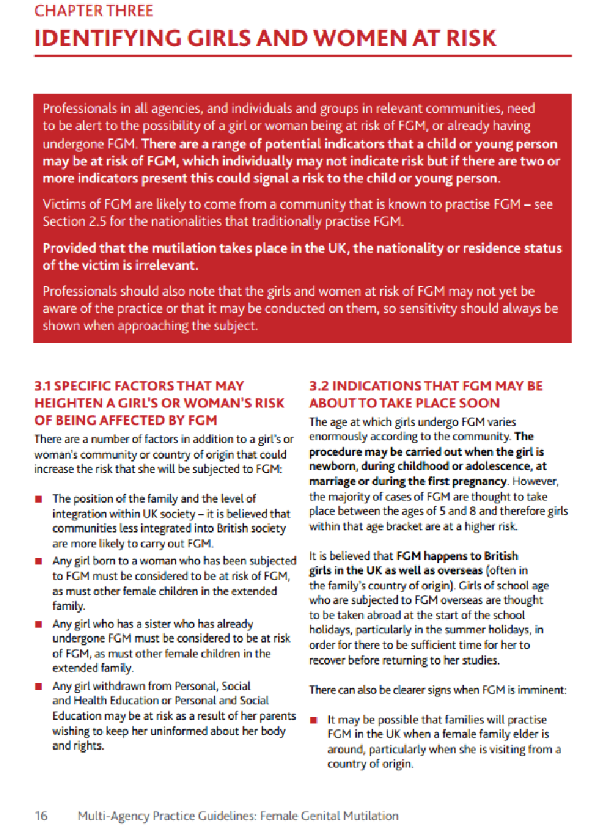

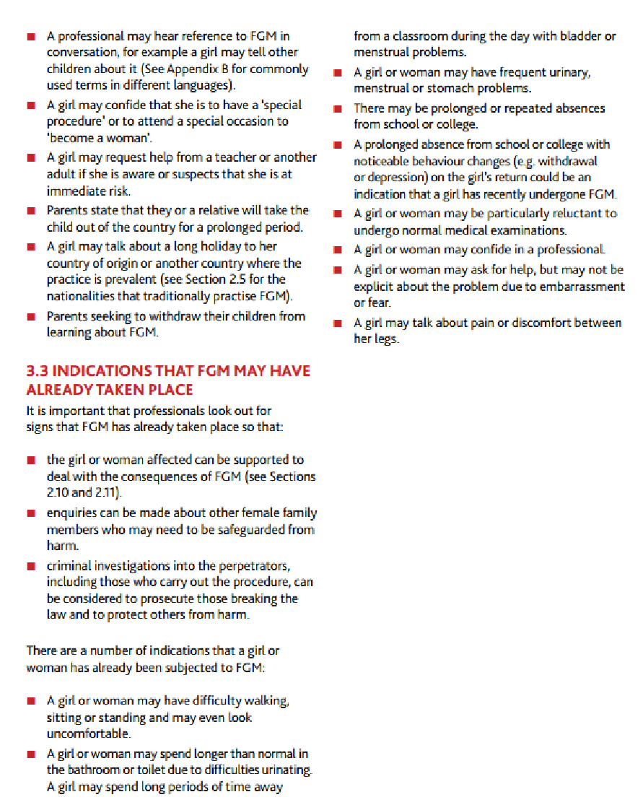

Appendix 4

Additional Information about Child Sexual Exploitation

Child Sexual Exploitation Warning signs that all staff and students should be mindful of:-
We know that different forms of harm often overlap, and that perpetrators may subject
children and young people to multiple forms of abuse, such as criminal exploitation (including county lines) and sexual exploitation.

In some cases the exploitation or abuse will be in exchange for something the victim needs or wants (for example, money, gifts or affection), and/or will be to the financial benefit or other advantage, such as increased status, of the perpetrator or facilitator.

Children can be exploited by adult males or females, as individuals or in groups. They
may also be exploited by other children, who themselves may be experiencing
exploitation – where this is the case, it is important that the child perpetrator is also
recognised as a victim.

Whilst the age of the child may be a contributing factor for an imbalance of power, there
are a range of other factors that could make a child more vulnerable to exploitation,
including, sexual identity, cognitive ability, learning difficulties, communication ability, physical strength, status, and access to economic or other resources.

Some of the following can be indicators of both child criminal and sexual exploitation
where children:
• appear with unexplained gifts, money or new possessions;
• associate with other children involved in exploitation;
• suffer from changes in emotional well-being;
• misuse drugs and alcohol;
• go missing for periods of time or regularly come home late; and
• regularly miss school or education or do not take part in education.

Children who have been exploited will need additional support to help maintain them in education.

CSE can be a one-off occurrence or a series of incidents over time and range from opportunistic to complex organised abuse. It can involve force and/or enticement-based
methods of compliance and may, or may not, be accompanied by violence or threats of violence.

Some additional specific indicators that may be present in CSE are children who:
• have older boyfriends or girlfriends; and
• suffer from sexually transmitted infections, display sexual behaviours beyond
expected sexual development or become pregnant.

Further information on signs of a child’s involvement in sexual exploitation is available in
Home Office guidance: Child sexual exploitation: guide for practitioners

Additional Advice and Information
Trafficking: safeguarding children - DfE and HO guidance

https://www.gov.uk/government/publications/safeguarding-children-who-may-have-been-trafficked-practice-guidance

Appendix 5

Supporting mental health, where there is a safeguarding concern

https://assets.publishing.service.gov.uk/government/uploads/system/uploads/attachment_data/file/623895/Preventing_and_tackling_bullying_advice.pdf

https://www.gov.uk/government/publications/mental-health-and-behaviour-in-schools--2

https://www.gov.uk/government/publications/promoting-children-and-young-peoples-emotional-health-and-wellbeing

https://campaignresources.phe.gov.uk/schools/topics/mental-wellbeing/overview

The harm test is explained further on the Disclosure and Barring service website on https://www.gov.uk/guidance/making-barring-referrals-to-the-dbs

