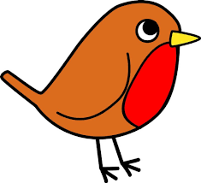Group: Robins
The Robins now have 10 words to learn each week. Most words will follow a pattern, and there will still be some of our Year 1 common exception words too. Y1 common exception words on weekly tests have now finished
Week 1 | Year 1 Spelling Practice  Summer Term: w/b 25.4.22 |  |  |  |  | Spelling Pattern: -es  Test: Friday 29.4.22
 | Look | Say | Cover | Write | Check |  | Write | Check | Write | Check
 | e x a m p l e |  |  | e x a m p e l | × |  | e x a m p l e |  | e x a m p l e
1 | buses
2 | foxes
3 | dishes
4 | wishes
5 | bushes
6 | crashes
7 | flashes
8 | misses
9 | classes
10 | glasses

Here’s how your child went on in their test: Green = correct Pink = incorrect * = letter reversal
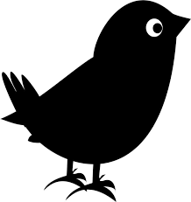Group: Blackbirds
The Blackbirds now have 8 words to learn each week. Most words will follow a pattern, and there will still be some of our Year 1 common exception words too. Words marked like * this * are our Y1 common exception words.
*** PLEASE RETURN RED FILE EACH FRIDAY – THANKS! ***

Week 1 | Year 1 Spelling Practice  Summer Term: w/b 25.4.22 |  |  |  |  | Spelling Pattern: a_e (split digraph)  Test: Friday 29.4.22
 | Look | Say | Cover | Write | Check |  | Write | Check | Write | Check
 | e x a m p l e |  |  | e x a m p e l | × |  | e x a m p l e |  | e x a m p l e
1 | came
2 | make
3 | shake
4 | awake
5 | plane
6 | brave
7 | grapes
8 | * school *

Here’s how your child went on in their test: Green = correct Pink = incorrect * = letter reversal
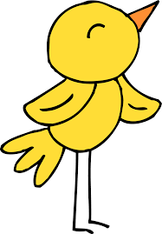 Group: Canaries
The Canaries now have 7 words to learn each week. Most words will follow a pattern, and there will be some of our Year 1 common exception words too. Words marked like * this * are our Y1 common exception words.
*** PLEASE RETURN RED FILE EACH FRIDAY – THANKS! ***

Week 1 | Year 1 Spelling Practice  Summer Term: w/b 25.4.22 |  |  |  |  | Spelling Pattern: or  Test: Friday 29.4.22
 | Look | Say | Cover | Write | Check |  | Write | Check | Write | Check
 | e x a m p l e |  |  | e x a m p e l | × |  | e x a m p l e |  | e x a m p l e
1 | c or n
2 | b or n
3 | f or k
4 | sh or t
5 | t or ch
6 | * says *
7 | * today *

Here’s how your child went on in their test: Green = correct Pink = incorrect * = letter reversal

