

Buckstones Community Primary School

Policy for Healthy Eating

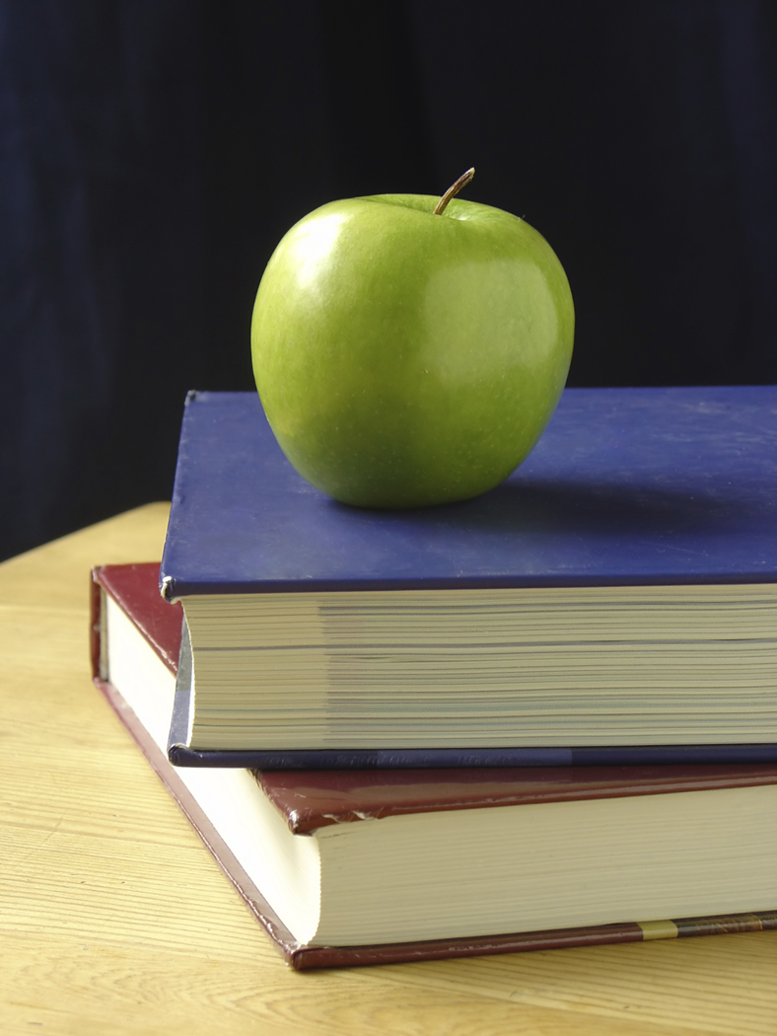

Buckstones Community Primary School

Introduction
We believe that healthy eating and healthy attitudes to food are vital to the physical and mental wellbeing of both our children and the adults at Buckstones. For this reason, we believe food education has a key role in our curriculum and the daily life of the school.

What are the aims of this policy?
- To make explicit the values and guidelines that underpin every aspect of food culture in Buckstones Primary school.
- To ensure that our children receive consistent and coherent messages about food and its role in their long-term health.

Why a policy is needed?
We recognise the important part a healthy diet plays for a child’s wellbeing and their ability to learn effectively and achieve.

We believe that the school, in partnership with parents and carers, can make a major contribution to improving children and young people’s health by increasing their knowledge and understanding of food and helping them to make healthy food choices.

What are the values that inform this policy?
- We believe that every adult at Buckstones can play a part in making sure that the children develop positive attitudes to food, make informed choices and enjoy eating healthily.
- We want the children to understand that good, nutritious food is essential to their ability to learn as well as to their long-term health.
- We want the children to apply their knowledge about food and make healthy choices both in and out of school.
- We want the children to enjoy cooking and learn certain core skills by the time they leave the school.
- We believe that food has a role in developing young people’s social skills.

Definition of Healthy Eating/Nutrition
A healthy diet is one which allows for a balance of different foods that sustain the wellbeing of the individual. Different lifestyles result in different dietary needs and individuals need to be aware of these and the effects of different foods on their bodies. A healthy, balanced diet may vary between individuals from different cultural, ethnic and social backgrounds.

Curriculum
Healthy Eating is explicitly addressed within the Science, PSHE, PE and D&T curriculum.
Each curriculum subject will be developing a range of skills and understanding that will contribute towards these areas.
There are also opportunities for cross curricular coverage of healthy lifestyles.

Fluid/Hydration
- Children have access to free and fresh water throughout the school day.
- Children are encouraged to bring their own water bottles into their classrooms and are allowed to drink water whenever they feel thirsty.
- Children who eat hot lunch have jugs of fresh water on their tables.
- Children are encouraged to drink water during the day as children are able to concentrate better if they are having the recommended fluid intake per day.
- Fizzy drinks are not allowed to be consumed in school and fruit drinks etc are only permitted to be taken at lunchtime. These drinks are not allowed during break times or at any other time of the school day.

Food throughout the school day/year:
- We ask that no foods containing nuts etc. are brought into the school in order to protect children with allergies.
- Sweets should not be used as a reward by adults working in the school, or as a treat to give out on birthdays.
- Special events such as Christmas parties are times when food contributes to a sense of celebration. On these occasions foods other than fruit and vegetables may be offered, but staff will remind children that it is an occasional treat for a special occasion.

Before and After School
- We discourage parents from providing children with sweets, chocolates and fizzy drinks on the school premises.

Breakfast
- We recognise the importance of eating a balanced breakfast and realise that it is hard to concentrate on learning and maintain energy levels without breakfast.
- We do not have a breakfast club at present.

Break Time
- Children in Key Stage One benefit from the National School Fruit Scheme – this entitles them to one free piece of fruit or vegetable a day.
- Only fresh fruit or vegetable snacks are allowed at break times for Key Stage 2 children.

Lunch Time – hot lunch in the dinner hall
- We provide our children with good quality, healthy food and we actively promote healthy choices.
- We recognise the importance of eating a hot lunch and hope that more children who take packed lunch will choose to switch to a hot lunch.
- The daily menu is on display for the children and parents in the kitchen window.
- We listen to the children’s opinions on the menu and adapt the menu accordingly.
- We now allow parents to choose the meal with their child at home.

Lunch Time – packed lunches
- Our caterers provide packed lunches for school trips in accordance with their own healthy eating policy.
- Below is the guidance we display to all parents for packed lunches.

What to bring in your packed lunch

For a balanced packed lunch select these healthier foods and drinks

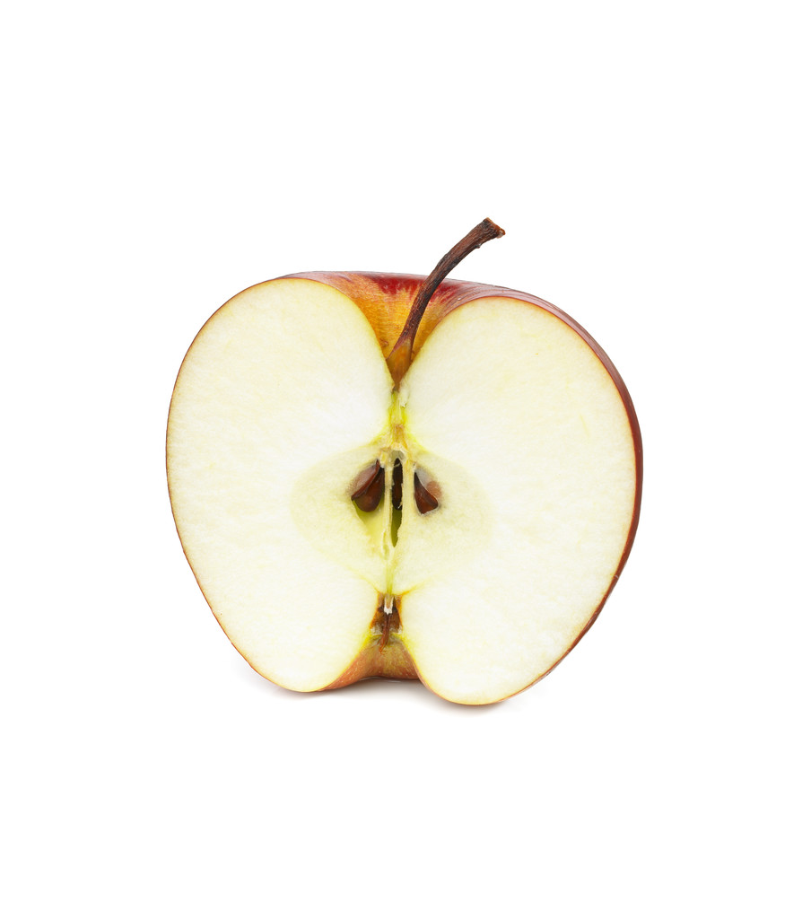Fruit and vegetables- include at least one portion of fruit and one portion of vegetables or salad every day.
Meat, fish or another source of non-dairy (e.g. lentils, kidney beans, and hummus) protein should be included every day.

A starchy food such as any type of bread or pasta, rice, couscous, noodles, potatoes or other cereals, should be included every day.

Include dairy food such as milk, cheese, yoghurt, fromage frais or custard every day.

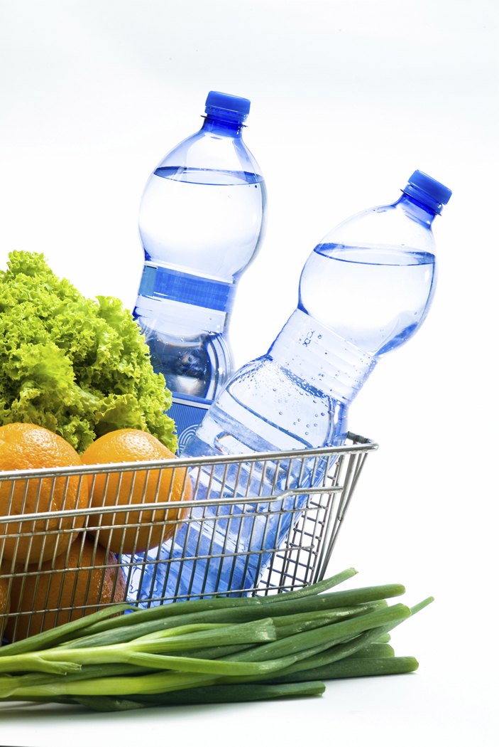Include only still fruit juices, water, milk or smoothies to drink.

_____________________________________________________________

Snacks such as crisps are allowed but healthier snacks could include savoury breadsticks, popcorn or crackers.

Confectionery such as chocolate bars (e.g. Twix, chocolate buttons, magic stars etc.) and sweets are not allowed. Cakes and biscuits are allowed but only as a part of a balanced diet.

Lunch Time – the dinner hall environment
- We aim to make sure children have time to eat their lunch and do not need to rush.
- Lunchtime Monitors work in the dinner hall each lunchtime and play an important role in improving the dinner hall environment. They help the adults to keep it clean, promote good manners and conversation and support children in making healthy choices with their food. Sweets, chocolate etc will be sent home if they are sent in the children’s packed lunch.
- We reward good behaviour with stickers, certificates and the Captain’s table.

Food in the Curriculum
- We exploit opportunities within the existing curriculum to discuss and work with food.
- We recognise that food has great potential for cross-curricular work.
- Staff receive training to make sure they are confident when working with food and their class.
- Formal food education is delivered via the Design and Technology curriculum (see scheme of work and policy). There are also topics in the PSHE and Science curriculum.

Gardening Club
- Meets regularly

Links to other policies
- This policy has links to the behaviour, PSHE, Equal Opportunities and Design and Technology policies.

