Buckstones Community Primary School

Policy for Phonics
(2022)

Written and agreed by staff: 24.7.22
Adopted by Governors: 24.1.23

Reading is fundamental to education. Proficiency in reading, writing and spoken language is vital for pupils’ success. Through these, they develop communication skills for education and for working with others: in school, in training and at work.

The reading framework Teaching the foundations of literacy January 2022

1. INTENT
At Buckstones Primary School we are committed to the delivery of excellence in the teaching of Phonics. We aim to develop each child so that they are able to read with fluency and confidence in any subject, as well as develop a love of reading that will stay with our children all their lives.
Being able to read is the most important skill children will learn during their early schooling and has far-reaching implications for lifelong confidence and well-being.
The use of phonics is one of the many skills needed to be able to be a reader and writer. We aim to teach high quality phonics to ensure the children have the best start possible in reading and writing. The learning of phonics is the beginning of children’s body of knowledge, skills and understanding that are an essential part of learning to read.
In order to read and understand texts, children must learn to recognise/decode the words on the page. Good quality phonics teaching allows the child to be secure in the skills of word recognition and decoding which allows children to read fluently. This will result in children being able to read for pleasure and will allow them to move onto developing higher order reading for meaning skills. These phonic skills need to be taught systematically and involve a variety of resources.
We believe that our children are entitled to a Phonics curriculum which enables them:
to gain a progressively deeper understanding of the phonetic structure of the English language.
to apply their phonic knowledge and skills to decode unfamiliar words fluently and accurately.
to read rapidly to apply what they have learned across the whole curriculum.
to become fluent readers, confident speakers and willing writers.
to develop a life-long love of reading.

2. IMPLEMENTATION
We have chosen to use the Twinkl Systematic Synthetic phonics scheme (SSP). We did so because we believe that phonics teaching should be:
• systematic
• discrete
• interactive
• engaging.
In line with the School’s policy and commitment to excellence in Phonics, each class in Reception and KS1 will teach phonics as a discrete lesson every day so the children can make use of their phonics skills in lessons across the curriculum.
The structure of each lesson at Buckstones and the journey of Phonics across the week enables all aspects of the blending and segmenting of phonemes/graphemes; lessons are carefully planned and to meet the needs of our learners. We provide experiences and opportunities to motivate the child, using a range of resources to engage individuals and groups of children.
Reading is given a high priority at Buckstones. Time is set aside for children in EYFS and Key Stage 1 to have a daily story time session, whilst children in Year 2 upwards have quiet reading time set aside each day. We have a whole-school reading incentive scheme in order to encourage children to read widely at home. However, for those children who do not read at home, we endeavour to hear them read as often as possible in school so that they do not fall behind.
We believe that positive home-school links are essential if children are to reach their full potential in reading and phonics. It is for this reason that parents are actively encouraged to read with their child, even into Key Stage 2. In EYFS and Year1, we hold a number of meetings for parents regarding the importance of reading and phonics, and when we hold our parental information meetings each September, reading is given a high priority.

3. IMPACT

Through the teaching of systematic phonics, our aim is for children to become fluent readers by the end of Key Stage One.
- Children enjoy and have confidence in their phonics learning. They will transfer these skills to support their reading for pleasure and writing.
- Children know more, remember more and understand more about Phonics, demonstrating this knowledge in all areas of the curriculum involving reading and writing.
- The large majority of children will achieve age related expectations in Phonics and this will be assessed through EYFS data and the Phonics Screening Check at the end of Year 1.
- Parents have a clear understanding of how phonics is taught throughout the school and the impact it is having on their children. They will also understand how to further support their children with this learning at home.
- Using Twinkl Phonics (our chosen SSP), staff teaching phonics consistently use the correct vocabulary, lesson structure and teaching techniques to ensure all children’s needs are being met in a fair and consistent way.

Phonics in School
1. Teaching and Learning
Our children are provided with a variety of opportunities to develop and extend their phonics skills in and across Reception and Key Stage One. It will also be continued into Key Stage Two, where necessary, to support those children who do not yet have the phonic knowledge and skills they need.
Discrete phonics lessons take place daily across Reception and Key Stage One. They follow the cycle of ‘Assess, Teach, Practise, Apply’ to ensure that children are consolidating phonic knowledge and skills over time and that they are able to apply them in context. Consequently, wherever possible, links between phonics knowledge and understanding are made to learning in both Reading and Writing.
New phonemes will be taught using the correct articulation and terminology and all children will use this terminology in their learning. e.g, phonemes, digraphs, trigraphs, splitdigraph etc.
These learning opportunities enable the children to develop their skills in aural discrimination and phonemic and rhyme awareness, blending and segmenting as well as grapheme-phoneme correspondence. Lessons follow the structure below and proceed at pace:

- Revisit and review
- Teach
- Practise
- Apply
- Consolidate
See Appendix 1 (Overview of Phonics Progression, including age-related expectations).

2. Planning
The school follows the systematic approach laid out in the Twinkl Phonics programme, which has been approved by the government. Our weekly phonics planning ensures progression and effective, high-quality teaching.

3. The Skills of Blending and Segmenting
When learning to read, children are taught four key skills:
• grapheme‒phoneme correspondences (that is, the alphabetic code) in a clearly defined, incremental sequence
• to synthesise (blend) phonemes (sounds) in order all through a word to read it
• to segment words into their constituent phonemes for spelling
• that blending and segmenting are reversible processes.
Our aim is to introduce the terms blending and segmenting to the children. Blending and segmenting are, ‘reversible processes’: that is, if you can blend the sounds together to read a word, you should also be able to identify and break down (segment) the individual sounds in a word you hear to spell it. To spell the word, you need to represent each sound you hear by a letter – or more than one letter.
The skill of blending sounds together needs to be taught directly. Children may be able to say the sound a letter ‘makes’ when shown the letter (for instance, on a flashcard), but this does not necessarily mean that they can blend individual sounds together to make a whole word. (Letters do not actually ‘make’ sounds: they are just a way of representing that sound in writing.)
In segmenting to spell a word, the teacher or the child is listening to a whole word, identifying the individual sounds (not letters) that make up the word choosing a letter or more than one letter to represent each individual sound.

4. Correct Articulation
Correct articulation is vital in helping children to learn to blend sounds together. We make sure that the sound produced (each individual phoneme) is as precise and accurate as possible and that no additional sounds are added. The importance of this is something that is shared with parents.
For instance, the sound /m/ that starts ‘mummy’ or is embedded in ‘impress’ needs to sound /mmmm/ and not /muh/. The clearer the sound, the easier it is for a child to blend together (synthesise) the individual sounds to read a word because there are no unnecessary sounds getting in the way.

5. Common Exception Words
Children will be taught to read and spell common exception words i.e. words that are not completely phonically regular. Children in Years 1 and 2 have a list of common exception words that they are expected to be able to read and spell before the end of their respective years; these are on display in the respective classrooms as we believe that it is important for the children to be able read these words on sight.
Many of the Year 1 and 2 common exception words are taught through our SSP, in addition to other common exception words at each level. Children also have the opportunity to practise their respective common exception words in Years 1 and 2 through weekly spelling tests. In terms of spelling, children are encouraged to focus on the ‘tricky’ parts of a word i.e. the letters that do not match the usual grapheme-phoneme correspondences they have learnt.

Reading in School
We use the Oxford Reading Tree reading scheme in school, which we have found provides the structure that children need when learning to read. A comprehensive audit of books has been carried out in order to ensure that the books our children use when learning to read are fully decodable.
Whilst learning to read, our children are given fully decodable books (green stickers), which tie in with the children’s phonics knowledge so far. In addition to these, we also have some books which are mostly decodable (yellow stickers) – these are designed to be shared with a grown up.
We recognise from experience that some of our children are reading at a level which is beyond the level of phonics that they are working on in class; we do not believe in holding them back, so these children will continue to read books which provide more of a challenge.

Assessment
Assessment is regarded as an integral part of teaching and learning and is a continuous process. We strive to make our assessment purposeful, allowing us to match the correct level of work to the needs of the pupils, thus benefiting the pupils and ensuring progress.
Staff keep track of the progress made by the children in their class, Each class (Reception to Year 2) uses a whole-class phonics tracker, which is updated half-termly; this continues to be updated as the child moves through school. This enables us to put into place interventions where we can see that children are falling behind.
In addition to the assessing the phonics attainment and progress of our children using the tracking system outlined above, it is also assessed through Reading and Writing assessments.
At the end of Year 1, children participate in the phonics screening check.
- This assesses their knowledge of grapheme-phoneme correspondence and their skills in blending.
- Those children who do not succeed in the phonics screening check are highlighted for further intervention and targeted support before completing the screening check again at the end of Year 2.
- For children who do not succeed a second time, provision is made for them to receive intervention and targeted support in Key Stage 2.
- Results are submitted to the LA.

Feedback
- Children are provided with constructive and timely feedback in lessons.
- Teachers provide parents with feedback on their child’s progress and achievement at parents’ evening and through the end of year report.
- Feedback regarding children’s reading is also given through their reading journals. We actively encourage parents to hear their child read as often as possible and to share their home reading feedback with us.
- Assessment information is also passed onto the next teacher as part of transition between year groups and phases.

Roles and responsibilities
Our phonics lead is also our Year 1 teacher and Deputy Head; she works alongside her phonics buddy (our EYFS lead).
Our phonics lead is responsible for the organisation of Phonics in school. Responsibilities include:
- Ensuring continuity and progression from year group to year group and the transition from each phase.
- Advising and supporting colleagues in the implementation and assessment of phonics in their phase of the school.
- Providing members of staff with guidelines regarding the importance of phonics
- Assisting with the requisition and maintenance of resources required for the teaching of phonics, within the confines of the school budget
- Monitoring the quality of teaching and learning in phonics across the phase of the school.
- Keeping up-to-date with phonics updates – both at a national level but also updates regarding our SSP.
Class teachers are responsible for:
- Ensuring children make progress with their acquisition of phonic knowledge and skills with due regard to the National Curriculum for English and the non-negotiables for each phase.
- Attending training as appropriate in order to develop and update their skills, knowledge and understanding of phonics .
- Identifying needs in children’s phonics learning, and adapting their planning to suit the needs of all children.
- Keeping appropriate on-going records
- Planning effectively for phonics using the Twinkl phonics Scheme, liaising with phonics lead when necessary.
- Informing pupils and parents of their progress, achievements and attainment in phonics.
Role of adults in class (including TAs):
- Feedback will be given throughout the lesson to individuals in order to move their learning forwards. Children will be given additional support or extensions where necessary.
- Other adults will model and demonstrate new learning with groups/individual children.
- Staff will use a variety of questioning techniques when asking the children to demonstrate their phonics knowledge e.g. by reading and spelling new or familiar words.

Inclusion
Literacy is as important for children with SEND as their peers, and for this reason, teachers should be ambitious about their progress as it is a critical skill in preparing them for adulthood. Consensus (between academics and teachers) is that the best method to begin phonics for children with SEND is a systematic synthetic phonics programme. All children have equal access to a daily phonics session. We will ensure that phonics is accessible to pupils by:

• Setting suitable learning objectives and success criteria.
• Responding to the variety of learning styles.
• Highlighting potential barriers to learning so that children can reach their full potential.
Throughout school, pupil performance across the curriculum is monitored to ensure that there is no disparity between groups. Our phonics trackers are a useful tool when tracking phonics progress.
Interventions: Children who still need extra support to develop their phonic knowledge across the EYFS, Key Stages 1 and 2 are identified and targeted for intervention using the Twinkl Phonics Scheme. Once a child’s needs have been assessed, we then take the most appropriate route forward.

This policy will be reviewed every two years.

Appendix 1: Overview of Phonics Progression at Buckstones
 | Autumn |  |  |  | Spring | Summer
Reception | Level 1 | Level 2 |  |  | Consolidate L2 | Level 3 | Level 4
 |  |  |  |  | Level 3
Year 1 | Consolidate L3 / L4 |  |  | Level 5
Year 2 | Consolidate L5 |  | Level 6

Age-related expectations for the end of the school year:
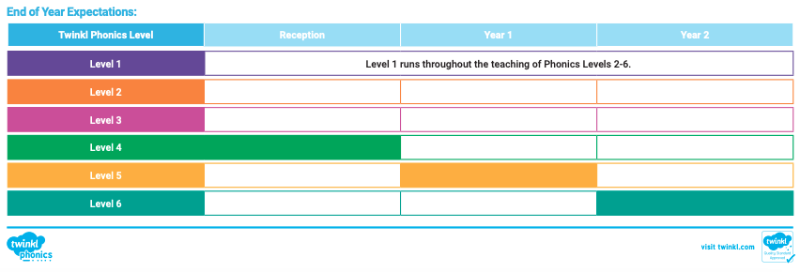

EYFS
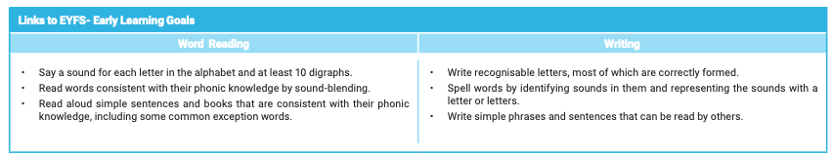

YEAR 1
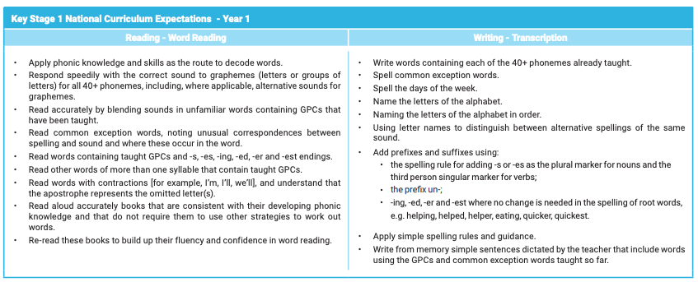

YEAR 2
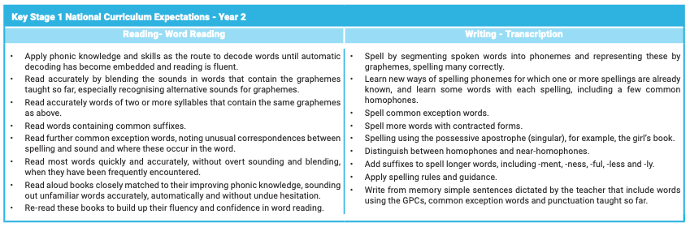

It is also expected that
By the end of Year 1, children begin to use correct letter names, ready for Year 2.
By the end of Year 2, children use the correct letter names when spelling words.

Appendix 2 - Twinkl Phonics Pilot Scheme
We have opted to be part of the Twinkl Phonics pilot scheme (academic year 2022-23) since we aim for our phonics teaching to be the best that it can be.
Twinkl Phonics will provide us with:
● our own dedicated Twinkl specialist that we can contact directly
● a minimum of four check ins throughout the year from our specialist, in order to support us on our journey.
What we have to provide:
Data – half-termly data on the progression of the children in school
Feedback – we answer a variety of questions around Twinkl Phonics and how you are using it in our setting.
Phonics Screening Results – comparative data from this year and last year’s phonics screening checks.

Appendix 3 - Phonics Terminology for Parents

As parents, it's important to make sure that we understand the key terms in phonics so that we can carry on the good work our child has done at school at home!
1 Blend: this is when you say the individual sounds that make up a word and then merge or blend them together to say the word as used when reading.
A blend is when consonants are put together (adjacent consonants) e,g, bl, cr, lf, xt, str
2 Consonant: most letters of the alphabet are consonants, except for the vowels: a,e,i,o,u.
3 CVC Words: this is an abbreviation used for consonant-vowel-consonant words. It describes the order of sounds. Some examples of CVC words are: cat, pen, top, chat (because ch makes one sound).
Other similar abbreviations include:
- VC (Vowel Consonant) words e.g. on, is, it.
- CCVC (Consonant, Consonant, Vowel, Consonant) words e.g. trap and black.
- CVCC (Consonant, Vowel, Consonant, Consonant) words e.g. milk and fast.
4 Digraph: this describes two letters which together make one sound e.g. ee, oa, ch, ay.
There are different types of digraph:
- Vowel digraph: a digraph in which at least one of the letters is a vowel: boat or day.
- Consonant digraph: two consonants which can go together: shop or thin.
- Split digraph (previously called magic e): two letters, which work as a pair to make one long vowel sound, but are separated within the word e.g. a-e, e-e, i-e, o-e, u-e. For example cake or pine. These used to be known as ‘magic e’ many moons ago!
5 Grapheme: it's a written letter or a group of letters which represent one single sound (phoneme) e.g. a, l, sh, air, ck.
There are 6 phonics Levels (formerly known as Phases):
- Level 1: hearing and talking about sounds and letter sounds. NURSERY
- Level 2: learning 19 letters of the alphabet, along with the first 5 'tricky words and using them to read and spell simple words and captions'. RECEPTION
- Level 3: learning the remaining letters of the alphabet, some 2 and 3 letter digraphs, along with the next set of 'tricky words'. Reading and writing captions and sentences. RECEPTION
- Level 4: learning to blend and segment longer words, including words with adjacent consonants and more than one syllable. Reading and writing using these and the next 'tricky words', within sentences. YEAR 1
- Level 5: learning alternative spellings and pronunciations for phonemes, including their common usage within words. Reading and writing using these and the next 'tricky words', within sentences. YEAR 1
- Level 6: learning longer words and spelling rules. Children may work from another document from this point, called 'Support for Spelling'. YEAR 2
6 Phoneme: it's a single sound that can be made by one or more letters - e.g. s, k, z, oo, ph, igh.
7 Phonics: it teaches children to listen to and identify the sounds that make up words. This helps them to read and write words.
8 Pure Sound: it's the skill of pronouncing each letter sound clearly and distinctly without adding additional sounds to the end e.g. 'f' not 'fuh.'
9 Segment: it's the opposite of blending as it means splitting a word up into individual sounds when spelling and writing.
10 Sound Buttons: Sound buttons are little spots or circles that can be placed or written below sounds in words to help children with reading skills. Each sound button denotes an individual phoneme and helps the children to use their phonics blending and segmenting skills by identifying the individual phonemes or sounds within a word.
Examples: 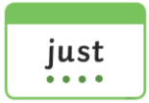

11 Tricky Words: they're the words that are difficult to sound out e.g. said, the, because which don't follow phonics rules.
12 Trigraph: this is when three letters go together to make one sound e.g. ear, air, igh, dge, tch.
13 Vowel: the letters a, e, i, o, u.

