

2022-23

☺ Welcome to Year 1 ☺

**Our week in view**

|  |  |  |  |
| --- | --- | --- | --- |
|  | **Homework** | **PE / Games** | **Clubs** |
| **Monday**  *Miss Platt* | * New spellings given out (red folder) | * PE/Games/Dance * | **Y1 clubs this year:**  Art Club (Spring)  French Club (Summer)  *Details to be confirmed* |
| **Tuesday**  *Miss Platt* |  |  |
| **Wednesday**  *Miss Platt* |  |  |
| **Thursday**  *Mrs. Tetlow* |  |  |
| **Friday**  *Mrs. Tetlow* | * Spelling test * *Please hand in red homework folders.* | * PE/Games/Dance |

**PE Kits:**

*Indoor kit only needed until Feb. half-term.

*Indoor AND outdoor kits needed after Feb. half-term until July.

*We will keep kits in school and send them home at the end of each half-term for a wash!

**Homework:**

Homework will be shared out between us over the term:

* Green folder (Miss Platt’s homework) – usually handed out at the start of the week.

* Black folder (Mrs. Tetlow’s homework) – usually handed out at the end of the week.

**Information Pack**

We have put together this pack of information for you; we hope you find it useful. Your pack contains a variety of maths and English information designed to you to help your child with his / her learning.

**Rewards**

We have lots of rewards in Year 1 – your child may come home talking about them! Our rewards include individual rewards such as stickers, certificates, house points, name on the proud cloud, etc. as well as whole class rewards such as ‘spaceships on the wall’. Children will receive house point certificates in assembly once they reach key landmarks e.g. 25, 50 etc.

**Uniform**

Please could we ask that

* Your child’s belongings are clearly labelled, especially kits, jumpers / cardies, shoes and coats.
* Children have 2 sports kits, to be kept in school, please:
* an **indoor** kit (shorts, t-shirt and pumps), and
* an **outdoor games kit** (jogging bottoms / leggings, hoodie / sweatshirt plus trainers).
* ***It is *really important* that children have the correct kits in school so that they can take part in PE lessons.***
* **Reminder** – earrings of any kind are not permitted in school.

**Our Topics for the autumn term:**

|  |  |  |
| --- | --- | --- |
| **AUTUMN TERM** | **1st half term** | **2nd half term** |
| **Science** | Ourselves & The Senses | |
| *Seasons topic ongoing throughout the year* | |
| **Geography** | Our Local Area | *-* |
| *Weather topic ongoing throughout the year* | |
| **History** | *-* | Toys |
| **Art / DT** | Painting / Colour (Art) | A Home for Teddy (DT) |
| **RE** | Introduction to Christianity | Christmas Gifts |

**Our Topics for the spring term:**

|  |  |  |
| --- | --- | --- |
|  | **1st half term** | **2nd half term** |
| **Science** | Materials | |
| *Seasons topic ongoing throughout the year* | |
| **Geography** | - | UK / London |
| *Weather topic ongoing throughout the year* | |
| **History** | The Great Fire of London | - |
| **Art / DT** | Printing (Art) | A Moving Postcard (DT) |
| **RE** | Introduction to Islam | |

**Our Topics for the summer term:**

|  |  |  |
| --- | --- | --- |
|  | **1st half term** | **2nd half term** |
| **Science** | Plants | |
| *Seasons topic ongoing throughout the year* | |
| **Geography** | - | The World: Hot & Cold Places |
| *Weather topic ongoing throughout the year* | |
| **History** | Women from History:  Annie Kenney / Rosa Parks | - |
| **Art / DT** | Sketching (Art) | Making a Fruit Salad (DT) |
| **RE** | Belonging to a Faith Community | Sacred Books and Stories |

[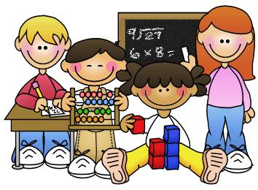](https://www.google.com/url?sa=i&rct=j&q=&esrc=s&frm=1&source=images&cd=&ved=0ahUKEwj8gcTjt6TWAhXEshQKHZEpDaAQjRwIBw&url=https%3A%2F%2Fwww.pinterest.com%2Fpin%2F208854501449381708%2F&psig=AFQjCNHjzK_kLcHtghzNbjmSDbFkziKhRw&ust=1505470224265853) **Maths** [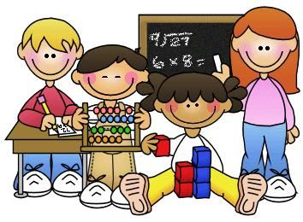](https://www.google.com/url?sa=i&rct=j&q=&esrc=s&frm=1&source=images&cd=&ved=0ahUKEwj8gcTjt6TWAhXEshQKHZEpDaAQjRwIBw&url=https%3A%2F%2Fwww.pinterest.com%2Fpin%2F208854501449381708%2F&psig=AFQjCNHjzK_kLcHtghzNbjmSDbFkziKhRw&ust=1505470224265853)

We will be learning lots of different things in maths this year!

* NUMBER FORMATION – it is essential that children can form all of their digits correctly *– see pack for number formation sheet to show how each digit should be formed.*
* ONLINE LEARNING – *we have included a list of some of the websites we use in our maths lessons in your pack.*
* COUNTING - there will be a lot of counting – forwards and backwards in 1s as well as counting in 2s, 5s and 10s, ready for learning times tables in Year 2.
* TEEN NUMBERS – this is a ‘biggie’ in Year 1 … we do a lot of work on place value, helping children to understand the difference between, for example, 13 (one ten and three) and 30 (3 tens). *An example of how to write teen numbers is included in your pack.*
* PLACE VALUE, CALCULATION AND FRACTIONS – *we have included in your pack the objectives for each of these areas of maths.*
* OTHER ASPECTS OF MATHS – children will continue to learn about shape, measure, direction etc … we do this practically, wherever possible!
* LEARN ITS – children will soon start to learn their key number facts, known as learn its. The aim of these is to speed up children’s mental maths skills. The first set the children learn are the Reception learn its (7 facts in 20 seconds), followed by the Year 1 learn its (17 facts in 30 seconds). Children will also need to know by heart their number bonds to 10 such as 8 + 2 = 10 (then to 20, such as 18 + 2 = 20). *See examples.*
* PROBLEM-SOLVING – children continue to develop their problem-solving and reasoning skills in our daily maths sessions.

[](https://www.google.com/url?sa=i&rct=j&q=&esrc=s&frm=1&source=images&cd=&cad=rja&uact=8&ved=0ahUKEwjoqOz2u6TWAhWLvRQKHSTKC04QjRwIBw&url=https%3A%2F%2F101clipart.com%2Fchildren-reading-clip-art%2F&psig=AFQjCNHCoxfDfPOFRFZMOpFBHmHRcMGI-w&ust=1505471335008751) **Reading** [](https://www.google.com/url?sa=i&rct=j&q=&esrc=s&frm=1&source=images&cd=&cad=rja&uact=8&ved=0ahUKEwjoqOz2u6TWAhWLvRQKHSTKC04QjRwIBw&url=https%3A%2F%2F101clipart.com%2Fchildren-reading-clip-art%2F&psig=AFQjCNHCoxfDfPOFRFZMOpFBHmHRcMGI-w&ust=1505471335008751)

**Reading regularly with your child is so important. Daily home reading really does make a **massive difference** to the progress your child will make**.

**PLEASE SEE YOUR CHILD’S READING RECORD FOR DETAILS OF HOW READING WORKS IN YEAR 1.**

*KEY WORDS:*

* Children will soon bring home a set of key words to read. The aim is for children to read these words **by heart**; please try to encourage him / her to read each word without sounding them out if possible.
* *The words in grey on their word lists are the common exception words that Year 1 children are expected to be able to read and spell.*

[](http://www.google.com/url?sa=i&rct=j&q=&esrc=s&frm=1&source=images&cd=&cad=rja&uact=8&ved=0ahUKEwiAlOugt6TWAhUEPxQKHZD-Dj0QjRwIBw&url=http%3A%2F%2Fwww.mycutegraphics.com%2Fgraphics%2Freading-images.html&psig=AFQjCNGxt-Mk6uT-vbZrT2gEfniDsgfSMg&ust=1505470072235851) **English** [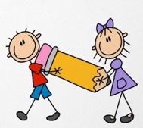](http://www.google.com/url?sa=i&rct=j&q=&esrc=s&frm=1&source=images&cd=&cad=rja&uact=8&ved=0ahUKEwiVpsjNt6TWAhUGwBQKHYV_CaEQjRwIBw&url=http%3A%2F%2Fgclipart.com%2Fwriting-clipart_1029%2F&psig=AFQjCNFo2wQkbxMysErjm-kDEdSagSjYSw&ust=1505470166553907)

**HOW OUR ENGLISH WORKS**

We are currently in the process of ‘easing the children in gently’ as the jump from Reception to Year 1 is a big one! Once we feel the children are ready, we will follow our Y1 weekly writing cycle:

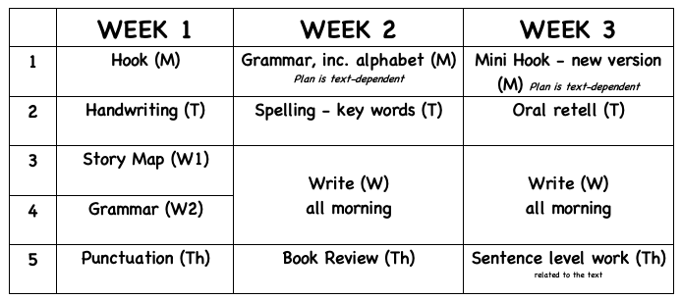

Phonics, handwriting and spelling activities are ongoing through the week.

**SPaG**

Children in Year 1 are expected to know, use and understand a lot of technical terminology – there are some ‘big words’ considering the children are only five and six years old! *Included in this pack is a booklet outlining the grammatical terminology the children need to know, as well as the punctuation they are expected to use.*

**HANDWRITING**

**We put a HUGE emphasis on correct letter formation and neat handwriting in Year 1 … these basic skills are SO important.**

* Children should be able to form **ALL** the letters in their name correctly – their first name initially, then we work on surnames too.
* When handwriting, letters should be correctly-formed and consistent in size. They should also sit correctly on the line.
* To reinforce work done in class, could we ask that you try to ensure that your child forms **ALL** of their letters (both lower-case and capitals) correctly and that they are consistent in size and sit correctly on the line. *See letter formation sheets in pack.*

**EXPECTATIONS**

We have included in your pack a list of the writing expectations for children in Year 1, to show you what we are aiming for. Please don’t be alarmed … *we find that with hard work and dedication both at home and at school, the children’s writing really does ‘come on’ over the course of the year! ☺*

**NEWS**

Sometimes we write about our news; children sometimes forget what they have been up to so a ‘Big Talk’ note will come home the night before in order to help the children with their writing the following day.

**PHONICS**

* In Year 1 we have daily phonics sessions. Most children take part in whole-class phonics sessions, with smaller sessions for those who need it.
* We not only work on recognising sounds (phonemes) in isolation, but also on spotting sounds within words (reading) and using our phonics knowledge to help us spell (writing).
* We also cover key word reading / spellings in our daily phonics sessions.
* We use the Twinkl Phonics Sceme.
* *See pack for glossary of phonics terminology.*

**Phonics Screening Check**

* In June of each year, all Year 1 children across the country are assessed on their phonics skills in the national government ‘test’ known as the *Phonics Screening Check. The check will go ahead in June 2023.*
* Don’t worry about this for now; please just keep reading! We will be in touch again about this nearer the time, when we will have a parental information meeting.

[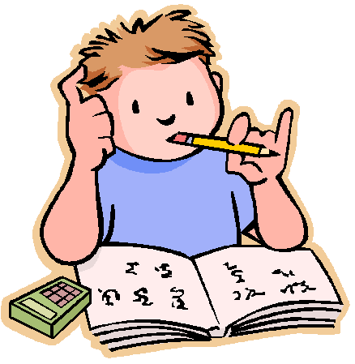](http://www.google.com/url?sa=i&rct=j&q=&esrc=s&frm=1&source=images&cd=&cad=rja&uact=8&ved=0ahUKEwjxqYbhuKTWAhUJrRQKHb1dCP8QjRwIBw&url=http%3A%2F%2Fwww.clipartpanda.com%2Fcategories%2Fhomework-clip-art-for-kids&psig=AFQjCNEGAHazRuqqnT6Xz1vHEj_Il5NUkQ&ust=1505470486002158) **Homework** [](http://www.google.com/url?sa=i&rct=j&q=&esrc=s&frm=1&source=images&cd=&cad=rja&uact=8&ved=0ahUKEwjvgPHuuKTWAhXBQBQKHSBMAfgQjRwIBw&url=http%3A%2F%2Fwww.clipartpanda.com%2Fcategories%2Fhomework-clip-art-for-kids&psig=AFQjCNEGAHazRuqqnT6Xz1vHEj_Il5NUkQ&ust=1505470486002158)

☺ **Your support with home learning tasks is invaluable.**

☺ Home reading is a crucial part of the Year 1 learning to read jigsaw. Please could you take time to read with your child as often as possible – a mix of school scheme books as well as books from home works best.

☺ Please refer to front of your child’s red spelling folder for ‘Making Spelling Fun’ ideas.

☺ Please could we ask that written homework tasks are **completed in pencil** rather than biro.

**Reading**

* See above for more information.
* We recommend reading for 5-10 minutes per night (reading and/or word lists). If your child has read his/her school books, feel free to read books from home.
* Our **termly reading challenges** for our EYFS and Key Stage 1 children continue (please see new challenge in your child’s reading record book at the start of each new term). Please date and sign when your child has completed a challenge. There are 8 challenges per term; if you like, you can send us photos of your child completing their favourite challenge(s) so that we can share them with the class via Tapestry.

**Spellings**

* From October onwards, children will receive a set of spellings to learn each week. *An example is included in your pack. Please can these be completed in pencil?*
* *Weekly spellings follow a pattern and also include some of our Y1 common exception words / phonics key words.*
* Spellings are usually handed out on a Monday, ready for a test on Friday. Please could you ensure that your child’s red spelling folder is returned to school each Friday.
* Later in the year, children will bring home a list of which common exception words (s)he is yet to learn … don’t worry about these for now!

**General Homework**

* Most weeks there will be an English, maths or topic-related homework task (depending on work done in class that week).
* Please could you ensure that your child’s homework has his/her name on it, and return it to school in his / her homework folders (where appropriate).
* Also, we would appreciate it if you could briefly annotate any homework sent home to let us know how your child has gone on, how much support (s)he needed etc. Many thanks ☺

**Forest Fun**

Children no longer do ‘Forest School’ in Year 1. Instead, this term we will be going out to explore the school grounds. Children do not need a specific set of clothes like they did in Reception; instead, a letter will be sent out to say when / if we need our wellies.

**Our Trips and visitors**

Whole class panto trip – December 2022

Trip to Gallery Oldham – January 2023

Trip to Fireground Museum, Rochdale – February 2023

**Miscellaneous**

VOLUNTEERS – If you are able to spare any time to come in and help in school, please do let us know. Any extra help is always welcome!

TAPESTRY – This is the platform that we will use to stay in touch. If you have any problems logging on, please contact the school office (0161 770 5850).

Many thanks for your continued support; it is very much appreciated ☺

☺ Year One Team ☺