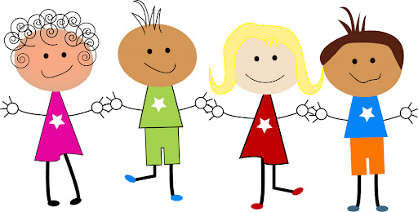

**Year 2**

**Information for Parents**

**2024-2025**

**WELCOME TO YEAR 2 ☺ ☺**

We look forward to the year ahead and sharing your child’s learning journey with you. We hope you find this information useful. There is always a lot of information at the start of a new class, so please keep this booklet safe so that you can refer back to it when necessary.

**Teachers**

* Teacher - Mrs K. Littlewood
* Teaching Assistant - Mrs C. Harding
* PPA Cover – Mrs A.Crossley
* Midday Supervisor – Mrs N. Mills

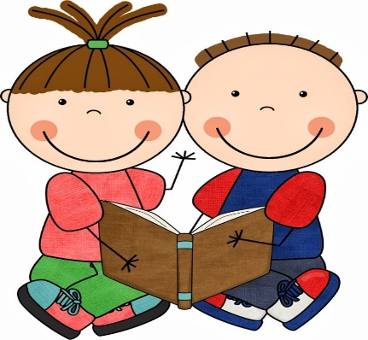 **Reading Books**

* We will hear children read in school at least once a week. We also do a group guided read once a week. Sometimes children will be heard more often, when staffing or parental help in school permits.
* Children will receive two books at a time and when they are ready to change their books they can put them in the ‘Book change box’. We endeavour to change them that day but if we are unable to, we encourage you to read books from home, or the library, or from the Oxford Owl website, making a note of them in your child’s reading journal.
* The reading **book ‘bookmark’ challenge** operates throughout the school. Please endeavour to read every night with your child, supplementing school books with your own books from home. Reading regularly really does make the world of difference to your child’s learning. (See explanation of the reward system in the front of the reading journal)
* See ‘**Infants Reading at Buckstones’** leaflet for more ways to help your child.
* See also the sheet entitled ‘**Can you tell us?**’ This can be used as an aide memoire for when you read with your child at home.

**Buckstones KS1 Reading Challenge**

We have an additional reading challenge across the school. This is to promote a love of reading as well as being a bit of fun! The reading challenge for Autumn is in the back of your child’s reading journal. We would love to see photos of any of the reading challenges.

* **See the Key Stage 1 Autumn, Spring and Summer Reading Challenges.**

**Guided Reading**

* When the children are ready, Mrs Littlewood and Mrs Harding will move from hearing individual readers to hearing the children read in guided reading sessions with groups of up to six children. These sessions will give the children an opportunity to read aloud from a shared text and ask and answer questions about what they have read.

**Book bags**

* Please check your child’s book bag every night as there may be important letters or pieces of information.
* Encourage your child to keep their bag tidy.
* If the children would like to put a keyring on their reading bag to help them identify them in the box, that is fine. Please only put one keyring on their bag as more than one takes up a lot of room in the box and we have a limited space to store book bags.

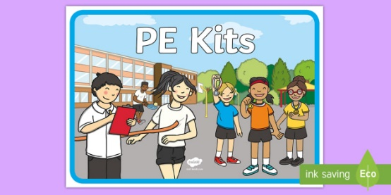

**Pump bags**

* Your child will be expected to bring a pump bag with their P.E clothes in (list of clothes needed is further on in this booklet) but also could you please make sure that there are a couple of spare pairs of socks/tights and some underpants/knickers in there too, just in case!



**Homework**

* Reading: 10-15 minutes per night.
* Practise weekly spellings and common exception spellings.
* Literacy/Numeracy – according to themes / concepts studied that week, set on Friday and to be returned by the following Thursday please.
* Homework should be presented in the same manner as schoolwork, with pencils only being used for written work.
* A tick list will be kept to ensure all children have completed homework set. A judgement for the quality of homework is given in the end of year report.

* **Spellings** will be given out on a Friday, ready for the test the following Thursday.



**Golden Time**

* Golden Time is on a Thursday after P.E. The children can choose from a variety of toys and games in the classroom.
* Golden Time may be reduced for a child if their behaviour is inappropriate during that week.
* The class can gain extra Golden Time, for example when making us proud during a certain lesson, or making a real effort learning a new skill, or showing excellent behaviour at playtime.



**P.E. (Thursday afternoon and Friday morning)**

|  |  |  |  |  |  |
| --- | --- | --- | --- | --- | --- |
| **Autumn Term** | | **Spring Term** | | **Summer Term** | |
| **Fundamentals**  **Team Building** | **Gymnastics**  **Sending and Receiving** | **Dance**  **Net and Wall Games** | **Yoga**  **Striking and Fielding Games** | **Target Games**  **Fitness** | **Athletics**  **Ball Skills** |

**P.E is on a Thursday and a Friday**

* P.E. kits are to remain in school but will be sent home every half term to be washed.
* Outdoor kit – joggers, leggings, t-shirt, jacket/jumper & trainers*, Sept – Dec, plus all of the summer term.
* Indoor kit – white/yellow PE t- shirt, black shorts & pumps, Sept- Dec, then all of the Spring Term(until Easter)

**\* Trainers must be worn for outdoor P.E**

**FOR HEALTH AND SAFETY REASONS WE CANNOT ALLOW CHILDREN TO DO GAMES/P. E OUTSIDE WITHOUT THE PROPER KIT INCLUDING TRAINERS.**

**End of Year Expectations**

**Reading Expectations**

See separate sheet

**Writing Expectations**

See separate sheet.

See also Year 2 Grammar and Punctuation booklet.

**Maths Expectations**

See separate sheet

**SATS**

SATS are no longer a statutory requirement however we will still sit them in May 2024. They are a useful form of summative assessment and help inform the end of year judgements alongside formative assessments.

If you have any questions, please don’t hesitate to contact school. We use Tapestry to keep in touch and share your child’s learning journey through Year 2.

Many thanks for your continued support,

Year Two Team.